**CHAPTER 1**

**Effects of climate and land cover change on forest songbirds of the Appalachian Mountains: A literature review and case study**

**Introduction**

**Global climate change effects on birds**

Global climate change is implicated as a factor in declines of avian populations. Defined as the unprecedented rate of increase in Earth’s surface temperature during the 20th and 21st centuries, due primarily to human activity (Karl and Trenberth 2003), global climate change can elicit a myriad of avian responses, including shifts in phenology, distributions, and communities; population responses to altered weather; and evolutionary changes (Oliver and Morecroft 2014). Impacts to birds can occur either directly or indirectly (Trautmann 2018). Direct mortality of migrating birds can occur when encountering storms, which are increasing in frequency and intensity under global climate change (Zumeta and Holmes 1978, Newton 2007). Temperature can interact with landscape factors to lower songbird productivity (Cox et al. 2013*a*), and increasing temperatures may elevate rates of nest failure caused by snakes and avian predators (Cox et al. 2013*b*). In terms of indirect effects, there is strong evidence that rising temperatures cause phenological mismatches between birds and vegetation budding dates and emergence of or peaks in their insect prey (Visser et al. 2006, Waite and Strickland 2006). In North America, the interval between spring green-up and arrival of migratory passerine species has increased, with certain species unable to keep pace (Mayor et al. 2017). Changes in phenology of migration and breeding are particularly prevalent in response to climate change (Both et al. 2004, 2006, Crick 2004, Møller et al. 2008). For instance, arrival dates of Australian and European migratory birds at their breeding grounds are advancing and departure dates from their breeding grounds for some species are delayed (Beaumont et al. 2006, Jonzén et al. 2006). Meanwhile, the clutch initiation dates of a multitude of migratory bird species, including tree swallows (*Tachycineta bicolor*) and pied flycatchers (*Ficedula hypoleuca*), are similarly advancing (Winkler et al. 2002, Both and Visser 2005). These phenological changes can have fitness consequences (Møller et al. 2008); species that advance their migration or breeding phenology to track changes in climate may benefit from a longer breeding period and possibly increased recruitment, but species with limited phenological plasticity may be facing an increasing mismatch between timing of food requirements and food availability (Both et al. 2009), lowering reproductive success. For instance, species that advance their egg-laying dates the least in response to increasing spring temperatures over time exhibit the most negative population trends (Franks et al. 2018). In addition to direct and indirect impacts to populations and phenology, global climate change is affecting avian biogeographical patterns.

There is evidence linking global climate change to long-term changes in avian distributions and geographical ranges (Chen et al. 2011). Many bird species in North America and Europe have expanded or contracted their wintering and/or breeding ranges northward (Thomas and Lennon 1999, Hitch and Leberg 2007, La Sorte and Thompson III 2007, Virkkala et al. 2008), but both latitudinal and altitudinal shifts have been documented and projected (Pounds et al. 1999, Rodenhouse et al. 2008, Maggini et al. 2011, Flousek et al. 2015). High-elevation species are particularly vulnerable to climate change (Siegel et al. 2014, Flousek et al. 2015, Freeman et al. 2018). As little as 1°C warming could reduce suitable habitat for certain high-elevation bird species by more than 50% (Rodenhouse et al. 2008). Meanwhile, low-elevation species are expanding upslope (DeLuca and King 2017, Freeman et al. 2018). However, along elevational gradients, climate change can cause potentially heterogeneous range shifts, as rising temperatures push species upslope while increased precipitation pulls them downslope (Tingley et al. 2012). Global climate change can further affect avian distributions indirectly by altering tree species distributions (Iverson et al. 2008), as well as the frequency, intensity, duration, and timing of forest disturbances, which can alter habitat quality during both breeding and non-breeding seasons (Dale et al. 2001). Looking into the future, both latitudinal and altitudinal shifts in North American bird distribution are predicted to continue, in conjunction with tree species responses to climate change (Matthews et al. 2011).

It is likely that climate change plays a role in declining forest songbird populations through direct, indirect, and synergistic effects (Jenouvrier 2013, Oliver and Morecroft 2014, Northrup et al. 2019), with consequences potentially greatest for long-distance migrants in seasonal habitats (Lemoine and Böhning-Gaese 2003, Both et al. 2010, Flousek et al. 2015, Zurell et al. 2018). In fact, migrant passerine species are projected to encounter novel climates throughout most of their annual cycle in the future (Zurell et al. 2018), which may adversely affect their survival rates (La Sorte et al. 2018). As the climate continues to warm, certain birds may even face extirpation and extinction (Schwartz et al. 2006, Sekercioglu et al. 2008, Tayleur et al. 2016, Freeman et al. 2018). Alternatively, some species are predicted to expand their distributions (Tayleur et al. 2016), and resident species may benefit from warmer winters (Rodenhouse et al. 2008). Ultimately, changes in bird communities are likely to result from climate change (Rodenhouse et al. 2008, Stralberg et al. 2009, Davey et al. 2012, Lindström et al. 2013), in part due to expanded ranges and increased relative abundance of habitat generalists (Davey et al. 2013); specifically, habitat specialists and cold-associated species tend to decline in numbers and are more negatively affected by higher temperatures than southerly distributed species associated with warm temperatures (La Sorte and Jetz 2010, Davey et al. 2012, Pearce-Higgins et al. 2015, Tayleur et al. 2016, Freeman et al. 2018).

**Land cover change as an additional factor**

Many studies addressing global change are focused on anthropogenic climate change, but it is important to also consider that landscapes have been altered significantly in the last century. Broad-scale trends are spatially and temporally variable, with some regions within the United States (e.g., West Virginia) experiencing stable or increasing trends in forest area within the past 5 decades (Childs 2005, Morin et al. 2016). However, cumulative historical changes in land cover and use, landscape composition, and landscape configuration over hundreds of years have tended to result in forest habitat loss, fragmentation, and decreased connectivity, which affect forest songbird populations and distributions (Villard et al. 1999). Certain forest songbirds require large tracts of relatively mature forest, which makes them sensitive to landscape change (Moenkkoenen and Welsh 1994). Losses in suitable forest habitat directly lead to subsequent declines or absences of associated forest bird populations (Pimm and Askins 1995, Trzcinski et al. 1999). Conversion of preferred habitat to less suitable habitat can also lead to population declines and reductions in species richness (Gaston et al. 2003, Aratrakorn et al. 2006, Zurita et al. 2006). For instance, urbanization and energy development tend to negatively impact native forest bird populations and communities (Nilon et al. 1995, Rottenborn 1999, Er et al. 2005, Farwell et al. 2016).

Forest habitat fragmentation, which is a landscape-scale process involving the simultaneous loss of forest, reduction in forest patch size, increase in the number of forest patches, and increased isolation of forest patches (Fahrig 2003). Previous studies using land cover datasets with moderate resolution (e.g., 30 m cell size) indicate that fragmentation generally has non-significant or positive relationships with overall abundance and richness (Fahrig 2017, Fahrig et al. 2019). However, it may also have negative effects, particularly for forest-interior species such as ovenbirds (*Seiurus aurocapillus*) (Bayne et al. 2005), red-eyed vireos (*Vireo olivaceus*) (Keller and Yahner 2007), and forest interior-edge species such as cerulean warblers (*Setophaga cerulea*) (Weakland and Wood 2005). For instance, forest-interior and forest interior-edge guild abundances decreased after specific thresholds in area of timber harvested within a heavily forested landscape in the central Appalachian Mountains (Becker et al. 2011). Similarly, forest-interior species abundance responded negatively to core forest (i.e., >100 m from a non-forest edge) loss, forest loss, and increased edge density after alteration of landscape structure by mountaintop removal activities (Becker et al. 2015). In fragmented forest habitat patches, forest-interior songbirds and long-distance migratory birds are subject to increased risk of nest predation and parasitism (Wilcove 1985, Robinson et al. 1995, Hobson and Bayne 2000, Donovan et al. 2012). Distance to edge, edge type, and type of timber harvest also influence nestling growth rates (Duguay et al. 2000, Kaiser and Lindell 2007). Ultimately, forest-interior songbird populations in severely fragmented landscapes can become extirpated (Temple and Cary 1988). However, the effects of forest fragmentation can vary by species, with some (e.g., edge-associated species) increasing in abundance and others showing no response (Uezu et al. 2005, Becker et al. 2015).

Because landscape change (encompassing land cover and land use change) can have significant impacts on bird populations, communities, and distributions (Rittenhouse et al. 2012), it is worth considering as an additional factor when evaluating avian responses to global climate change. In general, climate change may have greater influence on bird distributions than land cover change, as it likely affects range limits while land cover affects where species occur within those ranges. For instance, Sohl (2014) found that climate variables (i.e., mean annual temperature and precipitation) contributed more than land cover variables to models of 50 North American bird distributions in 2001 and that projected climate change resulted in larger overall range changes than projected land cover change. However, Sohl (2014) concluded that both climate and land cover variables are important for modeling contemporary and potential future species ranges, and other studies emphasize the importance of land cover change in driving bird population trends (Eglington and Pearce-Higgins 2012). At regional scales, adding vegetation cover / land cover / land use in species distribution models can create more refined projections (Seoane et al. 2004). For example, including tree species has been demonstrated to improve models for breeding bird species in the eastern United States (Matthews et al. 2011). Furthermore, the importance of including land cover change in projections of future avian ranges on a global scale was highlighted by models that coupled climate and land use change together (Jetz et al. 2007); they projected range reductions in many bird species, with land use change in the tropics responsible for range contractions of species currently not recognized as imperiled. Therefore, it is important to incorporate changing land cover and land uses in conjunction with global climate change, especially given that an altered climate regime itself can precipitate changes in vegetation communities and land cover types.

**Significance of the Appalachian Mountains**

Changes in the climate and land cover patterns are occurring within the Appalachian Mountains region, with likely consequences for its bird communities. The Appalachian Mountains, which first formed ~480 million years ago during the Ordovician Period, are a dominant land feature of the eastern United States. They contain a range of elevations and primarily forested habitats, from temperate deciduous forests at lower elevations/latitudes to boreal coniferous forests at higher elevations/latitudes. The biota in this extensive region reflects that habitat diversity, with forest songbird communities comprising species from a plethora of families. The Appalachian Mountains are a key component influencing contemporary species’ ranges, and they serve as the southern-most limit of many species’ breeding ranges, such as Canada warblers (*Cardellina canadensis*) and black-throated blue warblers (*Setophaga caerulescens*). Looking forward, the Appalachian Mountains will likely play an important role in shaping future distributions of birds, particularly those whose regional distributions seem to be influenced heavily by elevation and concomitant climatic conditions. As the climate warms over time, the elevational gradient of the Appalachian Mountains may enable them to serve as refugia for bird species (Keppel et al. 2012) or as a dispersal corridor that enables the northward migration of southerly species (Lawler et al. 2013, Zhu et al. 2021). However, the Appalachian Mountains region is also experiencing and projected to undergo rapid land cover change in some areas (Ordonez et al. 2014, Leonard et al. 2017), in part due to energy extraction (e.g., coal mines, wells and pipelines for natural gas) or production (e.g., wind turbines) and urban development (Lawler et al. 2014). Given the significance of the Appalachian Mountains and the potential impact on high-elevation species, there is a clear need to focus on this specific region and assess bird responses to the relative and cumulative effects of global climate change and land cover change. Greater understanding of how avian populations, communities, and species distributions in the Appalachian Mountains have been changing and will change over time will inform conservation and management efforts in this region.

**Purpose and objectives**

To determine the potential effects of both climate and land cover change on forest songbirds of the Appalachian Mountains, I conducted a comprehensive review of published literature and investigated a novel case study. The specific objectives of the review and case study were to: (1) provide a synthesis of documented and predicted changes in forest songbird species distributions, population dynamics, and communities in the Appalachian Mountains in response to climate and land cover change; (2) determine the relative influence of climate change and land cover change on 14 forest songbird distributions in the Appalachian Mountains over a 20-year period (1997–2017); and (3) project future distribution changes based on expected scenarios of climate change and land cover change.

**Review of climate and land cover change in the Appalachian Mountains and associated forest songbird responses**

**Historical and contemporary changes in climate and land cover**

The impacts of global climate change are already being experienced in the Appalachian Mountains; over the last several decades, this region has become warmer and wetter (Hayhoe et al. 2007, IPCC 2007, Huntington et al. 2009), though there is spatial variation in how precipitation has changed over time. Evidence of climate change in the northeastern USA, which encompasses the northern Appalachian Mountains (hereafter, Northern Appalachians), is extensive (Hayhoe et al. 2007, Huntington et al. 2009). Temperatures in the Northern Appalachians have risen over the last several decades (Rogers et al. 2016). This region has experienced an average increase in annual temperatures of ~0.08 °C per decade over the last century, with the rate increasing to ~0.25 °C per decade since 1970 (Hayhoe et al. 2007). Average annual temperatures in the 1990s were 0.6 °C warmer than the 1900–1999 long-term mean, with higher disparities in winter than summer (Hayhoe et al. 2007). In addition to warming temperatures, the Northern Appalachian region has seen accompanying increases in the number of extremely high temperature days (i.e., exceed the 95th percentile threshold for daily maximum temperature) and in warm minimum temperature extremes, as well as decreases in extremely cold temperature days (DeGaetano and Allen 2002) and in the ratio of snow to total precipitation (Huntington et al. 2004). However, broadly observed changes in precipitation in the northeast USA over the last century are speculated to be primarily driven by natural variability rather than a long-term climate trend (Hayhoe et al. 2007). Specific points within the Northern Appalachians echo broader regional trends; weather stations in the mountains of New Hampshire and Vermont have also reported increases in average annual temperatures and increases in precipitation since the 1960s (Beckage et al. 2008, Seidel et al. 2009, DeLuca and King 2017).

In the central Appalachian Mountains region (hereafter, Central Appalachians), annual temperatures are rising, and annual precipitation may be increasing. One study found non-significant but warming trends in maximum temperatures and significant increases in minimum temperatures, which averaged a difference of +0.2 °C over 31 years, as well as non-significant increases in precipitation by an average of 34 mm (Gaertner et al. 2019). A report from the U.S. Forest Service on observed climate change in the Central Appalachians also reported increases in annual and seasonal mean temperature and particularly minimum temperatures, with non-significant increases in annual mean precipitation and spatial variation in precipitation trends (Butler et al. 2015). Another study looking at a specific site within the Central Appalachians yielded the same general trends: average and minimum annual air temperatures increased significantly since the 1950s, and mean annual precipitation increased non-significantly (Young et al. 2019). A fourth study also found that mean annual temperatures in the Central Appalachians have increased significantly, but there were no significant changes in mean annual precipitation (Mathias and Thomas 2018). In particular, Mathias and Thomas (2018) noted that mean April temperatures increased by 0.06°C per year from 1989 to 2014 and were 0.72°C warmer during 1989–2014 than during 1940–1989. Within the Central Appalachians, the mid-Atlantic highlands (comprising most of Pennsylvania and West Virginia and the western portions of Maryland and Virginia) experienced relatively stable mean temperatures over the past century, while changes in precipitation have been spatially variable but high-intensity precipitation events have increased (Pitchford et al. 2011). Specifically within West Virginia, changes from 1900 to 2016 show that both minimum temperatures in the summer and annual precipitation are increasing, with an accelerated rate in the increase of precipitation since 1959 (Kutta and Hubbart 2019).

In the southern Appalachian Mountains region (hereafter, Southern Appalachians), temperatures have increased by 0.6 °C and precipitation has increased by 10% during the last century (IPCC 2007). One study that assessed temperature and precipitation trends from 1931 to 2004 in the Southern Appalachian region of North Carolina found that temperatures during both the cool and warm seasons increased slightly between the 1960s and 2004, but there were no long-term changes in precipitation (Warren and Bradford 2010). Another study found that, since the late 1970s, air temperatures have increased significantly, drought severity and frequency have increased, and the distribution of precipitation has become more extreme (Laseter et al. 2012). Burt et al. (2018) also note major periods of drought and a tendency for increased variability in annual rainfall totals over time at a site in the Southern Appalachians. More recently, minimum and maximum temperatures in the Southern Appalachians both significantly increased in the winter and minimum temperatures additionally increased in the summer from 1980–2008 (Hawkins and Smith 2011). Changes in precipitation likely reflects regional variation, ranging from no significant changes (Warren and Bradford 2010) to decreases in certain seasons (Hawkins and Smith 2011) to general increases across most seasons (Sayemuzzaman and Jha 2014).

Land cover in the Appalachian Mountains has also changed over the past 50 years, encompassing a history of timber harvest across the region; reforestation leading to increases in forest cover, particularly in the Northern Appalachians; conversion from forest to mining in the Central Appalachians; and increases in developed areas, especially in the Southern Appalachians (Brown et al. 2005, Sleeter et al. 2012, Sayler et al. 2016). All ecoregions within the Appalachian Mountains experienced net declines of up to 5% in forest and agricultural cover and net increases of up to 60% in developed land cover between 1973 and 2000 (Sleeter et al. 2013). Conversions from upland forest to developed land cover between 1973 and 2011 also occurred in all ecoregions (Auch et al. 2016). In addition, exurban development (i.e., rural sprawl or rural residential development) increased between 1970 and 2000 throughout the Appalachian Mountains region, accompanied by reductions in cropland (Brown et al. 2005).

The U.S. Geological Survey prepared a comprehensive report on the status and trends of land cover and land use change from 1973 to 2000 in the eastern United States, detailing changes in land cover and land use classes during four time periods (1973–1980, 1980–1986, 1986–1992, and 1992–2000) in individual ecoregions (Figure 1) (Sayler et al. 2016). In the Northeastern Highlands Ecoregion, declines in forest cover was the greatest land cover change between 1973 and 2000, whereas the Northern Appalachian Plateau and Uplands Ecoregion experienced initial declines in forest cover, followed by a slight increase for no net gain, and declines in agricultural land (Figure 1) (Sayler et al. 2016). In both ecoregions, timber harvest, grassland / shrubland, and developed land increased. The 3 ecoregions that lie primarily within the Central Appalachians (North Central Appalachians Ecoregion, Western Allegheny Plateau Ecoregion, and Western Allegheny Plateau Ecoregion) and the Ridge and Valley Ecoregion, which extends through both the Central and Southern Appalachians, all experienced declines in forest cover and agricultural land between 1973 and 2000, as well as increases in timber harvest and developed land (Figure 1) (Sayler et al. 2016). During this time period, mining land decreased in the Western Allegheny Plateau Ecoregion but increased in the North Central Appalachians Ecoregion and especially in the Central Appalachians Ecoregion, and grassland / shrubland increased in the Western Allegheny Plateau Ecoregion and Central Appalachians Ecoregion. In the 2 primary ecoregions of the Southern Appalachians (Southwestern Appalachians Ecoregion and Blue Ridge Mountains Ecoregion), forest cover and agricultural land declined, whereas timber harvest and developed land increased between 1973 and 2000 (Figure 1) (Sayler et al. 2016). In addition, the proportion of mining land declined, while the proportion of grassland / shrubland increased in the Southwestern Appalachians Ecoregion, perhaps because reclaimed mines may be re-classed to grassland over time.

Data from other sources and time periods agree with and build on these land cover trends, although there is scarce literature pertaining to land cover change within the past decade (2012–2022). In the Northern Appalachians, some forested land has been converted to open land, which consists of non-forested areas such as fields, highways, clear-cuts, and developed areas (Miller et al. 2010). Net increases in developed land cover ranged from 10–40% between 1973 and 2000 (Sleeter et al. 2013). Meanwhile, the Central Appalachian region is characterized by surface mining and reclamation as the dominant driver of land cover change (Townsend et al. 2009), with additional forest cover decline in favor of urbanization in recent years (Rosenberger et al. 2018). Net increases in developed land cover ranged from 10–20% between 1973 and 2000 (Sleeter et al. 2013). Within the north-central Appalachian region specifically, the primary change has been conversion of forests to mining, shale gas development, and urban lands (Napton et al. 2003). However, Gallant et al. (2004) modeled little overall change in relative abundance of land cover types in the North Central Appalachians Ecoregion from 1973 to 2000, with a gain of only 5 ha per year of urban development. In the Southern Appalachians, forest cover increased and forest fragmentation declined overall between 1950 and 1990, but areas at lower elevations and on more gentle terrain tended to remain in non-forest cover and experience recent losses of forest cover (Wear and Bolstad 1998, Turner et al. 2003). Meanwhile, the abundance of agricultural cover and developed areas in the Southern Appalachians has changed over time with shifting patterns of land use, with decreases in percent agriculture and increases in percent urban cover (Wear and Bolstad 1998, Gragson and Bolstad 2006). Specifically, the main change in land cover in recent decades has been an increase in urban development, particularly at higher elevations and in rural residential areas (Wear and Bolstad 1998, Turner et al. 2003, Gragson and Bolstad 2006). Net increases in developed land cover ranged from 10–60% between 1973 and 2000 (Sleeter et al. 2013). Correspondingly, the number and density of buildings in forested areas has increased, while forest cover in rapidly developing areas has declined (Turner et al. 2003). Often, urban development results in forest loss and fragmentation in the Southern Appalachians (Lumpkin and Pearson 2013).

Multiple studies focused on land cover change in the Blue Ridge Mountains Ecoregion in the Southern Appalachians. Napton et al. (2010) found only 2% of the ecoregion changed land cover from 1973 to 2000, with forest cover slowly declining, net agricultural land remaining stable, and developed land increasing at an annual rate of 0.35% until the 1990s when it increased to 0.54% annual change. Griffith et al. (2003) also looked at landscape patterns in the Blue Ridge Mountains from 1973 to 2000, with percent forest cover declining by ~1.3%, forest fragmentation increasing, percent agricultural land declining by ~0.8%, and percent urban cover increasing by ~0.8%. In a single county within the southern Blue Ridge province, development trends have increased in housing density from rural to exurban to suburban from 1906 to 2009, and the rate of development in forested areas increased between 1990 and 2009 (Kirk et al. 2012).

**Projected future changes in climate and land cover**

Relative to 1986–2005, global surface temperature changes are predicted to increase by an average of ~4 °C by 2081–2100 under a high greenhouse gas emissions scenario, with even higher predictions (ranging ~4–7 °C) for the United States (IPCC 2014). Across the entire Appalachian Mountains range, projections tend towards warmer temperatures by the end of the century (IPCC 2014); for instance, Rogers et al. (2016) reported that temperatures in the Appalachian Mountains are projected to increase by 2.2–3.0 °C by 2055 and 2.7–4.6 °C by 2080. Higher greenhouse gas emissions scenarios result in greater temperature increases (Iverson et al. 2008, Zhu et al. 2021). It is worth noting that these temperature increases exceed long-term global targets of staying under 1.5 °C of warming (IPCC 2018). In terms of precipitation, projected changes in precipitation patterns across the Appalachian Mountains include increased frequency of moderate to heavy (>12.5 mm) and widespread, heavy (>25 mm) precipitation events by 2050 (Rastogi et al. 2020). However, different projections vary in their predictions of whether average annual precipitation will increase or decrease. Some indicate drier conditions in the future (Elguindi and Grundstein 2013); however, most predict variable but generally higher precipitation amounts (IPCC 2014, Rogers et al. 2016). Furthermore, projections across the entire Appalachian Mountains range show varying regional trends in precipitation amounts and seasonality, with some scenarios predicting the highest increases in annual precipitation in the northeast portion (Fernandez and Zegre 2019).

Overall trends (e.g., increasing temperatures, variable precipitation) are consistent across the entire range of the Appalachian Mountains, but there is regional variation in specific predictions. The Northern Appalachians are predicted to experience a warmer, wetter climate, with increased variability in weather and increased likelihood of extreme weather events (Hayhoe et al. 2007, Huntington et al. 2009). Under higher greenhouse gas emissions scenarios, projected increases in annual regional surface temperature average 5.3 °C by 2070–2099, relative to 1961–1990 (Hayhoe et al. 2007). Additionally, precipitation and drought events will increase in variability and magnitude (IPCC 2014). Meanwhile, the Central Appalachians will experience substantial warming, with projections of mean, minimum, and maximum annual temperatures increasing by 7.7–7.8 °C from 2000 to 2100 under a high greenhouse gas emissions scenario (Butler et al. 2015). Annual precipitation overall is only projected to increase by 5–51 mm, depending on the emissions scenario, but there is both temporal and spatial variation in precipitation trends (Butler et al. 2015); in addition, the Central Appalachians may experience 2-4 more days of heavy (>76 mm) precipitation annually by the end of the century (Diffenbaugh et al. 2005). Consistent with the other 2 regions, climate in the Southern Appalachians is also projected to become warmer; for example, mid- to high-elevation areas may experience increases of +3.5 °C in the next 100 years (Schultheis et al. 2010). Although there is consensus that temperatures will increase regionwide within the Southern Appalachians (Mearns et al. 2003, Ingram et al. 2013, McDonnell et al. 2013, Wu et al. 2014), there is uncertainty regarding whether long-term annual precipitation will increase or decrease (Karl et al. 2009, Ingram et al. 2013). Some estimates indicate increased precipitation (IPCC 2007, Wu et al. 2014) and higher frequencies of extreme precipitation events (Ingram et al. 2013), whereas others predict less precipitation overall, including large decreases in summer precipitation but also increases in spring precipitation (Mearns et al. 2003).

Looking specifically at long-term (30-yr average from 2070–2099), downscaled, monthly projections (Iverson et al. 2019) for the avian breeding season in the Appalachian Mountains, mean temperatures and total precipitation in June are predicted to generally increase from 2000 to 2100, with varying regional trends depending on the emissions scenario (i.e., representative concentration pathway 4.5 vs. 8.5) (Figures 2–3). Under a low greenhouse gas emissions scenario for 2100, increases in June temperature range from ~2.0–2.6 °C, with the highest differences concentrated in the Central Appalachians (Figure 3). In the same scenario, there is less precipitation in the northern and southwestern Appalachian Mountains and increased precipitation in the southeastern region (i.e., western Virginia and western North Carolina). In contrast, a high greenhouse gas emissions scenario for 2100 predicts increases in June temperature ranging from ~5.5–7.0 °C, with the difference from 2000 increasing with latitude, such that the greatest increases in temperature are in the Northern Appalachians (Figure 3). Precipitation in the 2100 high greenhouse gas emissions scenario increases across most of the Appalachian Mountains, with the highest increases in the Southern Appalachians.

Although most studies that project future land cover in the Appalachian Mountains region have focused on the Southern Appalachians, estimates of the rates of climate and land cover change across the United States until 2050 indicate that the entire Appalachian Mountains region will experience relatively high rates of land cover change (Ordonez et al. 2014). Specifically, a study of projected land cover across the United States shows increases in cropland (particularly under a future scenario with high crop demand) and urban areas, decreases in pastureland, and a mix of increases and decreases in forest cover by 2051 (Lawler et al. 2014). The highest increases in developed and agricultural land and decreases in forest cover within the Appalachian Mountains from 2000 to 2100 are predicted under the highest emissions or most extreme climate change scenarios (Sleeter et al. 2012); in contrast, the lowest greenhouse gas emissions scenarios predict reduced or no change in developed land, decreased agricultural land, and reduced change or gains in forest cover.

In addition, forest cover patterns and structure in the southeastern USA are projected to experience dramatic changes during the next 50 years due to population growth and demand for wood products (Wear and Greis 2002). In the Southern Appalachians, reforestation is likely in less populated regions, but building density in forest habitats is projected to increase in the region in the future (Kirk et al. 2012), with declining forest cover in rapidly developing areas (Turner et al. 2003). In addition, conifer forests in the southernmost region are projected to be disturbed due to timber cuts or converted to another land cover class by 2050 (Sohl and Sayler 2008). Rapid urbanization is projected to occur in the Southern Appalachians, with the highest urbanization probability in the next 50 years in parts of western North Carolina (e.g., around Asheville), eastern Tennessee (e.g., around Knoxville), northwest South Carolina (e.g., around Greenville), northern Georgia (e.g., around Atlanta), and north-central Alabama (e.g., around Birmingham and Huntsville), resulting in corresponding losses in agricultural and forested areas (Terando et al. 2014).

Looking at future land cover data from projections produced by the U.S. Geological Survey Earth Resources Observation and Science Center (Sohl et al. 2007), the Appalachian Mountains region will remain heavily forested, but will experience notable increases in urban development by 2100, particularly under a higher greenhouse gas emissions scenario (Figures 4–5). Areas of urban expansion include around cities and / or major highways in southern New York, northern New Jersey, southeastern Pennsylvania, southwestern Pennsylvania, western Virginia, western North Carolina, and northern Alabama (Figure 5). Forest loss is relatively limited in the low greenhouse gas emissions scenario but more widespread and severe in the high greenhouse gas emissions scenario (Figure 5).

**Documented and predicted forest songbird responses to changing climate and land cover**

***Species distributions, occupancy, and abundance***

It is well-established that both climate and land cover factors affect the occupancy and abundance of forest songbirds, even when focusing solely on species and study sites occurring in the Appalachian Mountains. However, there is limited literature from the Appalachian Mountains that incorporates both climate and land cover variables in models of forest songbird responses. One of the few examples of this found that both climate and forest habitat influence bird abundance in the Northern Appalachians, with evidence for both direct and indirect climate effects (Duclos et al. 2019). Temperature had a positive direct effect on 2 of the 13 focal species, a negative direct effect on 1 species, a positive indirect effect on 5 species, and a negative indirect effect on 5 species, whereas precipitation had a positive direct effect on 5 of the 13 focal species, a negative direct effect on 4 species, a positive indirect effect on 7 species, and a negative indirect effect on 2 species (Duclos et al. 2019). In another study, both urban development and temperature were important predictors of bird species occupancy in the Southern Appalachians; Lumpkin and Pearson (2013) reported that both building density and mean temperature were included in the top occupancy models for 19 of 36 focal species and an interaction between the 2 factors was included in models for 8 bird species. In their study, forest-interior species and Neotropical migrants responded more strongly and negatively to urban development compared to forest canopy cover or mean temperature, whereas habitat generalists and resident species responded positively to temperature (Lumpkin and Pearson 2013).

Even fewer studies actually track forest songbird species responses to changes in climate or land cover at sites in the Appalachian Mountains over time, rather than measure the responses at sites that cover a gradient of those factors. For example, DeLuca and King (2017) studied forest songbirds in the Northern Appalachians from 1993 to 2009 and concluded that shifting ranges and changing abundances of low- and high-elevation species along an elevational gradient was likely due to increasing temperatures and changing precipitation regimes. One-third of the 9 low-elevation species in their study significantly expanded their upper elevational boundary higher and a single species expanded lower; the majority (N = 7) of the species also significantly shifted their center of occurrence higher, while the same single species shifted lower (DeLuca and King 2017). Of the 11 high-elevation species, a minority (N = 3) significantly shifted their upper elevational boundary lower and only 1 species shifted higher; 6 species also shifted their lower elevational boundary downslope, perhaps in response to the regrowth of conifer forests (i.e., spruce and fir) following historic logging (DeLuca and King 2017). Similarly, Kirchman and Van Keuren (2017) also documented shifting boundaries of altitudinal breeding ranges for 42 species in the Northern Appalachians over a period of 40 years (1974 to 2015), although they found a preponderance of uphill shifts which could be correlated with a regional trend toward warmer summers; specifically, the shift of abundance-weighted mean altitudes across their focal species was +82.8 m upslope. At a third study area in the Northern Appalachians, Glennon et al. (2019) examined changes in occupancy patterns for 8 species of boreal birds over a decade (2007–2016) and assessed the relative contribution of climate and non-climate drivers in determining colonization and extinction rates. Six of the species showed patterns of declining occupancy, and occupancy patterns were best described by climate drivers; their focal species appeared most likely to colonize sites with lower levels of precipitation, and they tended to persist in sites that were warmer in the breeding season and had low and less variable precipitation in the winter (Glennon et al. 2019*a*). In the Central Appalachians, the probability of occurrence and mean abundance of 2 forest songbird species (ovenbird and cerulean warbler) declined in response to expanding unconventional shale gas development from 2008 to 2017 (Farwell et al. 2019), and the relative abundance of forest-interior and interior-edge guild species declined over three time periods (1996–1998, 2001–2003, and 2007–2009) due to forest cover loss due to timber harvest (Becker et al. 2011).

Predicted changes in temperature, precipitation, and land cover in the next several decades will likely result in further shifts in species’ ranges and occupancy or abundance patterns. As such, several attempts have been made to project bird distributions in the future, especially under various scenarios of climate change. Although none of the efforts have focused primarily on the Appalachian Mountains (and instead encompass the entire eastern USA or contain parts of the Appalachian Mountains), observations can still be made from relative abundance maps for certain species or groups of species. For instance, Rodenhouse et al. (2008) projected the relative abundance of bird species in the northeastern USA, which includes the Northern Appalachians. In terms of range, they predicted that more bird species will maintain or increase their ranges than experience contractions, but the projected relative abundance of individual species of Nearctic-Neotropical migrants varied, with 24–47% of the 63 species projected to decline, 13–43% of the species projected to remain stable, and 33–40% of the species projected to increase as a result of climate change (Rodenhouse et al. 2008). Looking at associations with various habitat types, 36–54% of the 50 focal forest species are expected to decline in relative abundance, depending on the future climate scenario; in contrast, 8–38% of the species are expected to remain stable and 26–38% of the species expected to increase in relative abundance (Rodenhouse et al. 2008). More recently, Ralston and Kirchman (2013) used GIS-based climate niche models to project geographic distributions of 15 boreal forest bird species for the year 2080 under 2 emissions scenarios to predict the extent to which ranges will shift. They found that climate suitability for all species was predicted to shift northward by 772–934 km, with 12 of the 15 species expected to become extirpated (99–100% decrease in suitable area) in New York, Vermont, and New Hampshire by 2080 (Ralston and Kirchman 2013).

At a larger scale, the U.S. Forest Service Climate Change Bird Atlas made projections across the eastern USA, encompassing the entirety of the Appalachian Mountains range. Within those projections, higher latitude and higher elevation (i.e., cold-associated) species, such as black-throated blue warbler, black-throated green warbler (*Setophaga virens*), Blackburnian warbler (*Setophaga fusca*), Canada warbler, Nashville warbler (*Leiothlypis ruficapilla*), least flycatcher (*Empidonax minimus*), purple finch (*Haemorhous purpureus*), red-breasted nuthatch (*Sitta canadensis*), veery (*Catharus fuscescens*), and winter wren (*Troglodytes hiemalis*), were predicted to decline in both occurrence and relative abundance due to climate change (Landscape Change Research Group 2014). A more extreme case was the projection for Swainson’s thrush (*Catharus ustulatus*), which was virtually extirpated from the Appalachian Mountains under the highest emissions scenario (Landscape Change Research Group 2014). Cerulean warblers, which are a mid-elevation and mid-latitude species, also experienced projected declines in relative abundance, but more southern latitude and low elevation (i.e., warm-associated) species like Kentucky warbler (*Geothlypis formosa*) and summer tanager (*Piranga rubra*) were projected to increase significantly in range (Landscape Change Research Group 2014). Meanwhile, some common and/or widespread (i.e., climate generalist) species such as wood thrush (*Hylocichla mustelina*) and red-eyed vireo declined in relative abundance, while others like eastern wood-pewee (*Contopus virens*) and worm-eating warbler (*Helmitheros vermivorum*) shifted in their distribution of relative abundance (Landscape Change Research Group 2014). Overall, projected shifts in the distribution of relative abundance for 147 bird species averaged a distance of ~100–200 km in the north-northeast direction (Matthews et al. 2011).

There were few studies that explicitly projected the distributions or occupancy / abundance patterns of forest songbirds in the Appalachian Mountains in relation to changing land cover in the future. Landscape capability models have been specifically developed for the northeastern United States and were designed to apply in modeled future landscapes and climate scenarios as part of conservation planning (Loman et al. 2018), but such applications are still in progress and have yet to be published. Preliminary results from McGarigal et al. (2018) indicate a projected decline in landscape capability for Blackburnian warblers and blackpoll warblers across the northeastern United States by 2080 in response to a change in climate only. In addition, Lumpkin and Pearson (2013) speculate that the abundance of interior forest species and Neotropical migrants is likely to decline as urban development expands in the Southern Appalachians and throughout the entire region. However, the severity of declines probably relies upon the pattern of future urban development (e.g., expansion of already developed areas vs. establishment of new developed areas in forested landscapes). Ultimately, there is a clear need for research that focuses on or incorporates land cover changes into future projections of bird distributions and abundance in the Appalachian Mountains.

***Population dynamics***

There is an unfortunate dearth of studies that examine population dynamics of forest songbird species in the Appalachian Mountains in relation to ongoing or future climate and land cover change (i.e., studies that quantify survival and reproduction at sites undergoing changes in both climate and land cover over time). The few existing studies mostly just speculate about climate effects on population dynamics; for instance, Rodenhouse et al. (2008) predicted that mid-elevation species in the Northern Appalachians may experience declines in habitat quality due to climate change, which could affect demography. Although global climate change and land cover change have been shown to impact distributions and abundances of forest songbirds, the underlying mechanisms are not well understood and clearly need more investigation, especially focusing on effects on survival and reproduction.

***Communities and species composition***

As avian species shift in distribution due to climate and land cover change, avian communities may shift in composition. Global climate change has been implicated in changes in community-level indices, such as species richness (Davey et al. 2012, McDonald et al. 2012, Lindström et al. 2013). Species richness in the Appalachian Mountains varies along an elevational gradient, in part due to land cover, temperature, and precipitation, with the strongest association with land cover heterogeneity (Dillon and Conway 2021). At a broad scale, McDonald et al. (2012) documented an increase and northward shift in bird diversity in eastern North America between 1966 and 2010, which was best explained by an increase in regional pre-breeding season temperature. At a single study area in the Northern Appalachians, there have been temporal changes in avian community composition from 2007 to 2016, with boreal species exhibiting the largest changes in occupancy compared to the larger avian community (Glennon et al. 2019*b*). Looking into the future, Rodenhouse et al. (2008) predicted large changes in bird communities of the Northern Appalachians resulting from climate change, with areas simultaneously gaining and losing bird species and changes most dramatic under a high emissions scenario. In particular, Ralston and Kirchman (2013) predict a severe loss of diversity in boreal forest bird species across the Northern Appalachians by 2080.

**Conclusions**

Here, I present a literature review focused on the effects of climate change and land cover change on forest bird distributions in the Appalachian Mountains. This region boasts high bird diversity and corresponding high conservation value, but it is relatively understudied in terms of focusing on forest bird responses to changes in both climate and land cover across its range. My literature review covers documented and predicted changes in bird species distributions, population dynamics, and communities, and I find that climate and land cover have significant impacts. However, I also highlight the dearth of studies that track avian responses over long periods of time (>2–3 years) and incorporate elements of population dynamics (e.g., survival, recruitment). Identifying areas within the Appalachian Mountains that are associated with stable or increasing long-term trends in forest songbirds and determining climate and land cover factors that may be driving those trends would be valuable for conservation practitioners. Furthermore, the extent to which climate vs. land cover limits forest songbird species in the Appalachian Mountains has major implications for the conservation and management of those species, such as determining whether wildlife managers should focus on climate refugia preservation or management of particular landscape-level characteristics relating to land cover and land use (Stralberg et al. 2019, Ralston and Deluca 2020).

**Case study: influence of climate and land cover change on 14 forest songbird distributions in the Appalachian Mountains**

As a case study, I used North American Breeding Bird Survey (BBS) data from the Appalachian Mountains Bird Conservation Region (AMBCR; Figure 6) to evaluate how climate and land cover influence contemporary and future distributions of forest songbirds in the Appalachian Mountains. Specifically, I determined the relative importance and effects of 4 climate and 3 land cover variables on the current distributions and relative abundance of 14 forest songbirds, and then explored potential future changes in those metrics based on expected scenarios of changing climate and land cover patterns.

**Methods**

***Study area***

My study area was the AMBCR, which includes portions of 13 states in the eastern United States (Figure 6), extending from the Allegheny Plateau in New York to the Talladega Mountains in Alabama and Blue Ridge Mountains in Georgia. The AMBCR encompasses most of the Appalachian Mountains range, covering nearly 42 million ha and stretching across a latitudinal range of 1,260 km. It comprises 4 main physiographic provinces (Appalachian Plateau, Ridge and Valley, Blue Ridge, and Piedmont), contains 8 ecoregions (Figure 1) (Omernik 1987), and broadly forms the Appalachian Highlands physiographic division (Fenneman 1917). Elevation within the AMBCR ranges from below sea level to ~2,025 m above sea level. Mean breeding season precipitation and temperature vary widely across latitude and elevation.

The dominant land cover type within the AMBCR is mature forest (Figure 4). Tree diversity reflects local and regional geology, latitude, elevation, and moisture availability. Coniferous forests with pines (*Pinus* spp.), eastern hemlock (*Tsuga canadensis*), red spruce (*Picea rubens*), and firs tend to dominate the northern latitudes and high elevations. At middle and lower latitudes and elevations, deciduous tree communities include mixed mesophytic, northern hardwood, oak (*Quercus* spp.)-hickory (*Carya* spp.), and oak-pine forests (Turner et al. 2003). In the southernmost reaches of the AMBCR, there are also pockets of pine stands in the lowlands (Ruefenacht et al. 2008). The diversity in forest types at varying elevations supports a high diversity of forest bird species and allows for trailing edge populations of species that usually breed at higher latitudes (e.g., boreal forests of Canada).

***Focal species***

I focused on 14 forest songbird species that are considered passerines (i.e., Order Passeriformes), use mature forest as primary breeding habitat, and are readily detectable via roadside surveys; in total, they span 5 families and 11 genera, and comprise 12 species of regional conservation concern (Table 1). Mature forest as breeding habitat was kept consistent in part because between-habitat differences (e.g., forest vs. grassland) in species sensitivity to climate factors can confound the detectability of broad-scale climate change vs. land cover change impacts (Clavero et al. 2011). For each species, I assigned 1 of the following 3 climate classifications based on its occurrence and general range patterns within just the study region: cold-associated (i.e., primarily found at higher elevations or higher latitudes within the AMBCR; N = 5), warm-associated (i.e., primarily found at lower elevations or lower latitudes within the AMBCR; N = 4), or climate generalist (i.e., found throughout the AMBCR; N = 5).

***Bird count data***

I obtained 1997–2017 count data for the 14 individual bird species from BBS routes located within the AMBCR (Figure 6). The BBS is a long-term, large-scale, international avian monitoring program initiated in 1966 to track the status and trends of North American bird populations (Sauer et al. 2013); it is coordinated by the U.S. Geological Survey's Patuxent Wildlife Research Center and Environment Canada's Canadian Wildlife Service. Following a rigorous protocol, BBS data are collected by thousands of participants along randomly established roadside survey routes. Each survey route is approximately 40 km long, with 50 stops separated by ~800 m. At each stop, a 3-minute point count is conducted. During the count, every bird seen within a 400-m radius or heard is recorded. Surveys start one-half hour before local sunrise and continue for 5 hours.

For this case study, all statistical analyses were conducted at the route-level, as point-level location data were only available for the first stop along a route (representing 2% of the points). I downloaded data from all BBS routes within the AMBCR with at least 1 year of data during the 20-year period, for a total of 322 routes. I then calculated the summed count for each of the 14 focal species from each BBS route in each year to obtain 20 years of route-level annual total species counts, which served as the response variable in my analyses.

***Environmental data compilation***

I summarized all environmental data within regular hexagons with vertices at 0°, 60°, 120°, 180°, 240°, and 300° that were spaced approximately 24 km from the centerpoint of the hexagon (Figure 7). Hexagons were used to keep shape consistency between the first and second objectives of the case study and because hexagonal grids have advantages over square grids when applied to ecological networks or systems at this broad scale (Birch et al. 2007, Nhancale and Smith 2011), such as reduced edge effects and better fit to curved surfaces. As part of the first study objective, I generated 322 individual sampling hexagons that were centered on the first stop of each BBS route (the only points along the BBS route for which there was location data; Figure 7) and then compiled the corresponding environmental data from 1997–2017, using spatial analysis approaches in Program R (R Core Team 2022). I determined the dimensions of the sampling hexagon to ensure that the entire BBS route was fully encompassed within the hexagon (i.e., every route was completely contained within its corresponding hexagon). As part of the second study objective, I created 346 individual hexagons that formed a non-overlapping grid that encompassed the AMBCR (Figure 7), within which I summarized contemporary (2000) and future (2100) environmental data. The hexagonal grid cells used for prediction matched the dimensions of the sampling hexagons used for model building (Figure 7); thus, contemporary and future environmental data were compiled and projected at the same resolution across the entire study.

***Contemporary environmental data***

I considered 9 environmental covariates as contemporary predictor variables (Table 2): latitude, median elevation, mean breeding season (May–June) temperature, mean temperature difference between the growing (March–April) and breeding seasons, mean total growing season precipitation, mean total breeding season precipitation, and proportions of deciduous and mixed forest, conifer forest, and developed land. Latitude and elevation were included to control for their known effects on bird occupancy and abundance. Mean breeding season temperature and mean total breeding season precipitation were meant to assess direct climate effects on birds, while mean temperature difference between the growing and breeding seasons (i.e., temperature variability) and mean total growing season precipitation may have indirect effects via vegetation growing conditions. Proportions of the two forest types represent habitat cover, whereas proportion of developed land represents non-habitat cover. Correlations among the 9 environmental covariates ranged from -0.55 to 0.51, which is below the threshold of concern for collinearity (Dormann et al. 2013).

For the 3 land cover classes, I used various combinations of 8 land cover categories from the 2001–2016 National Land Cover Databases (NLCD) (Jin et al. 2019), such that: (1) deciduous and mixed forest was comprised of 3 NLCD land cover categories: deciduous forest, mixed forest, and woody wetlands; (2) conifer forest corresponded directly with the NLCD land cover category of evergreen forest; and (3) developed land was comprised of 4 NLCD land cover categories: developed – open space, developed – low intensity, developed – medium intensity, and developed – high intensity. Although developed land could include suitable areas (e.g., parks, small forest patches) for some of the 14 focal species, it was unlikely to be used as breeding habitat and served as a proxy of urban development and loss of core forest (Soifer et al. 2021).

To determine the relative importance and effects of climate and land cover variables on the current distributions and relative abundance of 14 forest songbirds (i.e., first study objective), I calculated latitude of the hexagon centerpoint and median elevation, means of the climate variables, and proportions of the land cover variables within each sampling hexagon. Central latitude and median elevation (derived from Shuttle Radar Topography Mission digital elevation data; Table 2) were static across the sampling period, but climate variables were calculated from PRISM Climate Group monthly temperature and precipitation data (Daly et al. 2008) corresponding to each year and land cover variables were derived from NLCD data (Jin et al. 2019), using the closest year available (i.e., 2001 land cover data was associated with 1997–2002 BBS data, 2004 land cover data was associated with 2003–2004 BBS data, 2006 land cover data was associated with 2005–2007 BBS data, 2008 land cover data was associated with 2008–2009 BBS data, 2011 land cover data was associated with 2010–2012 BBS data, 2013 land cover data was associated with 2013–2014 BBS data, and 2016 land cover data was associated with 2015–2017 BBS data).

To evaluate potential future changes in bird distributions and relative abundance across the AMBCR (i.e., second study objective), I used the year 2000 as the baseline (i.e., contemporary projection). Thus, I compiled data for each hexagonal grid cell using environmental metrics corresponding to just the year 2000. I calculated latitude of the centerpoint, median elevation, means of the climate variables from 2000 PRISM data, and proportions of the land cover variables from 2001 NLCD data.

***Future environmental data***

To project future distributions of counts across the AMBCR, I used the same 9 environmental covariates that I considered when estimating contemporary distributions (Table 2) and summarized projected conditions in the same manner as previously described.

For calculations of mean climate conditions in 2100, I used long-term (30-yr average from 2070–2099), downscaled, monthly data from 3 general circulation model outputs (Iverson et al. 2019): the Community Earth System Model 4.0 (CCSM; Gent et al. 2011) from the National Center for Atmospheric Research, the Geophysical Fluid Dynamics Laboratory model 3.0 (GFDL; Donner et al. 2011) from the National Aeronautics and Space Administration, and Hadley GEM2-ES (HAD; Collins et al. 2011) from the UK Hadley Centre. I further considered 2 representative concentration pathways (RCPs), 4.5 and 8.5, that reflect lower and higher levels of greenhouse gas emissions, respectively. These data were compiled into a 10-km2 grid (Iverson et al. 2019), from which I extracted area-weighted means for each hexagonal cell. For analysis purposes, I averaged the 3 circulation models for each RCP to yield an average low (ALE: average 4.5 RCP) and average high (AHE: average 8.5 RCP) emissions set of climate predictors. In addition to the 2 averages, I modeled the coolest scenario (COOL: CCSM-4.5 RCP) and warmest scenario (WARM: GFDL-8.5 RCP) to represent the 2 extreme possible outcomes from the climate analysis. These 4 scenarios all project a warmer, generally wetter eastern United States, with the higher greenhouse gas emissions scenarios resulting in greater increases in temperature by 2100 (Iverson et al. 2008).

To calculate future proportions of land cover, I used projections produced by the U.S. Geological Survey Earth Resources Observation and Science Center (Sohl et al. 2007). The Earth Resources Observation and Science Center used a modeling framework that forecasts scenarios of land cover change out to 2100 based on 3 greenhouse gas emissions scenarios: A1b, which assumes that current emission trends continue for several decades without modification and incorporates a balanced emphasis on all energy sources; A2, which assumes that current emission trends continue without modification and with regionally oriented economic development; and B1, which assumes that emissions will be reduced. Corresponding to the 2 RCPs of the future climate change scenarios, I used the higher (A1b) and lower (B1) emissions scenarios for projecting land cover change.

Combining the projected climate and land cover data together, I focus on 4 future scenarios: (1) the coolest (COOL) scenario combines the CCSM general circulation model with a 4.5 RCP and land cover change based on B1 emissions; (2) the average low emissions (ALE) scenario incorporates the averaged outputs of the 3 general circulation models with a 4.5 RCP and land cover change based on B1 emissions; (3) the average high emissions (AHE) scenario incorporates the averaged outputs of the 3 general circulation models with a 8.5 RCP and land cover change based on A1b emissions; and (4) the warmest (WARM) scenario combines the GFDL general circulation model with an 8.5 RCP and land cover change based on A1b emissions.

***Data analysis***

I modeled each of the 14 focal species individually, with the route-level annual total counts assumed to be a negative binomial random variable and the predictor variables consisting of the 9 environmental covariates described previously. Based on species-specific *a priori* predictions of relationships, latitude was specified as an orthogonal polynomial with either 1 degree (i.e., linear) or 2 degrees (i.e., quadratic) to allow for nonlinear relationships, and elevation was specified as an orthogonal polynomial with either 1 degree or 4 degrees to allow for multimodal relationships (Table 3). For 6 species (BTBW, BHVI, CAWA, LEFL, SUTA, VEER; 4-letter codes correspond to species in Table 1) whose relationship with elevation may vary with latitude (e.g., species with trailing-edge populations in the southern Appalachian Mountains), I modeled the route-level annual total counts as a function of latitude + elevation + latitude × elevation, plus the climate and land cover variables (Table 3). For the remaining 8 species (CERW, EAWP, KEWA, REVI, SCTA, SWWA, WEWA, WOTH), which generally had a widespread distribution or whose relationship with elevation was generally constant across latitudes, I modeled the route-level annual total counts as a function of latitude2 + elevation4, plus the climate and land cover variables (Table 3). For all models, the 4 climate variables were specified as orthogonal polynomials with 2 degrees to allow for nonlinear relationships and the 3 land cover variables were specified as orthogonal polynomials with 1 degree, based on an expectation for linear relationships with habitat vs. non-habitat cover types. Because my data included repeated observations at each route over time, all models also included a random site effect for log expected count.

It was important to ensure that these models based on contemporary data had good fit before I used them to project distributions in the future. To improve goodness-of-fit of the initial models, I incrementally added structural elements. First, I decided to account for spatial autocorrelation in species count distributions by building models with spatial dependence. Ten of the focal species exhibited spatial structure in their distribution (e.g., concentrated in the northern, central, or southern latitudes) and required spatial models to ensure that predictions followed the regional clustering patterns. To incorporate spatial relatedness among route-level annual total counts into these models, I included spatial random effects and assumed that the spatial process follows an exponential covariance structure (Banerjee et al. 2003, Royle and Wikle 2005). Adding spatial structure resolved model fit issues for ten species; however, four of the focal species were abundant and widespread across the study region, with over-dispersed counts and non-constant variance across space, so spatial models for them still yielded a poor fit. For these species, I next constructed models without spatial dependence but incorporated site-level random effects for the negative binomial dispersion parameter because they exhibited substantial regional variation in counts, and this allowed for site-level changes in count variance. With these 2 final sets of models, all 14 focal species achieved adequate model fit.

I used a Bayesian framework for inference and prediction, implemented with Markov chain Monte Carlo methods. For all parameters in each model, I used low-information (i.e., vague) prior distributions, which are listed in Appendices A and B. All gamma prior distributions, such as for the dispersion parameter, had a shape parameter of 0.01 and rate parameter of 0.01, and all Gaussian prior distributions, such as for the slope coefficients for each site covariate, had a mean of 0 and precision of 0.01. I fit the models in JAGS (Plummer 2003) using the “jagsUI” package (Kellner and Meredith 2021) in Program R (R Core Team 2022). I used the “autojags” function to run 3 chains for each model with a burn-in of 25,000 iterations, thinning rate of 50 iterations, and iteration increment of 50,000; models iteratively ran until reasonable convergence (R̂ ≤ 1.1) was achieved (Gelman et al. 2014), resulting in a range of 3,000 to 21,000 posterior draws (Table 3).

Model goodness-of-fit was assessed with posterior predictive checks that compared parameter sets derived from the original data with those derived for a replicate (simulated data set); significant differences between the observed and simulated data would indicate that model assumptions were not being met (Conn et al. 2018). To compare the 2 data sets, I used the sum of squared Pearson residuals as a test statistic; if the Bayesian p-value was between 0.05 and 0.95, I considered the model fit to be good (Gelman et al. 2014).

To determine the relative influence of climate change and land cover change on the 14 focal species, I compared variable importance and the marginal effects on expected count among the climate and land cover variables. Variable importance was determined by looking at whether credible intervals of the beta coefficient values overlapped zero; if the credible intervals did not overlap zero, the variable was considered important. To compare the marginal effects of each climate and land cover variable overall and for each species, I calculated the absolute difference between the maximum mean expected count and minimum mean expected count across all values of each covariate (while holding all other variables at their mean value), and then plotted the change in expected count from the minimum value to the maximum value of the covariate. Because some of the focal species had higher expected counts than others, which would lead to higher absolute differences, I also calculated a proportional difference for each covariate (Table 4), which is the absolute difference between the maximum and minimum mean expected species counts across all values of the individual predictor variable, divided by the maximum mean expected species count across all predictor variables. Thus, if the absolute difference is equal to the maximum mean expected count for a species, then that covariate would have a proportional difference of 1.

Once I ascertained that all the negative binomial models exhibited good fit, I used them to predict contemporary species counts (based on climate and land cover data associated with the year 2000) and future (2100) species counts (based on the 4 different future climate and land cover combination scenarios: COOL, ALE, AHE, and WARM) to the hexagonal grid covering the study area. I then quantified 3 indices of changes: (1) differences in the total projected count of individuals across the entire study region; (2) differences in the total number of occupied hexagonal grid cells (i.e., for which the expected count was >0) across the entire study region; and (3) shifts (measured by distance and angle) in the spatial mean-center of count distributions between 2000 and 2100 for each species, which was determined by calculating the count-weighted mean latitude and longitude values. All predicted counts were assumed to be an index of abundance.

Statistical significance of the changes in total projected counts and total number of occupied hexagonal grid cells were determined by whether the 95% credible interval of the distribution of differences between expected counts in 2000 and 2100 overlapped zero. Statistical significance of the shifts in count-weighted mean-center of the projected distributions was determined by whether the count-weighted mean-center in 2000 fell within a 95% isopleth around the projected 2100 count-weighted mean-centers from the posterior iterations.

**Results**

I ran a total of 14 models (Table 3), with model fit ranging from 0.211 to 0.839 (indicating good model fit for all species). The total number of important (i.e., 95% credible interval for any of the associated beta coefficients did not overlap zero) environmental predictor variables for each species ranged from 1 for Swainson’s warbler (*Limnothlypis swainsonii*) to 8 for wood thrush (Table 3; Figure 8). Latitude and elevation were included to account for their known effects and were important for all species except Swainson’s warbler (for which neither were important) and cerulean warbler (for which only elevation was important).

***Relative influence of climate vs. land cover variables based on variable importance***

To determine the relative influence of climate change and land cover change on the 14 focal species, I first compared variable importance on expected count among the climate and land cover variables. Based on the model results, all predictor variables of interest (i.e., climate or land cover variables) were important for at least 1 of the focal forest songbird species. Across all species, the most frequently important predictor variables were proportion of deciduous and mixed forest (N = 10 species), followed by temperature difference (N = 8 species). The least frequently important predictor variable was the proportion of conifer forest (N = 3 species). Among the 5 cold-associated species, all predictor variables were important for 1–2 species except for mean May–June temperature, which was unimportant for those species (i.e., 95% credible interval for the associated beta coefficient overlapped zero). For the warm-associated species, the proportion of deciduous and mixed forest was important for all 4 species, and the 2 temperature variables were important for 3 of the 4 species, whereas both mean March–April precipitation and proportion of developed land were unimportant for all 4 species. Among the 5 climate generalist species, the proportion of deciduous and mixed forest and the proportion of developed land were important for the most species (N = 4), but the proportion of conifer forest was not important for any species.

Land cover variables were more frequently important for the focal species overall and specifically for cold-associated species compared to climate variables. Across all 14 species, at least 1 climate variable was important for 11 species, and at least 1 land cover variable was important for 13 species (Table 3). In terms of the climate classifications, at least 1 climate variable was important for 3 of the 5 cold-associated species, 3 of the 4 warm-associated species, and all 5 climate generalist species, while at least 1 land cover variable was significant for 4 of the 5 cold-associated species, all 4 warm-associated species, and all 5 climate generalist species. Across the 3 climate classifications, climate variables were important for a higher percentage of climate generalist species (100%) than warm-associated species (75%) or cold-associated species (60%). Similarly, land cover variables were important for a higher percentage of climate generalist species (100%) and warm-associated species (100%) compared to cold-associated species (80%). Within each climate classification, I calculated the average percentage of species for which the individual predictor variables were important (e.g., May-June temperature was important for 60% of the climate generalist species) and found that the 3 land cover variables had higher average influence than the 4 climate variables for cold-associated species but equal average influence for the warm-associated and climate generalist species.

Focusing on variable importance for individual species, all 4 climate variables were important for wood thrush (climate generalist) and 3 of the 4 climate variables were important for 3 species: Kentucky warbler (warm-associated), summer tanager (warm-associated), and eastern wood-pewee (climate generalist). There was no species for which all 3 land cover variables were important, but 2 of the 3 land cover variables were important for 6 species: black-throated blue warbler (cold-associated), cerulean warbler (warm-associated), summer tanager (warm-associated), red-eyed vireo (climate generalist), scarlet tanager (climate generalist), and wood thrush (climate generalist).

***Relative influence of climate vs. land cover variables based on marginal effects***

To aid in determining the relative influence of climate change and land cover change on the 14 focal species, I also compared the marginal effect sizes of the climate and land cover variables on expected count. For each species, I calculated the absolute and proportional differences between the maximum and minimum mean expected counts corresponding to each covariate (Table 4). Across all species, changes in the proportion of conifer forest resulted in the greatest average absolute difference in mean expected count (primarily driven by its high modeled effect size on Swainson’s warbler and blue-headed vireo), followed by changes in the proportion of developed land and the proportion of deciduous and mixed forest. Changes in the proportions of conifer forest, deciduous and mixed forest, and developed land also resulted in the 3 highest average proportional differences, respectively. The proportion of conifer forest had a significant negative effect on 2 warm-associated species and a positive effect on 1 cold-associated species. The proportion of deciduous and mixed forest had a significant positive effect on 10 focal species, whereas the proportion of developed land had a significant negative effect on 5 of the 6 species for which it was an important predictor variable. Meanwhile, the lowest average absolute and proportional differences were associated with changes in mean total May–June precipitation, the mean temperature difference between March–April and May–June, and the mean total March–April precipitation.

Among the 5 cold-associated species, changes in the proportion of conifer forest had the greatest average effect (with generally positive relationships), followed by changes in the proportion of developed land (with generally negative relationships), and changes in mean total May–June precipitation had the least average effect. For the warm-associated species, changes in the proportion of conifer forest also had the highest magnitude effects (with generally negative relationships), whereas changes in mean total March-April precipitation and the mean temperature difference between March–April and May–June had little impact. However, the model for Swainson’s warbler produced a relatively high estimate for maximum mean expected count across the gradient of proportion of conifer forest, which drove the influence patterns for the warm-associated species group; excluding Swainson’s warbler, the highest average absolute and proportional changes in mean expected counts for the remaining 3 warm-associated species were associated with changes in the proportion of deciduous and mixed forest (with positive relationships). Among the 5 climate generalist species, changes in the proportion of deciduous and mixed forest resulted in the highest average difference in mean expected counts (with positive relationships), and changes in mean total May–June precipitation corresponded to the smallest average difference.

When comparing the mean marginal effect sizes across the 4 climate variables vs. the mean marginal effect sizes across the 3 land cover variables, the average effects of land cover changes on the mean expected count had higher magnitude overall (i.e., across all species), across the 3 climate classifications, and for all individual species (Table 4). Across all 14 species, the average absolute differences resulting from changes in land cover proportions were 7 (excluding Swainson’s warbler) to 62 (including Swainson’s warbler) times higher than the average absolute differences resulting from changes in the 4 climate variables. The average proportional differences varied by a magnitude of 4.6–5.2 times. Cold-associated, warm-associated, and climate generalist species all showed a similar pattern of higher average impacts from the land cover variables. Furthermore, across the 3 climate classifications, changes in both climate and land cover variables tended to have a higher average effect on climate generalist species than warm-associated species or cold-associated species, perhaps because climate generalist species were the most abundant of the focal species (Table 4).

Looking at individual species and predictor variables, the largest absolute differences in expected mean counts were for Swainson’s warbler and blue-headed vireo across the gradient of proportion of conifer forest and for Swainson’s warbler and veery across the gradient of proportion of developed land (Table 4, Figure 9). However, more species were impacted the most by changes in the proportion of deciduous and mixed forest (N = 8) compared to the proportions of conifer forest (N = 4) and developed land (N = 2). Specifically, changes in the proportion of deciduous and mixed forest corresponded to the highest proportional differences across the full set of climate and land cover variables for black-throated blue warbler (cold-associated), Canada warbler (cold-associated), cerulean warbler (warm-associated), Kentucky warbler (warm-associated), summer tanager (warm-associated), red-eyed vireo (climate generalist), scarlet tanager (climate generalist), and wood thrush (climate generalist). Although the 4 climate variables as a group had lower magnitude effects for all species, breeding season temperature tended to be the most impactful (Table 4); among just the climate variables, changes in mean May–June temperature produced the highest absolute differences in mean expected counts for 7 of the focal species and resulted in 1.7–2.3 times the proportional difference in mean expected counts compared to the next most impactful climate variable for 3 species: cerulean warbler (warm-associated), eastern wood-pewee (climate generalist), and scarlet tanager (climate generalist).

***Projected climate and land cover differences in 2100***

The 4 future climate and land cover combination scenarios varied slightly in predicted mean growing and breeding season temperatures and precipitation amounts in 2100 (Table 5). The COOL scenario combined the CCSM global circulation model with a 4.5 RCP and was among the driest of the future scenarios, whereas the WARM scenario combined the GFDL global circulation model with an 8.5 RCP and was among the wettest scenarios. The difference in mean temperatures between the COOL and WARM scenarios was 3.72°C in the growing season and 3.09°C in the breeding season, while the difference in mean precipitation amounts was 26.79 mm and 21.79 mm in the growing and breeding seasons, respectively. The differences between the ALE and AHE scenarios were less pronounced. In all 4 future climate and land cover combination scenarios, mean temperatures increased, mean total precipitation amounts stayed the same or increased, and the proportion of developed land increased from 2000 to 2100 (Table 6).

***Projected contemporary (2000) distribution***

Projections of each species’ distribution in 2000 using contemporary environmental data were largely consistent with the raw results from the BBS data (Figure 10). Spatial patterns were captured well for the 5 cold-associated species with trailing-edge populations in the central and southern Appalachian Mountains and the 4 most populous climate generalist species, but the model for the least common species, Swainson’s warbler, uniformly predicted low counts across the study region (although the model fit was good). In general, the modeled results for species with more significant predictor variables appeared to better visually match the raw BBS data.

***Projected differences in total species counts from 2000 to 2100***

There were statistically significant differences in the total counts across the entire study region between 2000 and 2100 for 7 species (Table 7), which consisted of at least 2 species from each of the 3 climate classifications. Of the 2 cold-associated species, blue-headed vireo was projected to increase by 7.17% in total species count in the AHE scenario, and least flycatcher was projected to increase by 7.47–12.36% in all 4 future scenarios, with the lowest percent increase in the COOL scenario and the highest percent increase in the WARM scenario. Of the 2 warm-associated species, all 4 future scenarios resulted in a slight percent decrease in Kentucky warbler total count and relatively large percent decrease in summer tanager total count. Of the 3 climate generalist species, worm-eating warbler and scarlet tanager were both projected to slightly decrease in the WARM scenario, and wood thrush was projected to slightly decrease in the ALE, AHE, and WARM scenarios. Of the 4 species (black-throated blue warbler, Canada warbler, summer tanager, and veery) projected to undergo a >5% decline, changes in land cover, such as increased proportions of developed land and decreases in proportions of deciduous and mixed forests, may have had a stronger influence than changes in climate on corresponding changes in relative abundance.

Across all species and all projections, there was an average change in total counts of -2.2% from 2000 to 2100, and the average change decreased in magnitude from the coolest (-2.5%) to the warmest (-1.9%) future climate and land cover combination scenario (Table 7). Among the climate classifications, warm-associated species experienced the greatest average declines (-3.7%) across the 4 future scenarios and in each future scenario. However, the decline in warm-associated species was largely driven by summer tanager, which was projected to significantly decline by an average of -12.5% across future climate and land cover combination scenarios from 2000 to 2100. The total counts for the other 3 warm-associated species remained relatively stable over time. Cold-associated species declined an average of -3.1% across the 4 future scenarios, but there was a high amount of variation in trends among the 5 species. Least flycatcher was the only species projected to consistently and significantly increase in total count from 2000 to 2100. In contrast, black-throated blue warbler and veery were projected to decline by an average of -12.4% and -10.4%, respectively, across the 4 future scenarios (although their changes in expected total count were not statistically significant). Meanwhile, the trends for blue-headed vireo and Canada warbler depended on the future scenario; for instance, Canada warbler total counts were projected to remain relatively stable in the COOL and ALE scenarios but decline by an average of -8.5% in the AHE and WARM scenarios. For both of the warmest scenarios, 3 of the 5 cold-associated species are projected to decrease in total count from 2000 to 2100. Projections for climate generalist species, both as a group and individually, are relatively stable across all 4 future scenarios, with an average change of <0.12% across all 5 species and 4 future scenarios.

Among the cold-associated species, 3 of the 5 species show a similar regional pattern of changes in expected species counts across the study region (Figures 11–12). For black-throated blue warbler, blue-headed vireo, and least flycatcher, the steepest declines are concentrated in the southern portion of their range and the highest increases are concentrated in the northern portion of their range. There does not appear to be a consistent regional trend for the warm-associated species, but 3 of the 5 climate generalist species (scarlet tanager, red-eyed vireo, and wood thrush) exhibit a distinct pattern of declines along the edges of the southern half of their ranges, particularly the southeastern edge.

***Projected differences in species occurrence from 2000 to 2100***

There were no statistically significant differences for any species regarding the total number of occupied hexagonal grid cells across the entire study between time periods (Table 8). In addition, no consistent trends in this metric emerged among the 3 climate classifications. The largest expansion (an average 5.0% gain across the 4 future scenarios) was projected for black-throated blue warbler, but the other 4 cold-associated species showed either no net change in range or a net gain / loss of only 1 hexagonal grid cell. The most contraction (an average of -2.8% across the 4 future scenarios) was projected for summer tanager. For the remaining warm-associated species and 4 of the 5 climate generalist species, the total number of occupied hexagonal grid cells did not change at all.

In terms of regional changes in occurrence, there were certain spatial patterns among the climate classifications. Four of the 5 cold-associated species expanded their range either exclusively or predominantly in the northern half of their range (Figures 11–12). For 3 of the 4 warm-associated species, contractions in range tended to be due to loss of occurrence in hexagonal grid cells that bordered unoccupied hexagonal grid cells (e.g., those on the edges or outskirts of the range). Three of the 5 climate generalist species neither expanded nor contracted their range anywhere within the study region, and the remaining 2 showed no consistency in regional trends concerning changes in occupancy.

***Projected shifts in spatial distributions from 2000 to 2100***

There were no statistically significant shifts in the count-weighted mean-center of the projected species distributions from 2000 to 2100 (Table 9). However, the greatest projected shift distance was projected for veery and exceeded 1,000 km in a generally southwestern direction. In terms of the climate classifications, cold-associated species had the highest average shift distances (470 km across the 4 future scenarios), with consistent movement in the northeast direction for 4 of the 5 species. In addition, for 4 of the 5 cold-associated species, the shift distances projected for the COOL and ALE scenarios tended to be less than those for the AHE and WARM scenarios. Warm-associated species had an average shift distance of 81 km across the 4 future scenarios, always in the northeastern or eastern direction. Climate generalist species had the lowest average shift distances (21 km across the 4 future scenarios), which was less than half the width of a single hexagonal grid cell.

***Synthesis of overall results***

Based on variable importance and their marginal effects on expected species counts, both climate and land cover covariates were important in shaping forest songbird distributions. However, the proportions of land cover types tended to be more influential and had higher effect sizes than temperature or precipitation amount across all species and across the 3 climate classifications. Furthermore, there was minimal deviance from this overall pattern when comparing among the cold-associated, warm-associated, and climate generalist species; as a group, species from each of the 3 climate classifications responded more strongly to the 3 land cover variables than the 4 climate variables. The magnitude and direction of differences between species distributions projected in 2000 vs. 2100 varied by species, but there were some consistent trends within the climate classifications. Cold-associated species were projected to experience slight declines in relative abundance, with the steepest declines concentrated in the southern portion of their ranges within the AMBCR, but there was little projected change in their overall ranges, with any expansions occurring predominantly in the northern half of their ranges. Correspondingly, the mean-center of projected distributions for cold-associated species shifted the greatest average distance, with consistent movement in the northeast direction. Under the warmest future climate and land cover combination scenarios, the declines in relative abundance and shifts in distributions were more pronounced. Meanwhile, the relative abundance and ranges for warm-associated species either declined or remained similar in the future, with range contractions tending to be on the edges and modest distribution shifts in the northeastern or eastern direction. Climate generalist species appeared to be least affected by future climate and land cover changes; there was little to no change in overall projected relative abundance or range, and very little to no shifts in their distribution; however, there was a distinct regional pattern of declining relative abundance along the edges of the southern half of their ranges within the AMBCR. In general, the 4 future climate and land cover combination scenarios had varying but limited impacts on projected relative abundance, regional occupancy, and shifts in the distribution of relative abundance corresponding to the 14 focal forest songbird species, with the strongest consistent effects on cold-associated species and the 2 warmest scenarios resulting in greater differences between contemporary and future projections.

**Discussion**

This novel case study furthers our understanding of the potential effects of both climate and land cover change on forest songbirds of the Appalachian Mountains. Here, I quantified the relative influence of climate change and land cover change on 14 forest songbird distributions during the breeding season and explored differences between their contemporary and future distributions, using 4 projections of climate and land cover conditions in 2100. At a broad spatiotemporal scale, the net projected impact on breeding forest songbirds within the Appalachian Mountains from climate change was modest. Based on the importance and effect sizes of land cover variables in this case study, I suspect that land use changes that result in reduced forest cover and increased urban cover may pose a more immediate threat than climate change to birds in this region. Conservation efforts might be better focused on mature forest habitat rather than implementing climate change strategies for individual species.

***Effects of global climate change and land cover change on forest songbirds in the Appalachian Mountains***

This case study reinforces how critical it is to conservation efforts to investigate the long-term potential effects of global climate change and land cover change simultaneously on bird distributions and communities. Mountain ranges in particular are globally important areas for biodiversity (La Sorte and Jetz 2010, Rodríguez-Rodríguez et al. 2011, Lehikoinen et al. 2019), and the Appalachian Mountains are no exception, with diverse wooded habitats that arise in part from steep elevational gradients and support populations of more than 100 forest-breeding bird species. A handful of previous studies have focused on the effects of changing climate and land cover regimes on birds occupying mountain ranges in other parts of the world (e.g., Chamberlain et al. 2013, Harris et al. 2014, Scridel et al. 2018, Lehikoinen et al. 2019) and in other regions of the United States (e.g., Siegel et al. 2014). However, results from other mountainous regions may not be applicable to the Appalachian Mountains, which are dominated by temperate forest. In addition, rather than hosting elevation-restricted or purely montane bird species, the Appalachian Mountains serves as the southern-most limit of many boreal bird species’ breeding ranges by supporting trailing edge populations at higher elevations. To my knowledge, no previous study had investigated the impacts of both climate and land cover change across the majority of the Appalachian Mountains range; therefore, this case study takes an important step in filling some of that knowledge gap and adding to the literature on this subject. My data were able to address a series of questions pertaining to the potential effects of both climate and land cover change on forest songbirds of the Appalachian Mountains, and my findings are largely congruent with other studies.

*Are both climate and land cover important in determining forest songbird distributions, and is one more influential than the other?*

I confirmed that both climate and land cover were important for the 14 focal forest songbird species within the AMBCR, which is consistent with expectations. Within the past decade, many studies have increasingly acknowledged and integrated the effects of both climate and land cover on bird distributions and abundance (Chamberlain et al. 2013, Mantyka-Pringle et al. 2015, Jarzyna et al. 2016, Betts et al. 2019, Northrup et al. 2019, Fumy and Fartmann 2021). Factors such as the amount and availability of suitable land cover can mediate species responses to climate change (Virkkala et al. 2005, Jarzyna et al. 2015, 2016, Bateman et al. 2016); alternatively, climate change can mediate or exacerbate the effects of land cover change (Chamberlain et al. 2013, Mantyka-Pringle et al. 2015, Northrup et al. 2019).

By comparing the relative influence of climate vs. land cover variables based on variable importance and marginal effects, I further distinguished that land cover change tended to be more influential, due to the importance of the proportion of deciduous and mixed forest to most of the focal forest songbird species. Land cover variables may have been more important than climate variables in this case study due to the study region and selection of focal forest songbird species. When modeling bird species responses to climate variables, it is usually better to consider as much of their range as possible (Chamberlain et al. 2013, Barbet-Massin and Jetz 2015). All 14 of our focal species have ranges that extend outside of the AMBCR, some quite significantly so (e.g., Canada warbler, summer tanager, red-eyed vireo). Within this portion of their range, it is reasonable that the relationships between these forest songbirds and the proportion of deciduous and mixed forest were truly stronger than their relationships with the temperature and precipitation variables used in this case study. Furthermore, there is evidence for strong effects of land cover change on avian species richness, abundance, and population trends (Eglington and Pearce-Higgins 2012, Rittenhouse et al. 2012). Other studies that also used North American Breeding Bird Survey data have consistently found that land cover variables influence distributions and impact population dynamics of forest songbird species (Venier et al. 2004, LeBrun et al. 2017, Betts et al. 2019, Northrup et al. 2019).

Although the 3 land cover variables in my case study were more frequently important and had higher effect sizes, the 4 climate variables were still important for many of the focal species. Climate can exert direct influences on bird abundance (Duclos et al. 2019, Ceresa et al. 2021), and there is plentiful evidence that climate plays a key role in shaping distributions and populations of bird species (Luoto et al. 2007, Zurell et al. 2018, Howard et al. 2020, Ramesh et al. 2022), particularly in North America (Jiménez-Valverde et al. 2011). Previous studies have found that climate has more influence than land cover on occupancy and abundance patterns (Venier et al. 2004, Sohl 2014, D. Stralberg et al. 2015, Glennon et al. 2019*a*). Accordingly, climate change is thought to have greater influence on bird species distributions than land cover change. However, many of these studies tend to incorporate even larger spatial scales than this case study; for instance, Jetz et al. (2007) found that climate change was the principal driver of bird species range contractions at higher latitudes across the world. Indeed, the relative importance of climate and land cover variables may be a simple matter of scale. Trends in the differential influence of climate vs. land cover likely arise because climatic conditions often determine overall range limits, whereas land cover patterns dictate where species occur within those ranges. For example, Luoto et al. (2007) suggest that the determinants of bird species distributions are hierarchically structured such that climate variables operate at a large-scale (>40 km) and then land cover variables secondarily operate at finer resolutions (<20 km); this scale-dependent hierarchy is supported by findings from other studies, such as Sohl (2014) and Brambilla et al. (2019). Although scientific understanding of the relative importance of climate vs. land cover is still incomplete (Heikkinen et al. 2006), there is ultimately a consensus that bird distribution models perform better and produce more accurate results when both climate and land cover variables (or other measures of habitat) are included (Luoto et al. 2007, Sohl 2014, Chamberlain et al. 2016, Betts et al. 2019, Duclos et al. 2019, Ceresa et al. 2021).

*Will forest songbird species experience changes in relative abundance, range, and distribution in the future due to changes in climate and land cover patterns?*

By comparing the projected relative abundance, overall range, and distribution of relative abundance of the 14 focal forest songbird species in 2000 vs. 2100, I noted that responses tended to vary by species and future scenario, but most species experienced little to no changes. For those species that did show differences between the 2 time periods, more species were projected to undergo a >5% decline (N = 4) than a >5% increase (N = 2), there was less change in range than in relative abundance, and the majority of >50 km distribution shifts were in the northeast or eastward direction.

Many of these findings are in agreement with previous research. Other studies have emphasized that avian responses to climate and land cover change are usually species-specific (Jetz et al. 2007, Lindström et al. 2013, Sohl 2014, D. Stralberg et al. 2015, Bateman et al. 2016, Lehikoinen and Virkkala 2016, Tayleur et al. 2016, Northrup et al. 2019, Ralston and Deluca 2020, Bradter et al. 2022). In addition, previous research has found bird species distributions remaining stable in response to climate change (Chamberlain et al. 2013), with forest birds in particular responding weakly to changes in temperature and precipitation (Jarzyna et al. 2016, LeBrun et al. 2017). LeBrun et al. (2017) point out that time frames greater than 100 years may be required for climate-related effects to be seen for some species. However, declines in populations and abundance in conjunction with warming temperatures are common in studies that look at montane bird species (e.g., Lehikoinen et al. 2014, Harris et al. 2014); for example, 9 of 14 montane bird species in northern Europe declined significantly in numbers as summer temperatures increased (Lehikoinen et al. 2014). Additionally, greater changes in relative abundance compared to overall range is consistent with previous studies (e.g., Rodenhouse et al. 2008, Harris et al. 2014). Although few studies examined the changes in the mean center of weighted species abundance or densities in response to climate change, their results were notably consistent with my findings. A study that used count data on a 1000 km south–north gradient in Finland found that between 1970–1989 and 2000–2012, 128 bird species shifted their densities an average of 37 km towards the north-northeast, with forest birds in particular shifting towards a north-eastern direction and declining montane species moving in the same direction as the highest and coldest montane areas (Lehikoinen and Virkkala 2016). Although my case study cannot be compared directly to the Finland study, the similar pattern is interesting to note and has been documented in eastern North America, where projected shifts in the distribution of relative abundance for 147 bird species averaged a distance of ~100–200 km in the north-northeast direction (Matthews et al. 2011).

I speculate that the temperate conditions and/or trailing edge bird populations of the Appalachian Mountains may have contributed to the limited response to climate and land cover change in my study. Other investigations from across the world, usually at more northern latitudes and focusing on northern or strictly montane bird species, have noted more pronounced effects from climate and land cover change. For example, a study from Sweden found that both range contractions of cold-associated species and range expansions of warm-associated species have occurred over a 15-year period of increasing temperatures (Tayleur et al. 2016). Looking into the future, climate change is expected to cause range declines of 74–84% for boreal and arctic species in northern Europe (Virkkala et al. 2008), as well as up to 47% decreases in range area and 61% decreases in population size for mid-elevation and high-elevation bird species in Indonesia (Harris et al. 2014). Indeed, it makes sense that climate change will have profound effects on species that are adapted to the coldest environments or to the highest elevations and lesser effects on more temperate species that are not as range-restricted. In addition to a disparity in study regions and focal species, differences in effect size of changes compared to my case study may be due to varying spatiotemporal scales, climate models, and future emissions scenarios. There is strong spatial and species variability in the impacts of climate change (Northrup et al. 2019). At increasingly larger spatial scales, Langham et al. (2015) warned that 314 North American bird species are projected to lose more than half of their current geographic range by 2099, Zurell et al. (2018) projected strong summer range contractions in 83% of 715 long-distance migratory birds of the Holarctic, and Jetz et al. (2007) projected that over 900 species across the world will undergo >50% range reductions by 2100.

*Are forest songbird species belonging to certain climate classifications more strongly or negatively affected than others?*

There were several key differences in climate vs. land cover influence and 2000 vs. 2100 projections among the 3 climate classifications. Compared to warm-associated species and climate generalist species, cold-associated species tended to be more influenced by land cover variables; be more likely to decline overall in relative abundance in the future, particularly in the southern portion of their range; experience the highest increases in relative abundance and expansions in occupancy within the northern half of their range; and shift both in the northeast direction and the greatest distances in their mean-center of relative abundance distribution. In contrast, climate variables were more likely to be important for a higher percentage of climate generalist species, and projections for climate generalist species showed little to no change in relative abundance and overall range, with the lowest average shift distances.

It is important to note that the species that I classified as cold-associated are primarily associated with higher latitudes and elevations specifically within the AMBCR, not range-wide; thus, it may be more accurate to say that their trailing-edge populations at the southern limits of their range are cold-associated, but not the species overall. That distinction may explain the trends for the cold-associated species despite their limited response to climate variables. Outside of my study region, the vulnerability of cold-associated species (encompassing species that are primarily found at high latitudes or high elevations) to climate change is well-documented and frequently considered, with examples from across the world. Northern (i.e., high latitude) species are experiencing or projected to experience range shifts and losses. A study looking at changes in the mean weighted latitude of density of 94 bird species in Finland found that northern species shifted northward more than southern species (Virkkala and Lehikoinen 2014). In northern Europe, boreal and arctic species are expected to experience large-scale range reductions due to climate change (Virkkala et al. 2008). For long-distance migratory birds of the Holarctic, summer range loss was predicted to be higher for migrants that breed further north, and species with small environmental niches were at a higher risk from summer range loss (Zurell et al. 2018). Montane (i.e., high elevation) species are particularly at risk. A prevalence of studies agree that high-elevation specialist and montane bird species are likely to be more vulnerable to climate change (Rodenhouse et al. 2008, La Sorte and Jetz 2010, Freeman et al. 2018, Sierra-Morales et al. 2021). A meta-analysis focusing on future distribution shifts suggested that montane bird species, particularly those whose breeding distributions are largely restricted to mountains, are more likely to be negatively impacted than other species (Scridel et al. 2018). Indeed, climate change has greater negative effects on high-elevation endemics in Indonesia, compared to mid-elevation bird species (Harris et al. 2014), and montane bird species populations across Europe are declining (Lehikoinen et al. 2014, 2019), perhaps due to higher summer temperatures, with species breeding at higher elevations having more negative trends than species breeding at lower elevations (Flousek et al. 2015). Ultimately, climate change is thought to have a larger impact on montane birds due their shrinking climatic niche (Lehikoinen et al. 2019), which is limited by elevation (Sekercioglu et al. 2008), but that does not appear to be the case for cold-associated, trailing-edge forest songbird populations in the Appalachian Mountains.

*Do higher emission scenarios result in stronger or more negative effects on forest songbird species?*

Among the 4 future climate and land cover combination scenarios, there were differences in the effect size between the 2 low greenhouse gas emissions scenarios (COOL and ALE) compared to the 2 high greenhouse gas emissions scenarios (AHE and WARM). For most species, regardless of climate classification, changes in relative abundance and overall range from 2000 to 2100 tended to have higher magnitude under the high emissions scenarios, and the shift distances projected for the high emissions scenarios tended to be greater than those for the low emissions scenarios. This is consistent with other studies, where higher greenhouse gas emissions scenarios generally have more negative or severe consequences for bird species. More extreme climate scenarios (i.e., warmer temperatures, higher emissions) have been forecasted to result in greater range declines of boreal and arctic species in northern Europe (Virkkala et al. 2008), higher percentages of population declines and range losses for mid-elevation and high elevation bird species in Indonesia (Harris et al. 2014), greater losses in bird species richness and increases in the number of species with declining ranges and declining incidence across the northeastern United States (Rodenhouse et al. 2008), more severe range shifts of bird species in the United States (Sohl 2014), and higher vulnerability of bird species to habitat loss across the world (Mantyka-Pringle et al. 2015). Additionally, an assessment of risk to North American birds from future climate change found that the global warming scenario of 3.0 °C was associated with more widespread and intense climate-related threats compared to 1.5 °C (Bateman et al. 2020).

*What are possible explanations for the effect sizes of climate and land cover change on forest songbirds in the Appalachian Mountains?*

At a broad scale, the findings from this case study indicate that climate and land cover change will result in subtle net differences in the distribution and relative abundance of breeding forest songbirds within the AMBCR over the next 80 years. There are several possible explanations for the lack of dramatic changes, including the range of expected climate and land cover changes, the role of forests in moderating the impacts of climate warming, and the possibility that the Appalachian Mountains are acting as a climate refuge.

The modest to minimal responses of the 14 focal bird species to future changes in climate and land cover may be explained by the contemporary comparative range of conditions experienced across the entire study region relative to the projected differences in those conditions in the future. Across the AMBCR, mean breeding season temperatures ranged 12.7 °C, from 13.6 °C to 23.4 °C in 2000, with the lowest temperatures in the north or at high elevations and the highest temperatures in the south at low elevations (Figure 3). Meanwhile, under the warmest scenario, the maximum mean breeding season temperature in 2100 was 28.5 °C and the maximum increase in mean breeding season temperatures in any given area within the AMBCR from 2000 to 2100 was 6.7 °C (Table 6). Thus, there was a definite rise in absolute temperature, but for many locations within the AMBCR, any increase was likely well within the contemporary temperature range of most of the species, particularly those with larger latitudinal gradients. In fact, for all temperature, precipitation, and land cover metrics considered in this case study, the maximum absolute value in 2100 may have increased from 2000, but the maximum difference in that value in 2000 vs. 2100 in any given area within the AMBCR was always less than the regionwide range of values (Table 6). It seems probable that most changes in these metrics in 2100 across the study region were still within a tolerable range for the focal forest songbird species, whose relatively large geographic distributions suggest correspondingly wide climatic niches (Barnagaud et al. 2012, Jarzyna et al. 2015, 2016) and high tolerances for thermal stress (Jiguet et al. 2006).

In addition, forests and montane regions may have the capacity to buffer the impacts of climate warming compared to open habitat or lowlands. Multiple studies have found that forest bird species are affected less by climate change than open habitat species (e.g., Chamberlain et al. 2013, Jarzyna et al. 2016), and there is some evidence that old growth forests have the capacity to buffer the negative effects of climate change for bird species that are sensitive to temperature increases (Frey et al. 2016, Betts et al. 2018, De Frenne et al. 2019). Trees intercept solar radiation and reduce direct sunlight below the canopy (De Frenne et al. 2021); therefore, thermal conditions beneath forest canopies are typically less extreme than those in open habitats (Suggitt et al. 2011, Betts et al. 2018), and canopy cover is associated with warmer minimum and cooler maximum temperatures (Gilbert et al. 2022). Dense forest canopies may moderate the impact of macroclimate warming by facilitating cooler microclimatic conditions during the summer (Suggitt et al. 2011, De Frenne et al. 2013, 2019, 2021). In fact, surface temperatures in the spring and summer decline as the proportion of forest increases, especially in landscape with spatially extensive forests (Wickham et al. 2013). Specifically, old growth forests in montane regions appear to have a strong, thermally insulating (i.e., cooling) effect on under-canopy air temperatures during the avian breeding season (Frey et al. 2016). Thus, the expansive mature forests of the Appalachian Mountains may provide microclimates that are uncoupled from regional thermal regimes and thus exert a modulating effect from changing climatic conditions in the future (Frey et al. 2016, Jarzyna et al. 2016, Betts et al. 2018, De Frenne et al. 2019). In addition, the forest habitats in the Appalachian Mountains are comprised of tree species with relatively long average life spans; with this inherent inertia, or lag in how quickly they will respond to changing climatic conditions, the long-lived nature of these forests may additionally enable them to serve as a buffer for species under rapid climate changes in the future (Duclos et al. 2019).

A further element to consider is the elevational gradient of the Appalachian Mountains, in which cooler temperatures at higher elevations may allow species to track their climatic niches by moving upslope (Tingley et al. 2012, Freeman et al. 2018). Although temperature warming can be especially pronounced at higher elevations (Pepin et al. 2015), certain regions within mountain ranges can still provide climate refugia for cold-associated bird species in the future (Diana Stralberg et al. 2015, Brambilla et al. 2022). Sites identified as climate refugia are likely to preserve suitable ecological conditions and thus allow the persistence of species and habitats at risk from climate change (Morelli et al. 2020). Indeed, regions within the Appalachian Mountains have been identified by Stralberg et al. (2018) as prime locations for microrefugia for songbirds in the eastern United States.

***Scope and context***

*Case study limitations*

I want to acknowledge certain limitations to this case study that contextualize my findings. Like many previous and concurrent studies that cover such a large geographic region within the United States, I used count data from the North American Breeding Bird Survey, which has known biases due to its roadside methods (Keller and Scallan 1999, Betts et al. 2007, Harris and Haskell 2007) and serves as an index of abundance rather than true abundance. My models incorporated the effects of changes in climate and land cover on bird relative abundance but assumed otherwise stable populations in the interval between 2000 and 2100. It is also important to note that my model projections make the same assumptions as any other species distribution model (Heikkinen et al. 2006): (1) historical predictor-response relationships remain constant through time; (2) the predictors used are comprehensive and ecologically relevant to birds; (3) the models of bird-habitat associations are able to capture the distribution of a species rather than spurious spatial associations; (4) biotic interactions with other species do not change the outcomes; (5) there are no major changes in forest dynamics. As with all species distribution models, violations of any of these assumptions could lead to model deficiencies. In addition, although I was using some of the best available data and models for contemporary and future climate and land cover, they are imperfect and have associated levels of error. For instance, there is intrinsic error in classification of land cover types, such that developed land could have encompassed small areas of suitable breeding habitats for the focal forest songbird species. Finally, none of the focal forest songbird species have breeding ranges that were fully encompassed by the study region; for many of the species, such as Canada warblers, I only captured a small portion of their breeding habitat proportional to their entire range. A broader scale evaluation of these species would have likely involved larger temperature and precipitation gradients and may have predicted greater shifts in abundance or distribution. My results were limited in spatial scope to the Appalachian Mountains Bird Conservation Region. Given the inherent constraints of the data and models, this case study nonetheless represents a robust analytical approach. Data were aggregated and modeled at a broad scale, with an intentional matching of spatiotemporal scales for both the data and analyses, and my models incorporated an honest assessment of uncertainty that is not often achieved by other similar modeling attempts. At least some of the non-significance of variables, relationships, and trends was due to high uncertainty in the predictions; despite this, there were a few consistent patterns among the species and climate classifications. Therefore, this case study is meant to provide a general, broad-scale perspective of relationships with climate or land cover and potential changes in the future due to changing conditions, and the model results should not be examined or interpreted at fine scales or beyond the boundaries of the study region.

*Additional ecological context*

There are several key components that support the limited magnitude of climate effects but could also significantly affect the ecological implications of this case study. It is likely that several of the focal forest songbird species are more strongly influenced by fine-scale habitat factors than by the broad-scale climate variables used in this investigation. I draw this conclusion based in part on the observation that climate variables were more important for a higher percentage of climate generalist species compared to more specialist species, and changes in both climate and land cover variables tended to have a higher average effect on climate generalist species than warm-associated species or cold-associated species. It seems that alternate factors, such as fine-scale habitat characteristics, have greater influence on the non-climate generalist species. In support of this notion, other studies have found that local habitat exceeded climate in better explaining model variation (Chamberlain et al. 2016) or trends in range shifts or abundance along elevation gradients (DeLuca and King 2017, Ceresa et al. 2021). Five of the focal forest songbird species in this case study (black-throated blue warbler, Canada warbler, Swainson’s warbler, veery, and worm-eating warbler) had significant relationships with 2 or fewer climate or land cover variables. Each of these species has known preferences for local habitat factors that were not accounted for my models. For example, all 5 species prefer breeding habitat with well-developed understory vegetation, relatively thick undergrowth, and / or dense patches of shrubs (Anich et al. 2020, Heckscher et al. 2020, Holmes et al. 2020, Reitsma et al. 2020, Vitz et al. 2020). Canada warblers additionally tend to occupy areas near water and with a developed layer of moss and uneven forest floor (Reitsma et al. 2020), while Swainson’s warblers are typically found in sites with abundant leaf litter and little herbaceous ground cover (Anich et al. 2020). Veeries further have a strong preference for moist or riparian habitat (Heckscher et al. 2020), and worm-eating warblers occur regularly on forested hillsides with moderate to steep slopes (Vitz et al. 2020). The presence of understory vegetation and other species-specific factors likely better explains the distribution of these 5 species when the climate and land cover variables are within tolerable levels.

Compounding the importance of fine-scale habitat factors, climate may have indirect effects on birds through its effects on vegetation (e.g., forest) composition, structure, and processes (Iverson et al. 2008, Matthews et al. 2011, Duclos et al. 2019, Ceresa et al. 2021). Multiple studies in montane regions have found that bird species experience both direct and indirect effects of climate (Duclos et al. 2019, Ceresa et al. 2021); for many of those species, the primary mechanism by which climate influenced their abundance across an elevational gradient was via an indirect pathway, mediated by vegetation or forest habitat. As a final consideration, it is important to remember that all organisms have limits in their tolerance of habitat conditions, including climate and land cover. In this case study, I assumed that the focal forest songbird species can persist when breeding season temperatures increase to 28.5 °C, precipitation amounts increase to 178 mm, and proportions of developed land rise to 0.771. However, unknown thresholds in tolerance could have drastic effects on my results. It is possible that future temperature, precipitation, or land cover conditions may surpass biological thresholds and cause avian responses to change dramatically.

***Future directions***

Fine-scale changes may be just as important in determining spatial distributions of forest songbirds in the Appalachian Mountains; in the future, our understanding of climate and land cover change effects on bird species would be improved by finer-scale analyses that explicitly consider changes along the extensive latitudinal and elevational gradients of this region. Indeed, other studies of climate change, elevational range shifts, and bird extinctions have noted the urgent need for high-resolution measurements of shifting elevational ranges of bird species, particularly to improve the precision of climate-induced extinction estimates (Sekercioglu et al. 2008). Furthermore, several of the focal species in my case study (e.g., black-throated blue warbler, Canada warbler, Swainson’s warbler, veery, worm-eating warbler) were likely responding more strongly to habitat-level factors, such as vegetative structure, ground cover, or moisture regimes. Therefore, it would be beneficial when possible to construct models at finer spatiotemporal scales that can incorporate interactions between species (Heikkinen et al. 2006, 2007, Ralston and Deluca 2020) and interactions between climate change and habitat (Duclos et al. 2019), as climate warming could change habitat composition (Beckage et al. 2008, Stralberg et al. 2015), suitability (Matthews et al. 2011), and/or quality (Rodenhouse et al. 2008). For example, warmer growing seasons could elevate mountain ecotones and confine high-elevation wildlife communities to higher, small, and more isolated patches (Rodenhouse et al. 2008). It is also critical to investigate both broad-scale and fine-scale trends in survival and recruitment of cold-associated, warm-associated, and climate generalist species in relation to changing climate and land cover patterns, as populations may be in decline but persist on the landscape. Any knowledge gained about avian biogeography and population dynamics in the Appalachian Mountains must be applied to identify areas of habitat that should be prioritized for protection and inform ongoing and future regional conservation efforts.

***Conclusions***

Developing effective conservation plans and planning management actions requires knowledge of predicted climate and land cover changes, the role of additive and interacting factors, and how those changes will affect species in the region at multiple spatiotemporal scales. This case study serves as an example of a broad-scale analysis addressing these research needs. The impact of projected climate change may be mediated in the Appalachian Mountains by their mature forests and elevational gradient, which potentially buffer the impacts of climate warming for forest songbird species. Combined with the greater relative importance and higher effect sizes of land cover change on the focal forest songbird species, it seems evident that conservation efforts in the Appalachian Mountains should incorporate prioritizing, preserving, and promoting mature forest habitat.

**Acknowledgments**

This research was supported by the National Science Foundation Graduate Research Fellowship under Grant No. DGE-1102689. In addition, I thank Stephen Matthews and Matthew Peters from the USDA Forest Service Northern Research Station and Northern Institute of Applied Climate Science for providing future climate data.

**Literature Cited**

Anich, N. M., T. J. Benson, J. D. Brown, C. Roa, J. C. Bednarz, R. E. Brown, and J. G. Dickson. 2020. Swainson's Warbler (*Limnothlypis swainsonii*), version 1.0. In Birds of the World (P. G. Rodewald, ed.). Cornell Lab of Ornithology, Ithaca, NY, USA.

Aratrakorn, S., S. Thunhikorn, and P. F. Donald. 2006. Changes in bird communities following conversion of lowland forest to oil palm and rubber plantations in southern Thailand. Bird Conservation International 16:71–82.

Auch, R. F., M. A. Drummond, G. Xian, K. L. Sayler, W. Acevedo, and J. L. Taylor. 2016. Regional differences in upland forest to developed (urban) land cover conversions in the conterminous U.S., 1973–2011. Forests 7:132.

Banerjee, S., B. P. Carlin, A. E. Gelfand, and S. Banerjee. 2003. Hierarchical modeling and analysis for spatial data. Chapman and Hall/CRC.

Barbet-Massin, M., and W. Jetz. 2015. The effect of range changes on the functional turnover, structure and diversity of bird assemblages under future climate scenarios. Global Change Biology 21:2917–2928.

Barnagaud, J. Y., V. Devictor, F. Jiguet, M. Barbet-Massin, I. Viol, and F. Archaux. 2012. Relating habitat and climatic niches in birds. PLOS ONE 7:e32819.

Bateman, B. L., A. M. Pidgeon, V. C. Radeloff, J. Vanderwal, W. E. Thogmartin, S. J. Vavrus, and P. J. Heglund. 2016. The pace of past climate change vs. potential bird distributions and land use in the United States. Global Change Biology 22:1130–1144.

Bateman, B. L., L. Taylor, C. Wilsey, J. Wu, G. S. LeBaron, and G. Langham. 2020. Risk to North American birds from climate change-related threats. Conservation Science and Practice 2:e243.

Bayne, E. M., S. L. Van Wilgenburg, S. Boutin, and K. A. Hobson. 2005. Modeling and field-testing of Ovenbird (*Seiurus aurocapillus*) responses to boreal forest dissection by energy sector development at multiple spatial scales. Landscape Ecology 20:203–216.

Beaumont, L. J., I. A. W. McAllan, and L. Hughes. 2006. A matter of timing: changes in the first date of arrival and last date of departure of Australian migratory birds. Global Change Biology 12:1339–1354.

Beckage, B., B. Osborne, D. G. Gavin, C. Pucko, T. Siccama, and T. Perkins. 2008. A rapid upward shift of a forest ecotone during 40 years of warming in the Green Mountains of Vermont. Proceedings of the National Academy of Sciences 105:4197–4202.

Becker, D. A., P. B. Wood, M. P. Strager, and C. Mazzarella. 2015. Impacts of mountaintop mining on terrestrial ecosystem integrity: Identifying landscape thresholds for avian species in the central Appalachians, United States. Landscape Ecology 30:339–356.

Becker, D. A., P. B. Wood, P. D. Keyser, T. B. Wigley, R. Dellinger, and C. A. Weakland. 2011. Threshold responses of songbirds to long-term timber management on an active industrial forest. Forest Ecology and Management 262:449–460.

Betts, M. G., B. Phalan, S. J. K. Frey, J. S. Rousseau, and Z. Yang. 2018. Old-growth forests buffer climate-sensitive bird populations from warming. Diversity and Distributions 24:439–447.

Betts, M. G., D. Mitchell, A. W. Diamond, and J. Bety. 2007. Uneven rates of landscape change as a source of bias in roadside wildlife surveys. Journal of Wildlife Management 71:2266.

Betts, M. G., J. Gutiérrez Illán, Z. Yang, S. M. Shirley, and C. D. Thomas. 2019. Synergistic effects of climate and land-cover change on long-term bird population trends of the western USA: a test of modeled predictions. Frontiers in Ecology and Evolution 7:186.

Birch, C. P. D., S. P. Oom, and J. A. Beecham. 2007. Rectangular and hexagonal grids used for observation, experiment and simulation in ecology. Ecological Modelling 206:347–359.

Both, C., A. V. Artemyev, B. Blaauw, R. J. Cowie, A. J. Dekhuijzen, T. Eeva, A. Enemar, L. Gustafsson, E. V. Ivankina, A. Järvinen, N. B. Metcalfe, N. E. I. Nyholm, J. Potti, P.-A. Ravussin, J. J. Sanz, B. Silverin, F. M. Slater, L. V. Sokolov, J. Török, W. Winkel, J. Wright, H. Zang, and M. E. Visser. 2004. Large–scale geographical variation confirms that climate change causes birds to lay earlier. Proceedings of the Royal Society of London B: Biological Sciences 271:1657–1662.

Both, C., and M. E. Visser. 2005. The effect of climate change on the correlation between avian life-history traits. Global Change Biology 11:1606–1613.

Both, C., C. A. M. Van Turnhout, R. G. Bijlsma, H. Siepel, A. J. Van Strien, and R. P. B. Foppen. 2010. Avian population consequences of climate change are most severe for long-distance migrants in seasonal habitats. Proceedings of the Royal Society B: Biological Sciences 277:1259–1266.

Both, C., M. van Asch, R. G. Bijlsma, A. B. van den Burg, and M. E. Visser. 2009. Climate change and unequal phenological changes across four trophic levels: Constraints or adaptations? Journal of Animal Ecology 78:73–83.

Both, C., S. Bouwhuis, C. M. Lessells, and M. E. Visser. 2006. Climate change and population declines in a long-distance migratory bird. Nature 441:81–83.

Bradter, U., A. Johnston, W. M. Hochachka, A. Soultan, J. E. Brommer, E. Gaget, J. A. Kålås, A. Lehikoinen, Å. Lindström, S. Piirainen, D. Pavón-Jordán, T. Pärt, I. J. Øien, and B. K. Sandercock. 2022. Decomposing the spatial and temporal effects of climate on bird populations in northern European mountains. Global Change Biology [Early View].

Brambilla, M., D. Rubolini, O. Appukuttan, G. Calvi, D. N. Karger, P. Kmecl, T. Mihelič, T. Sattler, B. Seaman, N. Teufelbauer, J. Wahl, and C. Celada. 2022. Identifying climate refugia for high-elevation alpine birds under current climate warming predictions. Global Change Biology 28:4276–4291.

Brambilla, M., M. Gustin, M. Cento, L. Ilahiane, and C. Celada. 2019. Predicted effects of climate factors on mountain species are not uniform over different spatial scales. Journal of Avian Biology 50:e02162.

Brown, D. G., K. M. Johnson, T. R. Loveland, and D. M. Theobald. 2005. Rural land‐use trends in the conterminous United States, 1950–2000. Ecological Applications 15:1851–1863.

Burt, T. P., C. Ford Miniat, S. H. Laseter, and W. T. Swank. 2018. Changing patterns of daily precipitation totals at the Coweeta Hydrologic Laboratory, North Carolina, USA. International Journal of Climatology 38:94–104.

Butler, P. R., L. Iverson, F. R. Thompson, L. Brandt, S. Handler, M. Janowiak, P. D. Shannon, C. Swanston, K. Karriker, J. Bartig, S. Connolly, W. Dijak, S. Bearer, S. Blatt, A. Brandon, E. Byers, C. Coon, T. Culbreth, J. Daly, W. Dorsey, D. Ede, C. Euler, N. Gillies, D. M. Hix, C. Johnson, L. Lyte, S. Matthews, D. McCarthy, D. Minney, D. Murphy, C. O’Dea, R. Orwan, M. Peters, A. Prasad, C. Randall, J. Reed, C. Sandeno, T. Schuler, L. Sneddon, B. Stanley, A. Steele, S. Stout, R. Swaty, J. Teets, T. Tomon, J. Vanderhorst, J. Whatley, and N. Zegre. 2015. Central Appalachians forest ecosystem vulnerability assessment and synthesis: a report from the Central Appalachians Climate Change Response Framework project. Gen. Tech. Rep. NRS-146. Newtown Square, PA: U.S. Department of Agriculture, Forest Service, Northern Research Station.

Ceresa, F., P. Kranebitter, J. S. Monrós, F. Rizzolli, and M. Brambilla. 2021. Disentangling direct and indirect effects of local temperature on abundance of mountain birds and implications for understanding global change impacts. PeerJ 9:e12560.

Chamberlain, D. E., M. Negro, E. Caprio, and A. Rolando. 2013. Assessing the sensitivity of alpine birds to potential future changes in habitat and climate to inform management strategies. Biological Conservation 167:127–135.

Chamberlain, D., M. Brambilla, E. Caprio, P. Pedrini, and A. Rolando. 2016. Alpine bird distributions along elevation gradients: the consistency of climate and habitat effects across geographic regions. Oecologia 181:1139–1150.

Chen, I. C., J. K. Hill, R. Ohlemüller, D. B. Roy, and C. D. Thomas. 2011. Rapid range shifts of species associated with high levels of climate warming. Science 333:1024–1026.

Childs, R. A. 2005. West Virginia’s Forests: Growing West Virginia’s Future. <http://www.wvforestry.com/Economic Impact Study.pdf>.

Collins, W. J., N. Bellouin, M. Doutriaux-Boucher, N. Gedney, P. Halloran, T. Hinton, J. Hughes, C. D. Jones, M. Joshi, S. Liddicoat, G. Martin, F. O’Connor, J. Rae, C. Senior, S. Sitch, I. Totterdell, A. Wiltshire, and S. Woodward. 2011. Development and evaluation of an Earth-System model - HadGEM2. Geoscientific Model Development 4:1051–1075.

Conn, P. B., D. S. Johnson, P. J. Williams, S. R. Melin, and M. B. Hooten. 2018. A guide to Bayesian model checking for ecologists. Ecological Monographs 88:526–542.

Cox, W. A., F. R. Thompson III, and J. L. Reidy. 2013b. The effects of temperature on nest predation by mammals, birds, and snakes. The Auk 130:784–790.

Cox, W. A., F. R. Thompson, J. L. Reidy, and J. Faaborg. 2013a. Temperature can interact with landscape factors to affect songbird productivity. Global Change Biology 19:1064–1074.

Crick, H. Q. P. 2004. The impact of climate change on birds. Ibis 146:48–56.

Dale, V. H., L. A. Joyce, S. McNulty, R. P. Neilson, M. P. Ayres, M. D. Flannigan, P. J. Hanson, L. C. Irland, A. E. Lugo, C. J. Peterson, D. Simberloff, F. J. Swanson, B. J. Stocks, and B. M. Wotton. 2001. Climate change and forest disturbances. Bioscience 51:723–734.

Daly, C., M. Halbleib, J. I. Smith, W. P. Gibson, M. K. Doggett, G. H. Taylor, J. Curtis, and P. P. Pasteris. 2008. Physiographically sensitive mapping of climatological temperature and precipitation across the conterminous United States. International Journal of Climatology 28:2031–2064.

Davey, C. M., D. E. Chamberlain, S. E. Newson, D. G. Noble, and A. Johnston. 2012. Rise of the generalists: evidence for climate driven homogenization in avian communities. Global Ecology and Biogeography 21:568–578.

Davey, C. M., V. Devictor, N. Jonzén, Å. Lindström, and H. G. Smith. 2013. Impact of climate change on communities: revealing species’ contribution. Journal of Animal Ecology 82:551–561.

De Frenne, P., F. Rodríguez-Sánchez, D. A. Coomes, L. Baeten, G. Verstraeten, M. Vellen, M. Bernhardt-Römermann, C. D. Brown, J. Brunet, J. Cornelis, G. M. Decocq, H. Dierschke, O. Eriksson, F. S. Gilliam, R. Hédl, T. Heinken, M. Hermy, P. Hommel, M. A. Jenkins, D. L. Kelly, K. J. Kirby, F. J. G. Mitchell, T. Naaf, M. Newman, G. Peterken, P. Petřík, J. Schultz, G. Sonnier, H. Van Calster, D. M. Waller, G. R. Walther, P. S. White, K. D. Woods, M. Wulf, B. J. Graae, and K. Verheyen. 2013. Microclimate moderates plant responses to macroclimate warming. Proceedings of the National Academy of Sciences of the United States of America 110:18561–18565.

De Frenne, P., F. Zellweger, F. Rodríguez-Sánchez, B. R. Scheffers, K. Hylander, M. Luoto, M. Vellend, K. Verheyen, and J. Lenoir. 2019. Global buffering of temperatures under forest canopies. Nature Ecology & Evolution 2019 3:5 3:744–749.

De Frenne, P., J. Lenoir, M. Luoto, B. R. Scheffers, F. Zellweger, J. Aalto, M. B. Ashcroft, D. M. Christiansen, G. Decocq, K. De Pauw, S. Govaert, C. Greiser, E. Gril, A. Hampe, T. Jucker, D. H. Klinges, I. A. Koelemeijer, J. J. Lembrechts, R. Marrec, C. Meeussen, J. Ogée, V. Tyystjärvi, P. Vangansbeke, and K. Hylander. 2021. Forest microclimates and climate change: Importance, drivers and future research agenda. Global Change Biology 27:2279–2297.

DeGaetano, A. T., and R. J. Allen. 2002. Trends in twentieth-century temperature extremes across the United States. Journal of Climate 15:3188–3205.

DeLuca, W. V., and D. I. King. 2017. Montane birds shift downslope despite recent warming in the northern Appalachian Mountains. Journal of Ornithology 158:493–505.

Diffenbaugh, N. S., J. S. Pal, R. J. Trapp, and F. Giorgi. 2005. Fine-scale processes regulate the response of extreme events to global climate change. Proceedings of the National Academy of Sciences of the United States of America 102:15774–15778.

Dillon, K. G., and C. J. Conway. 2021. Habitat heterogeneity, temperature, and primary productivity drive elevational gradients in avian species diversity. Ecology and Evolution 11:5985–5997.

Donner, L. J., B. L. Wyman, R. S. Hemler, L. W. Horowitz, Y. Ming, M. Zhao, J.-C. Golaz, P. Ginoux, S.-J. Lin, M. D. Schwarzkopf, J. Austin, G. Alaka, W. F. Cooke, T. L. Delworth, S. M. Freidenreich, C. T. Gordon, S. M. Griffies, I. M. Held, W. J. Hurlin, S. A. Klein, T. R. Knutson, A. R. Langenhorst, H.-C. Lee, Y. Lin, B. I. Magi, S. L. Malyshev, P. C. D. Milly, V. Naik, M. J. Nath, R. Pincus, J. J. Ploshay, V. Ramaswamy, C. J. Seman, E. Shevliakova, J. J. Sirutis, W. F. Stern, R. J. Stouffer, R. J. Wilson, M. Winton, A. T. Wittenberg, and F. Zeng. 2011. The dynamical core, physical parameterizations, and basic simulation characteristics of the atmospheric component AM3 of the GFDL Global Coupled Model CM3. Journal of Climate 24:3484–3519.

Donovan, T. M., P. W. Jones, E. M. Annand, and F. R. Thompson. 2012. Variation in local-scale edge effects: Mechanisms and landscape context. Ecology 78:2064–2075.

Dormann, C. F., J. Elith, S. Bacher, C. Buchmann, G. Carl, G. Carré, J. R. G. Marquéz, B. Gruber, B. Lafourcade, P. J. Leitão, T. Münkemüller, C. Mcclean, P. E. Osborne, B. Reineking, B. Schröder, A. K. Skidmore, D. Zurell, and S. Lautenbach. 2013. Collinearity: a review of methods to deal with it and a simulation study evaluating their performance. Ecography 36:27–46.

Duclos, T. R., W. V. DeLuca, and D. I. King. 2019. Direct and indirect effects of climate on bird abundance along elevation gradients in the Northern Appalachian mountains. Diversity and Distributions 25:1670–1683.

Duguay, J. P., P. B. Wood, and G. W. Miller. 2000. Effects of timber harvests on invertebrate biomass and avian nest success. Wildlife Society Bulletin 28:1123–1131.

Eglington, S. M., and J. W. Pearce-Higgins. 2012. Disentangling the relative importance of changes in climate and land-use intensity in driving recent bird population trends. PLOS ONE 7:e30407.

Elguindi, N., and A. Grundstein. 2013. An integrated approach to assessing 21st century climate change over the contiguous U.S. using the NARCCAP RCM output. Climatic Change 117:809–827.

Er, K. B. H., J. L. Innes, K. Martin, and B. Klinkenberg. 2005. Forest loss with urbanization predicts bird extirpations in Vancouver. Biological Conservation 126:410–419.

Fahrig, L. 2003. Effects of habitat fragmentation on biodiversity. Annual Review of Ecology, Evolution, and Systematics 34:487–515.

Fahrig, L. 2017. Ecological responses to habitat fragmentation per se. Annual Review of Ecology, Evolution, and Systematics 2017 48:1–23.

Fahrig, L., V. Arroyo-Rodríguez, J. R. Bennett, V. Boucher-Lalonde, E. Cazetta, D. J. Currie, F. Eigenbrod, A. T. Ford, S. P. Harrison, J. A. G. Jaeger, N. Koper, A. E. Martin, J.-L. Martin, J. P. Metzger, P. Morrison, J. R. Rhodes, D. A. Saunders, D. Simberloff, A. C. Smith, L. Tischendorf, M. Vellend, and J. I. Watling. 2019. Is habitat fragmentation bad for biodiversity? Biological Conservation 230:179–186.

Farwell, L. S., P. B. Wood, D. J. Brown, and J. Sheehan. 2019. Proximity to unconventional shale gas infrastructure alters breeding bird abundance and distribution. The Condor 121:1–20.

Farwell, L. S., P. B. Wood, J. Sheehan, and G. A. George. 2016. Shale gas development effects on the songbird community in a central Appalachian forest. Biological Conservation 201:78–91.

Fenneman, N. M. 1917. Physiographic Subdivision of the United States. Proceedings of the National Academy of Sciences 3:17–22.

Fernandez, R., and N. Zegre. 2019. Seasonal changes in water and energy balances over the Appalachian region and beyond throughout the twenty-first century. Journal of Applied Meteorology and Climatology 58:1079–1102.

Flousek, J., T. Telenský, J. Hanzelka, and J. Reif. 2015. Population trends of central European montane birds provide evidence for adverse impacts of climate change on high-altitude species. PLOS ONE 10:e0139465.

Franks, S. E., J. W. Pearce‐Higgins, S. Atkinson, J. R. Bell, M. S. Botham, T. M. Brereton, R. Harrington, and D. I. Leech. 2018. The sensitivity of breeding songbirds to changes in seasonal timing is linked to population change but cannot be directly attributed to the effects of trophic asynchrony on productivity. Global Change Biology 24:957–971.

Freeman, B. G., M. N. Scholer, V. Ruiz-Gutierrez, and J. W. Fitzpatrick. 2018. Climate change causes upslope shifts and mountaintop extirpations in a tropical bird community. Proceedings of the National Academy of Sciences of the United States of America 115:11982–11987.

Frey, S. J. K., A. S. Hadley, S. L. Johnson, M. Schulze, J. A. Jones, and M. G. Betts. 2016. Spatial models reveal the microclimatic buffering capacity of old-growth forests. Science Advances 2:e1501392.

Fumy, F., and T. Fartmann. 2021. Climate and land-use change drive habitat loss in a mountain bird species. Ibis 163:1189–1206.

Gaertner, B. A., N. Zegre, T. Warner, R. Fernandez, Y. He, and E. R. Merriam. 2019. Climate, forest growing season, and evapotranspiration changes in the central Appalachian Mountains, USA. Science of The Total Environment 650:1371–1381.

Gallant, A. L., T. R. Loveland, T. L. Sohl, and D. E. Napton. 2004. Using an ecoregion framework to analyze land-cover and land-use dynamics. Environmental Management 34:S89–S110.

Gaston, K. J., T. M. Blackburn, and K. Klein Goldewijk. 2003. Habitat conversion and global avian biodiversity loss. Proceedings of the Royal Society B: Biological Sciences 270:1293–1300.

Gelman, A., J. B. Carlin, H. S. Stern, and D. B. Rubin. 2014. Bayesian data analysis. Third edition. CRC Press, Boca Raton, FL, USA.

Gent, P. R., G. Danabasoglu, L. J. Donner, M. M. Holland, E. C. Hunke, S. R. Jayne, D. M. Lawrence, R. B. Neale, P. J. Rasch, M. Vertenstein, P. H. Worley, Z.-L. Yang, and M. Zhang. 2011. The Community Climate System Model Version 4. Journal of Climate 24:4973–4991.

Gilbert, N. A., N. M. Anich, M. Worland, and B. Zuckerberg. 2022. Microclimate complexities at the trailing edge of the boreal forest. Forest Ecology and Management 524:120533.

Glennon, M. J., S. F. Langdon, M. A. Rubenstein, and M. S. Cross. 2019a. Relative contribution of climate and non-climate drivers in determining dynamic rates of boreal birds at the edge of their range. PLOS ONE 14:e0224308.

Glennon, M. J., S. F. Langdon, M. A. Rubenstein, and M. S. Cross. 2019b. Temporal changes in avian community composition in lowland conifer habitats at the southern edge of the boreal zone in the Adirondack Park, NY. PLOS ONE 14:e0220927.

Gragson, T. L., and P. V. Bolstad. 2006. Land use legacies and the future of Southern Appalachia. Society and Natural Resources 19:175–190.

Griffith, J. A., S. V. Stehman, and T. R. Loveland. 2003. Landscape trends in mid-Atlantic and southeastern United States ecoregions. Environmental Management 32:572–588.

Harris, J. B. C., and D. G. Haskell. 2007. Land cover sampling biases associated with roadside bird surveys. Avian Conservation and Ecology 2:12.

Harris, J. B. C., D. Dwi Putra, S. D. Gregory, B. W. Brook, D. M. Prawiradilaga, N. S. Sodhi, D. Wei, and D. A. Fordham. 2014. Rapid deforestation threatens mid-elevational endemic birds but climate change is most important at higher elevations. Diversity and Distributions 20:773–785.

Hawkins, T. W., and K. L. Smith. 2011. Historical and projected climate trends along the Appalachian Trail, USA, and the implications for trail usage. Physical Geography 32:22–51.

Hayhoe, K., C. P. Wake, T. G. Huntington, L. Luo, M. D. Schwartz, J. Sheffield, E. Wood, B. Anderson, J. Bradbury, A. DeGaetano, T. J. Troy, and D. Wolfe. 2007. Past and future changes in climate and hydrological indicators in the US Northeast. Climate Dynamics 28:381–407.

Heckscher, C. M., L. R. Bevier, A. F. Poole, W. Moskoff, P. Pyle, and M. A. Patten. 2020. Veery (*Catharus fuscescens*), version 1.0. In Birds of the World (P. G. Rodewald, ed.). Cornell Lab of Ornithology, Ithaca, NY, USA.

Heikkinen, R. K., M. Luoto, M. B. Araújo, R. Virkkala, W. Thuiller, and M. T. Sykes. 2006. Methods and uncertainties in bioclimatic envelope modelling under climate change. Progress in Physical Geography 30:751–777.

Heikkinen, R. K., M. Luoto, R. Virkkala, R. G. Pearson, and J. H. Körber. 2007. Biotic interactions improve prediction of boreal bird distributions at macro-scales. Global Ecology and Biogeography 16:754–763.

Hitch, A. T., and P. L. Leberg. 2007. Breeding distributions of North American bird species moving north as a result of climate change. Conservation Biology 21:534–539.

Hobson, K. A., and E. Bayne. 2000. Effects of forest fragmentation by agriculture on avian communities in the southern boreal mixedwoods of western Canada. Wilson Bulletin 112:373–387.

Holmes, R. T., S. A. Kaiser, N. L. Rodenhouse, T. S. Sillett, M. S. Webster, P. Pyle, and M. A. Patten. 2020. Black-throated Blue Warbler (*Setophaga caerulescens*), version 1.0. In Birds of the World (P. G. Rodewald, ed.). Cornell Lab of Ornithology, Ithaca, NY, USA.

Howard, C., P. A. Stephens, J. W. Pearce-Higgins, R. D. Gregory, S. H. M. Butchart, and S. G. Willis. 2020. Disentangling the relative roles of climate and land cover change in driving the long-term population trends of European migratory birds. Diversity and Distributions 26:1442–1455.

Huntington, T. G. H. G., A. D. R. D. Richardson, K. J. M. J. McGuire, and K. H. Hayhoe. 2009. Climate and hydrological changes in the northeastern United States: recent trends and implications for forested and aquatic ecosystems. Canadian Journal of Forest Research 39: 199–212.

Huntington, T. G., G. A. Hodgkins, B. D. Keim, and R. W. Dudley. 2004. Changes in the proportion of precipitation occurring as snow in New England (1949–2000). Journal of Climate 17:2626–2636.

Ingram, K., K. Dow, L. Carter, J. Anderson (Eds.). 2013. Climate Change of the Southeast United States: Variability, Change, Impacts, and Vulnerability. Island Press, Washington DC, USA.

Intergovernmental Panel on Climate Change [IPCC]. 2007. Climate change 2007: the physical science basis. S. Solomon , D. Qin, M. Manning , M. Marquis , K. Averyt , M.M.B. Tignor , H.L. Miller Jr., and Z. Chen , eds., Contribution of Working Group I to the Fourth Assessment Report of the Intergovernmental Panel on Climate Change. Cambridge University Press, New York.

Intergovernmental Panel on Climate Change [IPCC]. 2014. Climate change 2014: Synthesis Report. Contribution of Working Groups I, II and III to the Fifth Assessment Report of the Intergovernmental Panel on Climate Change [Core Writing Team, R.K. Pachauri and L.A. Meyer (eds.)]. Intergovernmental Panel on Climate Change, Geneva, Switzerland.

Intergovernmental Panel on Climate Change [IPCC]. 2018. Summary for Policymakers. In: Global Warming of 1.5°C. An IPCC Special Report on the impacts of global warming of 1.5°C above pre-industrial levels and related global greenhouse gas emission pathways, in the context of strengthening the global response to the threat of climate change, sustainable development, and efforts to eradicate poverty [Masson-Delmotte, V., P. Zhai, H.-O. Pörtner, D. Roberts, J. Skea, P.R. Shukla, A. Pirani, W. Moufouma-Okia, C. Péan, R. Pidcock, S. Connors, J.B.R. Matthews, Y. Chen, X. Zhou, M.I. Gomis, E. Lonnoy, T. Maycock, M. Tignor, and T. Waterfield (eds.)]. Cambridge University Press, Cambridge, UK and New York, NY, USA.

Iverson, L. R., A. M. Prasad, S. N. Matthews, and M. Peters. 2008. Estimating potential habitat for 134 eastern US tree species under six climate scenarios. Forest Ecology and Management 254:390–406.

Iverson, L., M. Peters, A. Prasad, and S. Matthews. 2019. Analysis of climate change impacts on tree species of the eastern US: Results of DISTRIB-II modeling. Forests 10:302.

Jarzyna, M. A., B. Zuckerberg, A. O. Finley, and W. F. Porter. 2016. Synergistic effects of climate and land cover: grassland birds are more vulnerable to climate change. Landscape Ecology 31:2275–2290.

Jarzyna, M. A., W. F. Porter, B. A. Maurer, B. Zuckerberg, and A. O. Finley. 2015. Landscape fragmentation affects responses of avian communities to climate change. Global Change Biology 21:2942–2953.

Jenouvrier, S. 2013. Impacts of climate change on avian populations. Global Change Biology 19:2036–2057.

Jetz, W., D. S. Wilcove, and A. P. Dobson. 2007. Projected impacts of climate and land-use change on the global diversity of birds. PLoS Biology 5:1211–1219.

Jiguet, F., R. Julliard, C. D. Thomas, O. Dehorter, S. E. Newson, and D. Couvet. 2006. Thermal range predicts bird population resilience to extreme high temperatures. Ecology Letters 9:1321–1330.

Jiménez-Valverde, A., N. Barve, A. Lira-Noriega, S. P. Maher, Y. Nakazawa, M. Papeş, J. Soberón, J. Sukumaran, and A. T. Peterson. 2011. Dominant climate influences on North American bird distributions. Global Ecology and Biogeography 20:114–118.

Jin, S., C. Homer, L. Yang, P. Danielson, J. Dewitz, C. Li, Z. Zhu, G. Xian, and D. Howard. 2019. Overall methodology design for the United States National Land Cover Database 2016 products. Remote Sensing 11:2971.

Jonzén, N., A. Lindén, T. Ergon, E. Knudsen, J. O. Vik, D. Rubolini, D. Piacentini, C. Brinch, F. Spina, L. Karlsson, M. Stervander, A. Andersson, J. Waldenström, A. Lehikoinen, E. Edvardsen, R. Solvang, and N. C. Stenseth. 2006. Rapid advance of spring arrival dates in long-distance migratory birds. Science 312:1959–1961.

Kaiser, S. A., and C. A. Lindell. 2007. Effects of distance to edge and edge type on nestling growth and nest survival in the wood thrush. The Condor 109:288–303.

Karl, T. R., and K. E. Trenberth. 2003. Modern global climate change. Science 302:1719–1723.

Karl, T. R., J. M.Melillo, and T. C. Peterson. (Eds.). (2009). Global climate change impacts in the United States. New York: Cambridge University Press.

Keller, C. M. E., and J. T. Scallan. 1999. Potential roadside biases due to habitat changes along Breeding Bird Survey routes. The Condor 101:50–57.

Keller, G. S., and R. H. Yahner. 2007. Seasonal forest-patch use by birds in fragmented landscapes of south-central Pennsylvania. The Wilson Journal of Ornithology 119:410–418.

Kellner, K., and M. Meredith. 2021. Package “jagsUI.” <http://mcmc-jags.sourceforge.net>.

Keppel, G., K. P. Van Niel, G. W. Wardell-Johnson, C. J. Yates, M. Byrne, L. Mucina, A. G. T. Schut, S. D. Hopper, and S. E. Franklin. 2012. Refugia: Identifying and understanding safe havens for biodiversity under climate change. Global Ecology and Biogeography 21:393–404.

Kirchman, J. J., and A. E. Van Keuren. 2017. Altitudinal range shifts of birds at the southern periphery of the boreal forest: 40 years of change in the Adirondack mountains. The Wilson Journal of Ornithology 129:742–753.

Kirk, R. W., P. V. Bolstad, and S. M. Manson. 2012. Spatio-temporal trend analysis of long-term development patterns (1900–2030) in a Southern Appalachian County. Landscape and Urban Planning 104:47–58.

Kutta, E., and J. Hubbart. 2019. Climatic trends of West Virginia: A representative Appalachian microcosm. Water 11:1117.

La Sorte, F. A., and F. R. Thompson III. 2007. Poleward shifts in winter ranges of North American birds. Ecology 88:1803–1812.

La Sorte, F. A., and W. Jetz. 2010. Projected range contractions of montane biodiversity under global warming. Proceedings of the Royal Society B: Biological Sciences 277:3401–3410.

La Sorte, F. A., D. Fink, and A. Johnston. 2018. Seasonal associations with novel climates for North American migratory bird populations. Ecology Letters 21:845–856.

Landscape Change Research Group. 2014. Climate change atlas. Northern Research Station, U.S. Forest Service, Delaware, OH. <https://www.nrs.fs.fed.us/atlas>.

Laseter, S. H., C. R. Ford, J. M. Vose, and L. W. Swift. 2012. Long-term temperature and precipitation trends at the Coweeta Hydrologic Laboratory, Otto, North Carolina, USA. Hydrology Research 43:890–901.

Lawler, J. J., A. S. Ruesch, J. D. Olden, and B. H. McRae. 2013. Projected climate-driven faunal movement routes. Ecology Letters 16:1014–1022.

Lawler, J. J., D. J. Lewis, E. Nelson, A. J. Plantinga, S. Polasky, J. C. Withey, D. P. Helmers, S. Martinuzzi, D. Penningtonh, and V. C. Radeloff. 2014. Projected land-use change impacts on ecosystem services in the United States. Proceedings of the National Academy of Sciences of the United States of America 111:7492–7497.

LeBrun, J. J., J. E. Schneiderman, F. R. Thompson, W. D. Dijak, J. S. Fraser, H. S. He, and J. J. Millspaugh. 2017. Bird response to future climate and forest management focused on mitigating climate change. Landscape Ecology 32:1433–1446.

Lehikoinen, A., and R. Virkkala. 2016. North by north-west: climate change and directions of density shifts in birds. Global Change Biology 22:1121–1129.

Lehikoinen, A., L. Brotons, J. Calladine, T. Campedelli, V. Escandell, J. Flousek, C. Grueneberg, F. Haas, S. Harris, S. Herrando, M. Husby, F. Jiguet, J. A. Kålås, Å. Lindström, R. Lorrillière, B. Molina, C. Pladevall, G. Calvi, T. Sattler, H. Schmid, P. M. Sirkiä, N. Teufelbauer, and S. Trautmann. 2019. Declining population trends of European mountain birds. Global Change Biology 25:577–588.

Lehikoinen, A., M. Green, M. Husby, J. A. Kålås, and Å. Lindström. 2014. Common montane birds are declining in northern Europe. Journal of Avian Biology 45:3–14.

Lemoine, N., and K. Böhning-Gaese. 2003. Potential impact of global climate change on species richness of long-distance migrants. Conservation Biology 17:577–586.

Leonard, P. B., R. F. Baldwin, and R. D. Hanks. 2017. Landscape-scale conservation design across biotic realms: Sequential integration of aquatic and terrestrial landscapes. Scientific Reports 7: 14556.

Lindström, Å., M. Green, G. Paulson, H. G. Smith, and V. Devictor. 2013. Rapid changes in bird community composition at multiple temporal and spatial scales in response to recent climate change. Ecography 36:313–322.

Loman, Z. G., W. V. Deluca, D. J. Harrison, C. S. Loftin, B. W. Rolek, and P. B. Wood. 2018. Landscape capability models as a tool to predict fine-scale forest bird occupancy and abundance. Landscape Ecology 33:77–91.

Lumpkin, H. A., and S. M. Pearson. 2013. Effects of exurban development and temperature on bird species in the southern Appalachians. Conservation Biology 27:1069–1078.

Lumpkin, H. A., S. M. Pearson, and M. G. Turner. 2012. Effects of climate and exurban development on nest predation and predator presence in the southern Appalachian Mountains (U.S.A.). Conservation Biology 26:679–688.

Luoto, M., R. Virkkala, and R. K. Heikkinen. 2007. The role of land cover in bioclimatic models depends on spatial resolution. Global Ecology and Biogeography 16:34–42.

Maggini, R., A. Lehmann, M. Kéry, H. Schmid, M. Beniston, L. Jenni, and N. Zbinden. 2011. Are Swiss birds tracking climate change?: Detecting elevational shifts using response curve shapes. Ecological Modelling 222:21–32.

Mantyka-Pringle, C. S., P. Visconti, M. Di Marco, T. G. Martin, C. Rondinini, and J. R. Rhodes. 2015. Climate change modifies risk of global biodiversity loss due to land-cover change. Biological Conservation 187:103–111.

Mathias, J. M., and R. B. Thomas. 2018. Disentangling the effects of acidic air pollution, atmospheric CO2, and climate change on recent growth of red spruce trees in the Central Appalachian Mountains. Global Change Biology 24:3938–3953.

Matthews, S. N., L. R. Iverson, A. M. Prasad, and M. P. Peters. 2011. Changes in potential habitat of 147 North American breeding bird species in response to redistribution of trees and climate following predicted climate change. Ecography 34:933–945.

Mayor, S. J., R. P. Guralnick, M. W. Tingley, J. Otegui, J. C. Withey, S. C. Elmendorf, M. E. Andrew, S. Leyk, I. S. Pearse, and D. C. Schneider. 2017. Increasing phenological asynchrony between spring green-up and arrival of migratory birds. Scientific Reports 7:1902.

McDonald, K. W., C. J. W. McClure, B. W. Rolek, and G. E. Hill. 2012. Diversity of birds in eastern North America shifts north with global warming. Ecology and Evolution 2:3052–3060.

McDonnell, T. C., T. J. Sullivan, B. J. Cosby, W. A. Jackson, and K. J. Elliott. 2013. Effects of climate, land management, and sulfur deposition on soil base cation supply in national forests of the southern Appalachian Mountains. Water, Air, and Soil Pollution 224:1–18.

McGarigal, K., W.V. DeLuca, B.W. Compton, E. B. Plunkett, and J. Grand. 2017. Designing sustainable landscapes: modeling focal species. Report to the North Atlantic Conservation Cooperative, US Fish and Wildlife Service, Northeast Region.

Mearns, L. O., F. Giorgi, L. McDaniel, and C. Shields. 2003. Climate scenarios for the southeastern U.S. based on GCM and regional model simulations. Pages 7–35 in Issues in the Impacts of Climate Variability and Change on Agriculture. Springer, Dordrecht.

Miller, A. B., E. S. Bryant, and R. W. Birnie. 2010. An analysis of land cover changes in the Northern Forest of New England using multitemporal Landsat MSS data. International Journal of Remote Sensing 19: 245–265.

Moenkkoenen, M., and D. A. Welsh. 1994. A biogeographical hypothesis on the effects of human caused landscape changes on the forest bird communities of Europe and North America. Annales Zoologici Fennici 31:61–70.

Møller, A. P., D. Rubolini, and E. Lehikoinen. 2008. Populations of migratory bird species that did not show a phenological response to climate change are declining. Proceedings of the National Academy of Sciences of the United States of America 105:16195–16200.

Morelli, T. L., C. W. Barrows, A. R. Ramirez, J. M. Cartwright, D. D. Ackerly, T. D. Eaves, J. L. Ebersole, M. A. Krawchuk, B. H. Letcher, M. F. Mahalovich, G. W. Meigs, J. L. Michalak, C. I. Millar, R. M. Quiñones, D. Stralberg, and J. H. Thorne. 2020. Climate-change refugia: biodiversity in the slow lane. Frontiers in Ecology and the Environment 18:228–234.

Morin, R. S., G. W. Cook, C. J. Barnett, B. J. Butler, S. J. Crocker, M. A. Hatfield, C. M. Kurtz, T. W. Lister, W. G. Luppold, W. H. McWilliams, P. D. Miles, M. D. Nelson, C. H. Perry, R. J. Piva, J. E. Smith, J. A. Westfall, R. H. Widmann, and C. W. Woodall. 2016. West Virginia Forests 2013. Resources Bulletin NRS-105. Newtown Square, PA: U.S. Department of Agriculture, Forest Service, Northern Research Station.

Napton, D. E., R. F. Auch, R. Headley, and J. L. Taylor. 2010. Land changes and their driving forces in the Southeastern United States. Regional Environmental Change 10:37–53.

Napton, D. E., T. L. Sohl, R. F. Auch, and T. R. Loveland. 2003. Land use and land cover change in the North Central Appalachians ecoregion. Pennsylvania Geographer 41:46–66.

Newton, I. 2007. Weather-related mass-mortality events in migrants. Ibis 149:453–467.

Nhancale, B. A., and R. J. Smith. 2011. The influence of planning unit characteristics on the efficiency and spatial pattern of systematic conservation planning assessments. Biodiversity and Conservation 2011 20:8 20:1821–1835.

Nilon, C. H., C. N. Long, and W. C. Zipperer. 1995. Effects of wildland development on forest bird communities. Landscape and Urban Planning 32:81–92.

Northrup, J. M., J. W. Rivers, Z. Yang, and M. G. Betts. 2019. Synergistic effects of climate and land-use change influence broad-scale avian population declines. Global Change Biology 25:1561–1575.

Oliver, T. H., and M. D. Morecroft. 2014. Interactions between climate change and land use change on biodiversity: attribution problems, risks, and opportunities. Wiley Interdisciplinary Reviews: Climate Change 5:317–335.

Omernik, J. M. 1987. Ecoregions of the conterminous United States. Annals of the Association of American Geographers 77:118–125.

Ordonez, A., S. Martinuzzi, V. C. Radeloff, and J. W. Williams. 2014. Combined speeds of climate and land-use change of the conterminous US until 2050. Nature Climate Change 2014 4:9 4:811–816.

Pearce-Higgins, J. W., S. M. Eglington, B. Martay, and D. E. Chamberlain. 2015. Drivers of climate change impacts on bird communities. Journal of Animal Ecology 84:943–954.

Pepin, N., R. S. Bradley, H. F. Diaz, M. Baraer, E. B. Caceres, N. Forsythe, H. Fowler, G. Greenwood, M. Z. Hashmi, X. D. Liu, J. R. Miller, L. Ning, A. Ohmura, E. Palazzi, I. Rangwala, W. Schöner, I. Severskiy, M. Shahgedanova, M. B. Wang, S. N. Williamson, and D. Q. Yang. 2015. Elevation-dependent warming in mountain regions of the world. Nature Climate Change 2015 5:5 5:424–430.

Pimm, S. L., and R. A. Askins. 1995. Forest losses predict bird extinctions in eastern North America. Proceedings of the National Academy of Sciences 92:9343–9347.

Pitchford, J. L., C. Wu, L. Lin, J. T. Petty, R. Thomas, W. E. Veselka, D. Welsch, N. Zegre, and J. T. Anderson. 2011. Climate change effects on hydrology and ecology of wetlands in the Mid-Atlantic Highlands. Wetlands 2011 32:1 32:21–33.

Plummer, M. 2003. JAGS: A Program for Analysis of Bayesian Graphical Models Using Gibbs Sampling. In K Hornik, F Leisch, A Zeileis (eds.). Proceedings of the 3rd International Workshop on Distributed Statistical Computing (DSC 2003). Vienna, Austria.

Pounds, J. A., M. P. L. Fogden, and J. H. Campbell. 1999. Biological response to climate change on a tropical mountain. Nature 398:611–615.

R Core Team. 2022. R: A language and environment for statistical computing. R Foundation for Statistical Computing, Vienna, Austria. https://www.R-project.org/.

Ralston, J., and J. J. Kirchman. 2013. Predicted range shifts in North American boreal forest birds and the effect of climate change on genetic diversity in blackpoll warblers (*Setophaga striata*). Conservation Genetics 14:543–555.

Ralston, J., and W. V. Deluca. 2020. Conservation Lessons from the Study of North American Boreal Birds at Their Southern Periphery. Diversity 12:257.

Ramesh, V., P. R. Gupte, M. W. Tingley, V. V. Robin, and R. DeFries. 2022. Using citizen science to parse climatic and land cover influences on bird occupancy in a tropical biodiversity hotspot. Ecography 2022:e06075.

Rastogi, D., D. Touma, K. J. Evans, and M. Ashfaq. 2020. Shift Toward Intense and Widespread Precipitation Events Over the United States by Mid-21st Century. Geophysical Research Letters 47:e2020GL089899.

Reitsma, L. R., M. T. Hallworth, M. McMahon, and C. J. Conway. 2020. Canada Warbler (*Cardellina canadensis*), version 2.0. In Birds of the World (P. G. Rodewald and B. K. Keeney, eds.). Cornell Lab of Ornithology, Ithaca, NY, USA.

Robinson, S. K., F. R. Thompson, T. M. Donovan, D. R. Whitehead, and J. Faaborg. 1995. Regional forest fragmentation and the nesting success of migratory birds. Science 267:1987–1990.

Rodenhouse, N. L., S. N. Matthews, K. P. McFarland, J. D. Lambert, L. R. Iverson, A. Prasad, T. S. Sillett, and R. T. Holmes. 2008. Potential effects of climate change on birds of the Northeast. Mitigation and Adaptation Strategies for Global Change 13:517–540.

Rodríguez-Rodríguez, D., B. Bomhard, S. H. M. Butchart, and M. N. Foster. 2011. Progress towards international targets for protected area coverage in mountains: A multi-scale assessment. Biological Conservation 144:2978–2983.

Rogers, B. M., P. Jantz, S. J. Goetz, and D. M. Theobald. 2016. Vulnerability of tree species to climate change in the Appalachian Landscape Conservation Cooperative. Pages 212–233 in Climate Change in Wildlands: Pioneering Approaches to Science and Management. Island Press, Washington, DC.

Rosenberger, J., J. Chester, and C. Jantz. 2018. Spatiotemporal analysis of long-term and short-term land cover trends along the Kittatinny Ridge corridor in Pennsylvania’s Appalachian landscape. Middle States Geographer 51:33–45.

Rottenborn, S. C. 1999. Predicting the impacts of urbanization on riparian bird communities. Biological Conservation 88:289–299.

Royle, J. A., and C. K. Wikle. 2005. Efficient statistical mapping of avian count data. Environmental and Ecological Statistics 12:225–243.

Ruefenacht, B., M. V. Finco, M. D. Nelson, R. Czaplewski, E. H. Helmer, J. A. Blackard, G. R. Holden, A. J. Lister, D. Salajanu, D. Weyermann, and K. Winterberger. 2008. Conterminous U.S. and Alaska forest type mapping using forest inventory and analysis data. Photogrammetric Engineering and Remote Sensing 74:1379–1388.

Sauer, J. R., W. A. Link, J. E. Fallon, K. L. Pardieck, and D. J. Ziolkowski. 2013. The North American Breeding Bird Survey 1966–2011: summary analysis and species accounts. North American Fauna 79:1–32.

Sayemuzzaman, M., and M. K. Jha. 2014. Seasonal and annual precipitation time series trend analysis in North Carolina, United States. Atmospheric Research 137:183–194.

Sayler, K. L., W. Acevedo, and J. L. Taylor. 2016. Status and trends of land change in the Eastern United States—1973 to 2000. U.S. Geological Survey Professional Paper 1794–D.

Schultheis, E. H., K. N. Hopfensperger, and J. C. Brenner. 2010. Potential impacts of climate change on Sphagnum bogs of the southern Appalachian Mountains. Natural Areas Journal 30:417–424.

Schwartz, M. W., L. R. Iverson, A. M. Prasad, S. N. Matthews, and R. J. O’Connor. 2006. Predicting extinctions as a result of climate change. Ecology 87:1611–1615.

Scridel, D., M. Brambilla, K. Martin, A. Lehikoinen, A. Iemma, A. Matteo, S. Jähnig, E. Caprio, G. Bogliani, P. Pedrini, A. Rolando, R. Arlettaz, and D. Chamberlain. 2018. A review and meta-analysis of the effects of climate change on Holarctic mountain and upland bird populations. Ibis 160:489–515.

Seidel, T., D. Weihrauch, K. Kimball, A. Pszenny, R. Soboleski, E. Crete, and G. Murray. 2009. Evidence of climate change declines with elevation based on temperature and snow records from 1930s to 2006 on Mount Washington, New Hampshire, U.S.A. Arctic, Antarctic, and Alpine Research 41:362–372.

Sekercioglu, C. H., S. H. Schneider, J. P. Fay, and S. R. Loarie. 2008. Climate change, elevational range shifts, and bird extinctions. Conservation Biology 22:140–150.

Seoane, J., J. Bustamante, and R. Díaz-Delgado. 2004. Competing roles for landscape, vegetation, topography and climate in predictive models of bird distribution. Ecological Modelling 171:209–222.

Siegel, R. B., P. Pyle, J. H. Thorne, A. J. Holguin, C. A. Howell, S. Stock, and M. W. Tingley. 2014. Vulnerability of birds to climate change in California’s Sierra Nevada. Avian Conservation & Ecology 9:7.

Sierra-Morales, P., O. Rojas-Soto, C. A. Ríos-Muñoz, L. M. Ochoa-Ochoa, P. Flores-Rodríguez, and R. C. Almazán-Núñez. 2021. Climate change projections suggest severe decreases in the geographic ranges of bird species restricted to Mexican humid mountain forests. Global Ecology and Conservation 30:e01794.

Sleeter, B. M., T. L. Sohl, M. A. Bouchard, R. R. Reker, C. E. Soulard, W. Acevedo, G. E. Griffith, R. R. Sleeter, R. F. Auch, K. L. Sayler, S. Prisley, and Z. Zhu. 2012. Scenarios of land use and land cover change in the conterminous United States: Utilizing the special report on emission scenarios at ecoregional scales. Global Environmental Change 22:896–914.

Sleeter, B. M., T. L. Sohl, T. R. Loveland, R. F. Auch, W. Acevedo, M. A. Drummond, K. L. Sayler, and S. V. Stehman. 2013. Land-cover change in the conterminous United States from 1973 to 2000. Global Environmental Change 23:733–748.

Sohl, T. L. 2014. The relative impacts of climate and land-use change on conterminous United States bird species from 2001 to 2075. PLoS ONE 9:e112251.

Sohl, T. L., K. L. Sayler, M. A. Drummond, and T. R. Loveland. 2007. The FORE-SCE model: A practical approach for projecting land cover change using scenario-based modeling. Journal of Land Use Science 2:103–126.

Sohl, T., and K. Sayler. 2008. Using the FORE-SCE model to project land-cover change in the southeastern United States. Ecological Modelling 219:49–65.

Soifer, L. G., S. K. Donovan, E. T. Brentjens, and A. R. Bratt. 2021. Piecing together cities to support bird diversity: Development and forest edge density affect bird richness in urban environments. Landscape and Urban Planning 213:104122.

Stralberg, D., C. Carroll, J. H. Pedlar, C. B. Wilsey, D. W. McKenney, and S. E. Nielsen. 2018. Macrorefugia for North American trees and songbirds: Climatic limiting factors and multi-scale topographic influences. Global Ecology and Biogeography 27:690–703.

Stralberg, D., D. Berteaux, C. R. Drever, M. Drever, I. N. Lewis, F. K. A. Schmiegelow, and J. A. Tremblay. 2019. Conservation planning for boreal birds in a changing climate: A framework for action. Avian Conservation and Ecology 14:art13.

Stralberg, D., D. Jongsomjit, C. A. Howell, M. A. Snyder, J. D. Alexander, J. A. Wiens, and T. L. Root. 2009. Re-shuffling of species with climate disruption: a no-analog future for California birds? PLoS ONE 4:e6825.

Stralberg, D., S. M. Matsuoka, A. Hamann, E. M. Bayne, P. Sólymos, F. K. A. Schmiegelow, X. Wang, S. G. Cumming, and S. J. Song. 2015. Projecting boreal bird responses to climate change: The signal exceeds the noise. Ecological Applications 25:52–69.

Stralberg, Diana, E. M. Bayne, S. G. Cumming, P. Sólymos, S. J. Song, and F. K. A. Schmiegelow. 2015. Conservation of future boreal forest bird communities considering lags in vegetation response to climate change: a modified refugia approach. Diversity and Distributions 21:1112–1128.

Suggitt, A. J., P. K. Gillingham, J. K. Hill, B. Huntley, W. E. Kunin, D. B. Roy, and C. D. Thomas. 2011. Habitat microclimates drive fine-scale variation in extreme temperatures. Oikos 120:1–8.

Tayleur, C. M., V. Devictor, P. Gaüzère, N. Jonzén, H. G. Smith, and Å. Lindström. 2016. Regional variation in climate change winners and losers highlights the rapid loss of cold-dwelling species. Diversity and Distributions 22:468–480.

Temple, S. A., and J. R. Cary. 1988. Modeling dynamics of habitat‐interior bird populations in fragmented landscapes. Conservation Biology 2:340–347.

Terando, A. J., J. Costanza, C. Belyea, R. R. Dunn, A. McKerrow, and J. A. Collazo. 2014. The southern megalopolis: Using the past to predict the future of urban sprawl in the Southeast U.S. PLOS ONE 9:e102261.

Thomas, C. D., and J. J. Lennon. 1999. Birds extend their ranges northwards. Nature 399:213.

Tingley, M. W., M. S. Koo, C. Moritz, A. C. Rush, and S. R. Beissinger. 2012. The push and pull of climate change causes heterogeneous shifts in avian elevational ranges. Global Change Biology 18:3279–3290.

Townsend, P. A., D. P. Helmers, C. C. Kingdon, B. E. McNeil, K. M. de Beurs, and K. N. Eshleman. 2009. Changes in the extent of surface mining and reclamation in the Central Appalachians detected using a 1976–2006 Landsat time series. Remote Sensing of Environment 113:62–72.

Trautmann, S. 2018. Climate change impacts on bird species. Pages 217–234 in Bird Species. Springer, Cham.

Trzcinski, M. K., L. Fahrig, and G. Merriam. 1999. Independent effects of forest cover and fragmentation on the distribution of forest breeding birds. Ecological Applications 9:586–593.

Turner, M. G., S. M. Pearson, P. Bolstad, and D. N. Wear. 2003. Effects of land-cover change on spatial pattern of forest communities in the Southern Appalachian Mountains (USA). Landscape Ecology 18:449–464.

Uezu, A., J. P. Metzger, and J. M. E. Vielliard. 2005. Effects of structural and functional connectivity and patch size on the abundance of seven Atlantic Forest bird species. Biological Conservation 123:507–519.

Venier, L. A., J. Pearce, J. E. McKee, D. W. McKenney, and G. J. Niemi. 2004. Climate and satellite-derived land cover for predicting breeding bird distribution in the Great Lakes Basin. Journal of Biogeography 31:315–331.

Villard, M. A., M. Kurtis Trzcinski, and G. Merriam. 1999. Fragmentation effects on forest birds: relative influence of woodland cover and configuration on landscape occupancy. Conservation Biology 13:774–783.

Virkkala, R., and A. Lehikoinen. 2014. Patterns of climate-induced density shifts of species: poleward shifts faster in northern boreal birds than in southern birds. Global Change Biology 20:2995–3003.

Virkkala, R., M. Luoto, R. K. Heikkinen, and N. Leikola. 2005. Distribution patterns of boreal marshland birds: modelling the relationships to land cover and climate. Journal of Biogeography 32:1957–1970.

Virkkala, R., R. K. Heikkinen, N. Leikola, and M. Luoto. 2008. Projected large-scale range reductions of northern-boreal land bird species due to climate change. Biological Conservation 141:1343–1353.

Visser, M. E., L. J. M. Holleman, and P. Gienapp. 2006. Shifts in caterpillar biomass phenology due to climate change and its impact on the breeding biology of an insectivorous bird. Oecologia 147:164–172.

Vitz, A. C., L. A. Hanners, and S. R. Patton. 2020. Worm-eating Warbler (*Helmitheros vermivorum*), version 1.0. In Birds of the World (A. F. Poole, ed.). Cornell Lab of Ornithology, Ithaca, NY, USA.

Waite, T. A., and D. Strickland. 2006. Climate change and the demographic demise of a hoarding bird living on the edge. Proceedings of the Royal Society B: Biological Sciences 273:2809–2813.

Warren, R. J., and M. A. Bradford. 2010. Seasonal climate trends, the North Atlantic Oscillation, and salamander abundance in the Southern Appalachian Mountain Region. Journal of Applied Meteorology and Climatology 49:1597–1603.

Weakland, C. A., and P. B. Wood. 2005. Cerulean warbler (Dendroica cerulea) microhabitat and landscape-level habitat characteristics in southern West Virginia. The Auk 122:497.

Wear, D. N., and J. G. Greis. 2002. Southern forest resource assessment: Summary of findings. Journal of Forestry 100:6–14.

Wear, D. N., and P. Bolstad. 1998. Land-use changes in Southern Appalachian landscapes: Spatial analysis and forecast evaluation. Ecosystems 1:575–594.

Wickham, J. D., T. G. Wade, and K. H. Riitters. 2013. Empirical analysis of the influence of forest extent on annual and seasonal surface temperatures for the continental United States. Global Ecology and Biogeography 22:620–629.

Wilcove, D. S. 1985. Nest predation in forest tracks and the decline of migratory songbirds. Ecology 66:1211–1214.

Winkler, D. W., P. O. Dunn, and C. E. McCulloch. 2002. Predicting the effects of climate change on avian life-history traits. Proceedings of the National Academy of Sciences of the United States of America 99:13595–13599.

Wu, W., J. S. Clark, and J. M. Vose. 2014. Response of hydrology to climate change in the southern Appalachian Mountains using Bayesian inference. Hydrological Processes 28:1616–1626.

Young, D., N. Zégre, P. Edwards, and R. Fernandez. 2019. Assessing streamflow sensitivity of forested headwater catchments to disturbance and climate change in the central Appalachian Mountains region, USA. Science of The Total Environment 694:133382.

Zhu, G., M. Papeş, X. Giam, S. H. Cho, and P. R. Armsworth. 2021. Are protected areas well-sited to support species in the future in a major climate refuge and corridor in the United States? Biological Conservation 255:108982.

Zhu, G., M. Papeş, X. Giam, S.-H. Cho, and P. R. Armsworth. 2021. Are protected areas well-sited to support species in the future in a major climate refuge and corridor in the United States? Biological Conservation 255:108982.

Zumeta, D. C., and R. T. Holmes. 1978. Habitat shift and roadside mortality of scarlet tanagers during a cold wet New England spring. Wilson Bulletin 90:575–586.

Zurell, D., C. H. Graham, L. Gallien, W. Thuiller, and N. E. Zimmermann. 2018. Long-distance migratory birds threatened by multiple independent risks from global change. Nature Climate Change 2018 8:11 8:992–996.

Zurita, G. A., N. Rey, D. M. Varela, M. Villagra, and M. I. Bellocq. 2006. Conversion of the Atlantic Forest into native and exotic tree plantations: effects on bird communities from the local and regional perspectives. Forest Ecology and Management 235:164–173.

**Tables**

Table 1. List of the 14 focal forest songbird species used in the case study, including their climate classification, common and scientific names, 4-letter species code, and taxonomic family. Climate classifications were assigned based on the species’ occurrence and general range patterns within just the study region: cold-associated (i.e., primarily found at higher elevations or higher latitudes within the Appalachian Mountains Bird Conservation Region [AMBCR]; N = 5), warm-associated (i.e., primarily found at lower elevations or lower latitudes within the AMBCR; N = 4), or climate generalist (i.e., found throughout the AMBCR; N = 5). An asterisk following the common name indicates a species of regional conservation concern (i.e., listed as an Appalachian Mountains Joint Venture Priority Species or North American Bird Conservation Initiative’s Watch List species).

|  |  |  |  |
| --- | --- | --- | --- |
| **Climate Classification** | **Common Name  (*Scientific Name*)** | **Code** | **Family** |
| Cold-associated | Black-throated blue warbler  (*Setophaga caerulescens*) | BTBW | Parulidae |
|  | Blue-headed vireo  (*Vireo solitarius*) | BHVI | Vireonidae |
|  | Canada warbler*  (*Cardellina canadensis*) | CAWA | Parulidae |
|  | Least flycatcher  (*Empidonax minimus*) | LEFL | Tyrannidae |
|  | Veery  (*Catharus fuscescens*) | VEER | Turdidae |
| Warm-associated | Cerulean warbler*  (*Setophaga cerulea*) | CERW | Parulidae |
|  | Kentucky warbler*  (*Geothlypis formosa*) | KEWA | Parulidae |
|  | Summer tanager*  (*Piranga rubra*) | SUTA | Cardinalidae |
|  | Swainson’s warbler*  (*Limnothlypis swainsonii*) | SWWA | Parulidae |
| Climate generalist | Eastern wood-pewee*  (*Contopus virens*) | EAWP | Tyrannidae |
|  | Scarlet tanager*  (*Piranga olivacea*) | SCTA | Cardinalidae |
|  | Red-eyed vireo  (*Vireo olivaceus*) | REVI | Vireonidae |
|  | Worm-eating warbler*  (*Helmitheros vermivorum*) | WEWA | Parulidae |
|  | Wood thrush*  (*Hylocichla mustelina*) | WOTH | Turdidae |

Table 2. List of variables with detailed descriptions including units and identification of data sources including the spatial resolution of the dataset, organized by time period (1997–2017 vs. 2100).

|  |  |  |
| --- | --- | --- |
| **Variable** | **Description (Unit)** | **Data Source (resolution)** |
| Latitude | Latitude (decimal degrees) of the starting point of the Breeding Bird Survey route (also the center of the sampling hexagon) or of the central point of a hexagonal grid cell | North American Breeding Bird Survey route data, U.S. Geological Survey |
| Elevation | Median elevation (m) within sampling hexagon or within hexagonal grid cell | Shuttle Radar Topography Mission digital elevation data (~20–25 m), Consultative Group on International Agricultural Research – Consortium for Spatial Information |
| *Time Period: 1997–2017* | | |
| Mean May-June temperature | Mean (°C) of mean monthly temperatures in May within sampling hexagon and mean monthly temperatures in June within sampling hexagon | PRISM Climate Group monthly temperatures (4 km) |
| Temperature difference | Difference (°C) between mean March-April temperature (calculated as described above but for March and April) and mean May-June temperature |
| March-April precipitation | Mean (mm) of total monthly precipitation in March within sampling hexagon and total monthly precipitation in April within sampling hexagon | PRISM Climate Group monthly precipitation (4 km) |
| May-June precipitation | Mean (mm) of total monthly precipitation in May within sampling hexagon and total monthly precipitation in June within sampling hexagon |
| Deciduous and mixed forest | Proportion of each land cover class within the sampling hexagon | National Land Cover Database (30 m; 1:60,000 scale), U.S. Geological Survey |
| Conifer forest |
| Developed land |

Table 2. Continued.

|  |  |  |
| --- | --- | --- |
| **Variable** | **Description (Unit)** | **Data Source (resolution)** |
| *Time Period: Future (2100)* | | |
| Mean May-June temperature | Mean (°C) of area-weighted mean monthly temperatures in May within hexagonal grid cell and area-weighted mean monthly temperatures in June within hexagonal grid cell | Long-term (30-yr average), downscaled, monthly temperature data from 3 general circulation model outputs and 2 representative concentration pathways (10 km), U.S. Forest Service Northern Research Station |
| Temperature difference | Difference (°C) between mean March-April temperature (calculated as described above but for March and April) and mean May-June temperature |
| March-April precipitation | Mean (mm) of area-weighted mean total precipitation in March within hexagonal grid cell and area-weighted mean monthly precipitation in April within hexagonal grid cell | Long-term (30-yr average), downscaled, monthly precipitation data from 3 general circulation model outputs and 2 representative concentration pathways (10 km), U.S. Forest Service Northern Research Station |
| May-June precipitation | Mean (mm) of area-weighted mean total precipitation in May within hexagonal grid cell and area-weighted mean monthly precipitation in June within hexagonal grid cell |
| Deciduous and mixed forest | Proportion of each land cover class within the hexagonal grid cell | Projections from the Forecasting Scenarios (FORE-SCE) of land use model (250 m), U.S. Geological Survey |
| Conifer forest |
| Developed land |

Table 3. Measures of prevalence based on North American Breeding Bird Survey data from routes surveyed in 1997–2017, model type and model fit, the number of iterations in the posterior distribution, and statistical significance of predictor variables for the 14 focal forest songbird species (see Table 1 for species codes). Routes is the total number of routes across years where at least 1 individual was detected, and Count is the total count across years (i.e., the total number of individuals detected across all routes and years). Model type refers to whether the negative binomial model included spatial dependence (1) or not (0). Model fit was assessed with posterior predictive checks. Predictor variables (latitude [LAT], elevation [ELEV], interaction between latitude and elevation [L**×**E], mean May-June temperature [MJT], difference between mean March-April temperature and mean May-June temperature [TD], mean total March-April precipitation [MAP], mean total May-June precipitation [MJP], proportions of deciduous and mixed forest [DF], conifer forest [CF], and developed land [DL]) are marked with an X if the credible interval of their beta coefficient did not overlap zero (which indicates statistical significance) and with a 0 if their beta coefficient did overlap zero. Horizontal lines delineate the cold-associated species (N = 5), warm-associated species (N = 4), and climate generalists (N = 5).

|  |  |  |  |  |  |  |  |  |  |  |  |  |  |  |  |
| --- | --- | --- | --- | --- | --- | --- | --- | --- | --- | --- | --- | --- | --- | --- | --- |
| **Species** | **Routes** | **Count** | **Model Type** | **Model Fit** | **Iterations** | **LAT** | **ELEV** | **L×E** | **MJT** | **TD** | **MAP** | **MJP** | **DF** | **CF** | **DL** |
| BTBW | 857 | 3,016 | 1 | 0.725 | 18,000 | X | X | X | 0 | 0 | 0 | 0 | X | 0 | X |
| BHVI | 1,768 | 6,995 | 1 | 0.313 | 15,000 | X | X | 0 | 0 | X | X | 0 | 0 | X | 0 |
| CAWA | 411 | 1,041 | 1 | 0.41 | 15,000 | X | X | X | 0 | 0 | 0 | 0 | 0 | 0 | 0 |
| LEFL | 1,352 | 5,299 | 1 | 0.452 | 21,000 | X | X | X | 0 | X | X | 0 | X | 0 | 0 |
| VEER | 1,590 | 11,441 | 1 | 0.679 | 6,000 | X | X | X | 0 | 0 | 0 | X | 0 | 0 | X |
| CERW | 904 | 2,761 | 1 | 0.448 | 3,000 | 0 | X | --- | X | X | 0 | 0 | X | X | 0 |
| KEWA | 1,317 | 3,575 | 1 | 0.647 | 3,000 | X | X | --- | X | X | 0 | X | X | 0 | 0 |
| SUTA | 826 | 3,078 | 1 | 0.839 | 15,000 | X | X | 0 | X | X | 0 | X | X | X | 0 |
| SWWA | 114 | 183 | 1 | 0.616 | 18,000 | 0 | 0 | --- | 0 | 0 | 0 | 0 | X | 0 | 0 |
| EAWP | 3,933 | 20,348 | 0 | 0.459 | 3,000 | X | X | --- | X | X | 0 | X | 0 | 0 | X |
| REVI | 4,481 | 140,488 | 0 | 0.317 | 3,000 | X | X | --- | 0 | X | X | 0 | X | 0 | X |
| SCTA | 4,034 | 34,152 | 0 | 0.413 | 3,000 | X | X | --- | X | 0 | 0 | 0 | X | 0 | X |
| WOTH | 4,412 | 56,553 | 0 | 0.211 | 3,000 | X | X | --- | X | X | X | X | X | 0 | X |
| WEWA | 1,274 | 3,648 | 0 | 0.519 | 6,000 | X | X | --- | 0 | 0 | X | 0 | X | 0 | 0 |

Table 4. Minimum and maximum of the mean expected species counts (see Table 1 for species codes) across all values of each predictor variable (latitude [LAT], elevation [ELEV], mean May-June temperature [MJT], difference between mean March-April and mean May-June temperature [TD], mean total March-April precipitation [MAP], mean total May-June precipitation [MJP], proportions of deciduous and mixed forest [DF], conifer forest [CF], and developed land [DL]) and the corresponding absolute difference and percent proportional difference (i.e., the difference between the maximum and minimum mean expected species counts across all values of the individual predictor variable divided by the maximum mean expected species count across all predictor variables, then multiplied by 100%) for the 14 focal forest songbird species. Horizontal lines delineate the cold-associated species (N = 5), warm-associated species (N = 4), and climate generalists (N = 5).

|  |  |  |  |  |  |  |  |  |  |  |
| --- | --- | --- | --- | --- | --- | --- | --- | --- | --- | --- |
| **Species** | **Count Metric** | **LAT** | **ELEV** | **MJT** | **TD** | **MAP** | **MJP** | **DF** | **CF** | **DL** |
| BTBW | *minimum* | 0.000 | 0.000 | 0.006 | 0.007 | 0.007 | 0.007 | 0.002 | 0.007 | 0.001 |
|  | *maximum* | 0.077 | 5.011 | 0.008 | 0.011 | 0.008 | 0.008 | 0.021 | 0.014 | 0.016 |
|  | *difference* | 0.077 | 5.011 | 0.001 | 0.004 | 0.001 | 0.001 | 0.019 | 0.007 | 0.015 |
|  | *% difference* | 1.5 | 100.0 | 0.0 | 0.1 | 0.0 | 0.0 | 0.4 | 0.1 | 0.3 |
| BHVI | *minimum* | 0.083 | 0.042 | 0.182 | 0.182 | 0.166 | 0.242 | 0.150 | 0.166 | 0.244 |
|  | *maximum* | 0.524 | 10.560 | 0.369 | 0.352 | 0.266 | 0.323 | 0.368 | 8.522 | 0.461 |
|  | *difference* | 0.441 | 10.518 | 0.187 | 0.170 | 0.099 | 0.081 | 0.218 | 8.355 | 0.217 |
|  | *% difference* | 4.2 | 99.6 | 1.8 | 1.6 | 0.9 | 0.8 | 2.1 | 79.1 | 2.1 |
| CAWA | *minimum* | 0.000 | 0.000 | 0.001 | 0.001 | 0.001 | 0.001 | 0.000 | 0.001 | 0.000 |
|  | *maximum* | 0.036 | 1.731 | 0.001 | 0.001 | 0.001 | 0.001 | 0.005 | 0.003 | 0.001 |
|  | *difference* | 0.036 | 1.731 | 0.000 | 0.000 | 0.000 | 0.001 | 0.005 | 0.003 | 0.001 |
|  | *% difference* | 2.1 | 100.0 | 0.0 | 0.0 | 0.0 | 0.0 | 0.3 | 0.1 | 0.1 |
| LEFL | *minimum* | 0.000 | 0.006 | 0.030 | 0.031 | 0.024 | 0.043 | 0.016 | 0.041 | 0.016 |
|  | *maximum* | 2.686 | 2.725 | 0.060 | 0.047 | 0.046 | 0.051 | 0.090 | 0.144 | 0.058 |
|  | *difference* | 2.685 | 2.719 | 0.030 | 0.016 | 0.022 | 0.008 | 0.073 | 0.103 | 0.042 |
|  | *% difference* | 98.5 | 99.8 | 1.1 | 0.6 | 0.8 | 0.3 | 2.7 | 3.8 | 1.6 |
| VEER | *minimum* | 0.000 | 0.002 | 0.021 | 0.024 | 0.025 | 0.023 | 0.024 | 0.022 | 0.014 |
|  | *maximum* | 2.692 | 8.590 | 0.026 | 0.031 | 0.031 | 0.030 | 0.030 | 0.244 | 2.782 |
|  | *difference* | 2.692 | 8.588 | 0.005 | 0.007 | 0.006 | 0.006 | 0.006 | 0.222 | 2.768 |
|  | *% difference* | 31.3 | 100.0 | 0.1 | 0.1 | 0.1 | 0.1 | 0.1 | 2.6 | 32.2 |

Table 4. Continued.

|  |  |  |  |  |  |  |  |  |  |  |
| --- | --- | --- | --- | --- | --- | --- | --- | --- | --- | --- |
| **Species** | **Metric** | **LAT** | **ELEV** | **MJT** | **TD** | **MAP** | **MJP** | **DF** | **CF** | **DL** |
| CERW | *minimum* | 0.018 | 0.010 | 0.030 | 0.015 | 0.021 | 0.035 | 0.001 | 0.001 | 0.010 |
|  | *maximum* | 0.052 | 0.056 | 0.092 | 0.039 | 0.039 | 0.072 | 0.350 | 0.067 | 0.054 |
|  | *difference* | 0.034 | 0.046 | 0.063 | 0.024 | 0.018 | 0.036 | 0.349 | 0.067 | 0.044 |
|  | *% difference* | 9.8 | 13.0 | 17.8 | 6.9 | 5.1 | 10.4 | 99.7 | 19.1 | 12.6 |
| KEWA | *minimum* | 0.051 | 0.029 | 0.113 | 0.037 | 0.126 | 0.129 | 0.031 | 0.132 | 0.097 |
|  | *maximum* | 1.283 | 0.210 | 0.258 | 0.155 | 0.144 | 0.259 | 0.357 | 0.255 | 0.155 |
|  | *difference* | 1.233 | 0.181 | 0.145 | 0.118 | 0.018 | 0.130 | 0.326 | 0.123 | 0.058 |
|  | *% difference* | 96.0 | 14.1 | 11.3 | 9.2 | 1.4 | 10.2 | 25.4 | 9.6 | 4.5 |
| SUTA | *minimum* | 0.000 | 0.000 | 0.008 | 0.004 | 0.009 | 0.009 | 0.001 | 0.000 | 0.002 |
|  | *maximum* | 11.450 | 0.341 | 0.018 | 0.011 | 0.009 | 0.016 | 0.046 | 0.014 | 0.013 |
|  | *difference* | 11.449 | 0.341 | 0.010 | 0.006 | 0.001 | 0.008 | 0.046 | 0.014 | 0.011 |
|  | *% difference* | 100.0 | 3.0 | 0.1 | 0.1 | 0.0 | 0.1 | 0.4 | 0.1 | 0.1 |
| SWWA | *minimum* | 0.059 | 0.065 | 0.057 | 0.063 | 0.056 | 0.059 | 0.001 | 0.034 | 0.058 |
|  | *maximum* | 0.117 | 0.154 | 0.188 | 0.095 | 0.199 | 0.249 | 3.288 | 160.543 | 47.534 |
|  | *difference* | 0.058 | 0.089 | 0.131 | 0.033 | 0.143 | 0.190 | 3.287 | 160.509 | 47.477 |
|  | *% difference* | 0.0 | 0.1 | 0.1 | 0.0 | 0.1 | 0.1 | 2.0 | 100.0 | 29.6 |
| EAWP | *minimum* | 0.555 | 0.490 | 0.681 | 0.855 | 0.998 | 0.951 | 0.870 | 0.485 | 0.296 |
|  | *maximum* | 1.333 | 1.471 | 1.176 | 1.110 | 1.014 | 1.093 | 1.297 | 1.110 | 1.237 |
|  | *difference* | 0.778 | 0.980 | 0.495 | 0.255 | 0.016 | 0.141 | 0.427 | 0.625 | 0.941 |
|  | *% difference* | 52.9 | 66.7 | 33.7 | 17.3 | 1.1 | 9.6 | 29.0 | 42.5 | 64.0 |
| REVI | *minimum* | 0.600 | 0.503 | 0.951 | 0.974 | 0.984 | 0.917 | 0.457 | 0.974 | 0.430 |
|  | *maximum* | 1.102 | 1.232 | 1.056 | 1.157 | 1.172 | 1.005 | 1.611 | 1.327 | 1.160 |
|  | *difference* | 0.502 | 0.729 | 0.105 | 0.183 | 0.188 | 0.088 | 1.154 | 0.353 | 0.730 |
|  | *% difference* | 31.1 | 45.3 | 6.5 | 11.3 | 11.7 | 5.5 | 71.6 | 21.9 | 45.3 |

Table 4. Continued.

|  |  |  |  |  |  |  |  |  |  |  |
| --- | --- | --- | --- | --- | --- | --- | --- | --- | --- | --- |
| **Species** | **Metric** | **LAT** | **ELEV** | **MJT** | **TD** | **MAP** | **MJP** | **DF** | **CF** | **DL** |
| SCTA | *minimum* | 0.309 | 0.487 | 0.763 | 0.996 | 0.888 | 0.964 | 0.326 | 0.964 | 0.489 |
|  | *maximum* | 1.311 | 1.222 | 1.048 | 1.039 | 1.012 | 1.037 | 1.976 | 1.496 | 1.142 |
|  | *difference* | 1.003 | 0.735 | 0.285 | 0.043 | 0.125 | 0.073 | 1.650 | 0.532 | 0.652 |
|  | *% difference* | 50.7 | 37.2 | 14.4 | 2.2 | 6.3 | 3.7 | 83.5 | 26.9 | 33.0 |
| WEWA | *minimum* | 0.061 | 0.050 | 0.117 | 0.129 | 0.114 | 0.128 | 0.019 | 0.108 | 0.113 |
|  | *maximum* | 0.228 | 0.329 | 0.138 | 0.166 | 0.148 | 0.140 | 0.465 | 1.064 | 0.657 |
|  | *difference* | 0.167 | 0.279 | 0.021 | 0.037 | 0.034 | 0.011 | 0.446 | 0.956 | 0.544 |
|  | *% difference* | 15.7 | 26.2 | 1.9 | 3.5 | 3.2 | 1.1 | 41.9 | 89.8 | 51.2 |
| WOTH | *minimum* | 0.584 | 0.428 | 0.722 | 0.846 | 0.521 | 0.845 | 0.571 | 0.731 | 0.530 |
|  | *maximum* | 1.288 | 1.494 | 1.034 | 1.019 | 1.033 | 1.078 | 1.411 | 1.051 | 1.121 |
|  | *difference* | 0.704 | 1.066 | 0.312 | 0.173 | 0.511 | 0.232 | 0.840 | 0.320 | 0.592 |
|  | *% difference* | 47.1 | 71.4 | 20.9 | 11.6 | 34.2 | 15.6 | 56.2 | 21.4 | 39.6 |

Table 5. Mean and standard deviation (SD) of growing season (March-April) and breeding season (May-June) temperatures (°C) and precipitation (mm) in 2100 predicted by the 6 combinations of 3 general circulation models (Community Climate System Model [CCSM], Geophysical Fluid Dynamics Laboratory model [GFDL], and Hadley GEM2-ES [HAD] model) and 2 representative concentration pathways (RCP) that correspond to lower (4.5) and higher (8.5) levels of greenhouse gas emissions, as well as the averages of the 3 general circulation models for each RCP (ALE: average 4.5 RCP, AHE: average 8.5 RCP).

|  |  |  |  |  |  |  |  |  |
| --- | --- | --- | --- | --- | --- | --- | --- | --- |
| **Climate scenario** | **March-April Temperature** | | **May-June Temperature** | | **March-April Precipitation** | | **May-June Precipitation** | |
| *Mean* | *SD* | *Mean* | *SD* | *Mean* | *SD* | *Mean* | *SD* |
| CCSM-4.5 RCP | 9.90 | 3.09 | 20.75 | 2.14 | 102.42 | 17.65 | 112.10 | 8.86 |
| CCSM-8.5 RCP | 11.87 | 3.07 | 22.86 | 2.18 | 114.95 | 22.41 | 111.30 | 13.65 |
| GFDL-4.5 RCP | 11.02 | 2.86 | 22.05 | 1.92 | 122.34 | 21.90 | 130.67 | 14.81 |
| GFDL-8.5 RCP | 13.62 | 2.68 | 23.84 | 1.91 | 129.21 | 17.32 | 133.89 | 14.19 |
| HAD-4.5 RCP | 11.87 | 2.91 | 21.71 | 2.08 | 117.11 | 23.28 | 113.44 | 10.90 |
| HAD-8.5 RCP | 13.43 | 2.85 | 23.81 | 2.44 | 124.18 | 17.97 | 117.94 | 10.95 |
| ALE | 10.93 | 2.95 | 21.50 | 2.05 | 113.96 | 20.73 | 118.73 | 10.83 |
| AHE | 12.97 | 2.87 | 23.50 | 2.17 | 122.78 | 18.63 | 121.04 | 10.50 |

Table 6. Range in values of mean March-April (MAT) and May-June (MJT) temperatures (°C), mean total March-April (MAP) and May-June (MJP) precipitation (mm), and proportions of deciduous and mixed forest (DF), conifer forest (CF), and developed land (DL) across the AMBCR in 2000 and 2100, based on the 4 future climate and land cover combination scenarios (COOL: CCSM-4.5 RCP, ALE: average of lower emissions, AHE: average of higher emissions, and WARM: GFDL-8.5 RCP), as well as the mean and maximum differences in values from 2000 to 2100.

|  |  |  |  |  |  |  |
| --- | --- | --- | --- | --- | --- | --- |
| **Variable** | **Metric** | **2000** | **COOL** | **ALE** | **AHE** | **WARM** |
| MAT | Minimum | 2.1 | 3.9 | 5.1 | 7.3 | 8.3 |
|  | Maximum | 14.8 | 16.5 | 17.3 | 19.1 | 19.5 |
|  | Range | 12.7 | 12.6 | 12.2 | 11.8 | 11.2 |
|  | Mean difference from 2000 | --- | 1.6 | 2.7 | 4.7 | 5.4 |
|  | Max difference from 2000 | --- | 2.0 | 3.2 | 5.5 | 6.7 |
| MJT | Minimum | 13.6 | 16.0 | 16.9 | 18.8 | 19.5 |
|  | Maximum | 23.4 | 25.6 | 26.3 | 28.5 | 28.5 |
|  | Range | 9.8 | 9.6 | 9.4 | 9.8 | 9.0 |
|  | Mean difference from 2000 | --- | 2.4 | 3.2 | 5.2 | 5.5 |
|  | Max difference from 2000 | --- | 2.6 | 3.7 | 5.9 | 6.7 |
| MAP | Minimum | 67.4 | 66.6 | 75.6 | 86.4 | 99.8 |
|  | Maximum | 143.5 | 150.0 | 166.1 | 171.9 | 173.9 |
|  | Range | 76.1 | 83.4 | 90.5 | 85.5 | 74.1 |
|  | Mean difference from 2000 | --- | 2.8 | 14.3 | 23.2 | 29.6 |
|  | Max difference from 2000 | --- | 13.0 | 33.5 | 40.3 | 45.9 |
| MJP | Minimum | 81.9 | 79.5 | 83.3 | 84.1 | 87.9 |
|  | Maximum | 143.2 | 144.9 | 157.8 | 164.8 | 178.0 |
|  | Range | 61.3 | 65.4 | 74.5 | 80.7 | 90.1 |
|  | Mean difference from 2000 | --- | 0.0 | 6.6 | 8.9 | 21.8 |
|  | Max difference from 2000 | --- | 12.9 | 20.9 | 29.9 | 37.1 |
| DF | Minimum | 0.199 | 0.202 | 0.202 | 0.153 | 0.153 |
|  | Maximum | 0.968 | 0.976 | 0.976 | 0.943 | 0.943 |
|  | Range | 0.769 | 0.774 | 0.774 | 0.790 | 0.790 |
|  | Mean difference from 2000 | --- | -0.010 | -0.010 | -0.084 | -0.084 |
|  | Max difference from 2000 | --- | 0.075 | 0.075 | 0.035 | 0.035 |
| CF | Minimum | 0.002 | 0.002 | 0.002 | 0.002 | 0.002 |
|  | Maximum | 0.297 | 0.302 | 0.302 | 0.277 | 0.277 |
|  | Range | 0.295 | 0.301 | 0.301 | 0.275 | 0.275 |
|  | Mean difference from 2000 | --- | -0.002 | -0.002 | -0.011 | -0.011 |
|  | Max difference from 2000 | --- | 0.024 | 0.024 | 0.004 | 0.004 |
| DL | Minimum | 0.001 | 0.001 | 0.001 | 0.001 | 0.001 |
|  | Maximum | 0.493 | 0.627 | 0.627 | 0.771 | 0.771 |
|  | Range | 0.493 | 0.626 | 0.626 | 0.771 | 0.771 |
|  | Mean difference from 2000 | --- | 0.028 | 0.028 | 0.050 | 0.050 |
|  | Max difference from 2000 | --- | 0.358 | 0.358 | 0.489 | 0.489 |

Table 7. Total projected count of individuals for each species (see Table 1 for species codes) across the entire study region (“Count”) in 2000 and 2100, based on the 4 future climate and land cover combination scenarios (COOL: CCSM-4.5 RCP, ALE: average of lower emissions, AHE: average of higher emissions, and WARM: GFDL-8.5 RCP), as well as the percent change from 2000 to 2100 (“%”). Bolded text indicates a statistically significant difference between years. Horizontal lines delineate the cold-associated species (N = 5), warm-associated species (N = 4), and climate generalists (N = 5).

|  |  |  |  |  |  |  |  |  |  |
| --- | --- | --- | --- | --- | --- | --- | --- | --- | --- |
| **Species** | **2000** | **COOL** | | **ALE** | | **AHE** | | **WARM** | |
| *Count* | *Count* | *%* | *Count* | *%* | *Count* | *%* | *Count* | *%* |
| BTBW | 471 | 416 | -11.68 | 417 | -11.46 | 410 | -12.95 | 408 | -13.38 |
| BHVI | 711 | 696 | -2.11 | 695 | -2.25 | 762 | **+7.17** | 736 | +3.52 |
| CAWA | 2,048 | 2071 | +1.12 | 2,072 | +1.17 | 1,855 | -9.42 | 1,891 | -7.67 |
| LEFL | 348 | 374 | **+7.47** | 375 | **+7.76** | 379 | **+8.91** | 391 | **+12.36** |
| VEER | 1,179 | 1,015 | -13.91 | 1,014 | -13.99 | 1,098 | -6.87 | 1,100 | -6.7 |
| CERW | 72 | 71 | -1.39 | 71 | -1.39 | 71 | -1.39 | 72 | 0.00 |
| KEWA | 110 | 108 | **-1.82** | 108 | **-1.82** | 109 | **-0.91** | 109 | **-0.91** |
| SUTA | 1,393 | 1,206 | **-13.42** | 1,244 | **-10.70** | 1,189 | **-14.64** | 1,236 | **-11.27** |
| SWWA | 1 | 1 | 0.00 | 1 | 0.00 | 1 | 0.00 | 1 | 0.00 |
| EAWP | 1,194 | 1,195 | +0.08 | 1,194 | 0.00 | 1,194 | 0.00 | 1,192 | -0.17 |
| REVI | 8,057 | 8,057 | 0.00 | 8,057 | 0.00 | 8,057 | 0.00 | 8,059 | +0.02 |
| SCTA | 1,839 | 1,838 | -0.05 | 1,837 | -0.11 | 1,837 | -0.11 | 1,833 | **-0.33** |
| WEWA | 197 | 198 | +0.51 | 197 | 0.00 | 197 | 0.00 | 195 | **-1.02** |
| WOTH | 3,550 | 3,551 | +0.03 | 3,541 | **-0.25** | 3,544 | **-0.17** | 3,525 | **-0.70** |

Table 8. Total number of occupied hexagonal grid cells (i.e., where projected species count >0; “Cells”) for each species (see Table 1 for species codes) across the entire study region in 2000 and 2100, based on the 4 future climate and land cover combination scenarios (COOL: CCSM-4.5 RCP, ALE: average of lower emissions, AHE: average of higher emissions, and WARM: GFDL-8.5 RCP), as well as the percent change from 2000 to 2100 (“%”). There were no statistically significant differences between years. Horizontal lines delineate the cold-associated species (N = 5), warm-associated species (N = 4), and climate generalists (N = 5).

|  |  |  |  |  |  |  |  |  |  |
| --- | --- | --- | --- | --- | --- | --- | --- | --- | --- |
| **Species** | **2000** | **COOL** | | **ALE** | | **AHE** | | **WARM** | |
| *Cells* | *Cells* | *%* | *Cells* | *%* | *Cells* | *%* | *Cells* | *%* |
| BTBW | 55 | 57 | +3.64 | 58 | +5.45 | 58 | +5.45 | 58 | +5.45 |
| BHVI | 142 | 142 | 0.00 | 142 | 0.00 | 143 | 0.70 | 143 | 0.70 |
| CAWA | 75 | 76 | +1.33 | 76 | +1.33 | 74 | -1.33 | 74 | -1.33 |
| LEFL | 108 | 108 | 0.00 | 108 | 0.00 | 108 | 0.00 | 108 | 0.00 |
| VEER | 135 | 134 | -0.74 | 134 | -0.74 | 134 | -0.74 | 134 | -0.74 |
| CERW | 2 | 2 | 0.00 | 2 | 0.00 | 2 | 0.00 | 2 | 0.00 |
| KEWA | 63 | 63 | 0.00 | 63 | 0.00 | 63 | 0.00 | 63 | 0.00 |
| SUTA | 80 | 78 | -2.5 | 78 | -2.5 | 77 | -3.75 | 78 | -2.5 |
| SWWA | 0 | 0 | 0.00 | 0 | 0.00 | 0 | 0.00 | 0 | 0.00 |
| EAWP | 346 | 346 | 0.00 | 346 | 0.00 | 346 | 0.00 | 346 | 0.00 |
| REVI | 346 | 346 | 0.00 | 346 | 0.00 | 346 | 0.00 | 346 | 0.00 |
| SCTA | 346 | 346 | 0.00 | 346 | 0.00 | 346 | 0.00 | 346 | 0.00 |
| WEWA | 154 | 153 | -0.65 | 153 | -0.65 | 153 | -0.65 | 151 | -1.95 |
| WOTH | 346 | 346 | 0.00 | 346 | 0.00 | 346 | 0.00 | 346 | 0.00 |

Table 9. Distance (km) and angle (consisting of the degree, where 0 is directly east and 90 is directly north, and corresponding cardinal direction) of the shift in count-weighted mean-center of the projected distribution for each species (see Table 1 for species codes) from 2000 to 2100, based on the 4 future climate and land cover combination scenarios (COOL: CCSM-4.5 RCP, ALE: average of lower emissions, AHE: average of higher emissions, and WARM: GFDL-8.5 RCP). There were no statistically significant differences between years. Horizontal lines delineate the cold-associated species (N = 5), warm-associated species (N = 4), and climate generalists (N = 5).

|  |  |  |  |  |  |  |  |  |
| --- | --- | --- | --- | --- | --- | --- | --- | --- |
| **Species** | **COOL** | | **ALE** | | **AHE** | | **WARM** | |
| *Distance* | *Angle* | *Distance* | *Angle* | *Distance* | *Angle* | *Distance* | *Angle* |
| BTBW | 407 | 45  (NE) | 416 | 45  (NE) | 513 | 46  (NE) | 528 | 46  (NE) |
| BHVI | 71 | 53  (NE) | 89 | 50  (NE) | 46 | 61  (NNE) | 84 | 52  (NE) |
| CAWA | 32 | 254  (SSW) | 66 | 238  (SSW) | 74 | 47  (NE) | 20 | 34  (ENE) |
| LEFL | 250 | 41  (NE) | 233 | 42  (NE) | 283 | 39  (NE) | 313 | 35  (NE) |
| VEER | 1,111 | 211  (WSW) | 1,114 | 211  (WSW) | 1,921 | 215  (SW) | 1,828 | 215  (SW) |
| CERW | 154 | 29  (ENE) | 59 | 24  (ENE) | 75 | 28  (ENE) | 57 | 10  (E) |
| KEWA | 71 | 46  (NE) | 71 | 40  (NE) | 24 | 67  (NNE) | 37 | 17  (ENE) |
| SUTA | 72 | 19  (ENE) | 62 | 21  (ENE) | 82 | 10  (E) | 67 | 9  (E) |
| SWWA | 70 | 33  (ENE) | 61 | 43  (NE) | 82 | 59  (NNE) | 257 | 48  (NE) |
| EAWP | 32 | 200  (WSW) | 6 | 79  (NNE) | 17 | 181  (W) | 9 | 21  (ENE) |
| REVI | 15 | 208  (WSW) | 10 | 216  (SW) | 11 | 219  (SW) | 28 | 220  (SW) |
| SCTA | 16 | 206  (WSW) | 9 | 61  (NNE) | 8 | 130  (NW) | 31 | 53  (NE) |
| WEWA | 44 | 219  (SW) | 9 | 203  (WSW) | 12 | 157  (WNW) | 38 | 55  (NE) |
| WOTH | 31 | 197  (WSW) | 34 | 45  (NE) | 13 | 130  (NW) | 51 | 35  (NE) |

**Figures**

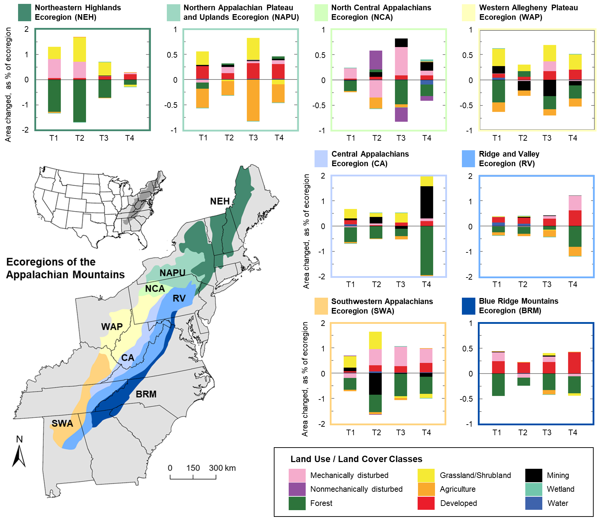

Figure 1. Map of the 8 ecoregions (color-coded and labeled) located within the Appalachian Mountains in the eastern United States, and graphs of land cover change corresponding to each ecoregion. The bar graphs were created by Sayler et al. (2016) as part of a U.S. Geological Survey report on the status and trends of land change from 1973 to 2000 in the eastern United States, detailing changes in land cover classes during 4 time periods (1973–1980, 1980–1986, 1986–1992, and 1992–2000). The graphs indicate changes in the area (measured as the percent of the ecoregion; y-axis) of 9 land cover classes (see legend for categories and color designations) within each ecoregion during the 4 time periods covered by the report (x-axis): T1 = 1973–1980, T2 = 1980–1986, T3 = 1986–1992, and T4 = 1992–2000.

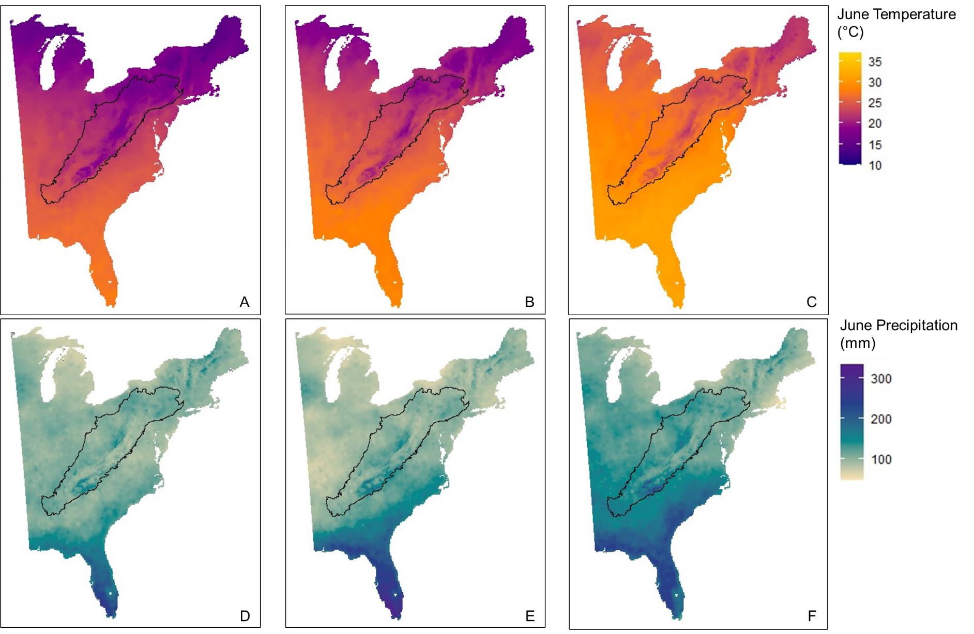

Figure 2. Mean June temperatures in Celsius (first row: A, B, C) and total June precipitation in mm (second row: D, E, F) across the eastern United States in 2000 (first column: A, D) and projected to 2100 under lower (second column: B, E) and higher (third column: C, F) greenhouse gas emissions scenarios, with the Appalachian Mountains Bird Conservation Region outlined in black. Contemporary and future monthly climate projections were calculated and compiled by Iverson et al. (2019).

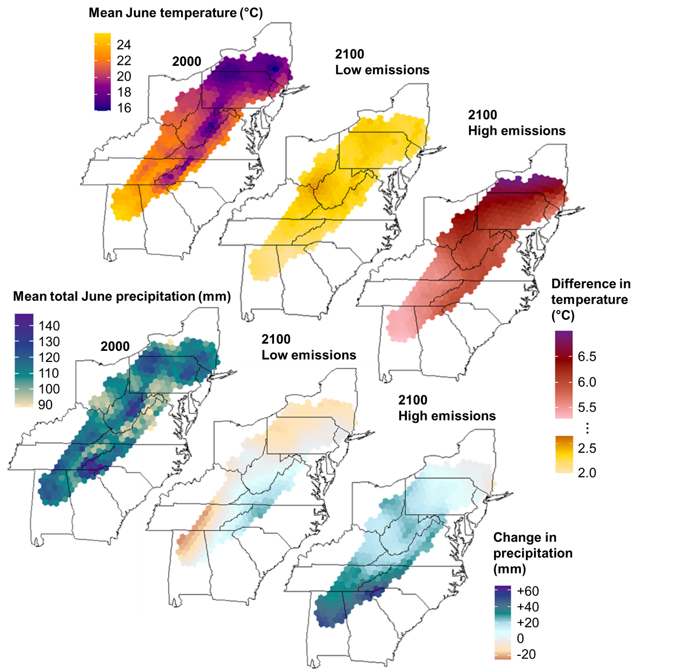

Figure 3. Mean June temperature in Celsius and mean total June precipitation in mm within the Appalachian Mountains Bird Conservation Region (hexagonal grid extent) in 2000 and projections of changes in those climate metrics in 2100 under low and high greenhouse gas emissions scenarios. Contemporary and future monthly climate projections were calculated and compiled by Iverson et al. (2019).



Figure 4. Land cover of the eastern United States in (A) 2000 and projected to 2100 under (B) lower and (C) higher greenhouse gas emissions scenarios. Within the Appalachian Mountains Bird Conservation Region (black outline), shades of green represent different types of forest (deciduous, mixed, and conifer), red represents developed land, and shades of yellow or orange represent agriculture (cropland and hay / pasture land). Future land cover projections were produced by the U.S. Geological Survey Earth Resources Observation and Science Center (Sohl et al. 2007).



Figure 5. Proportion of developed land and proportion of deciduous and mixed forest within the Appalachian Mountains Bird Conservation Region (hexagonal grid extent) in 2000 and projections of changes in those proportions in 2100 under low and high greenhouse gas emissions scenarios. Future land cover projections were produced by the U.S. Geological Survey Earth Resources Observation and Science Center (Sohl et al. 2007).

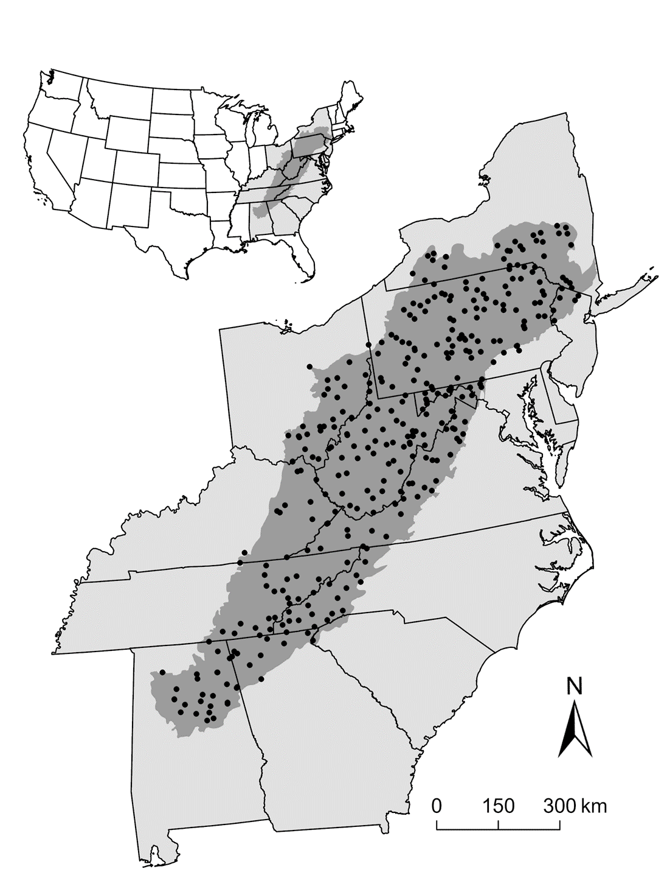

Figure 6. Location and extent of the Appalachian Mountains Bird Conservation Region (shaded in dark gray) in the eastern United States, along with the starting point associated with 322 North American Breeding Bird Survey routes (black points; Sauer et al. 2013) within the study region.

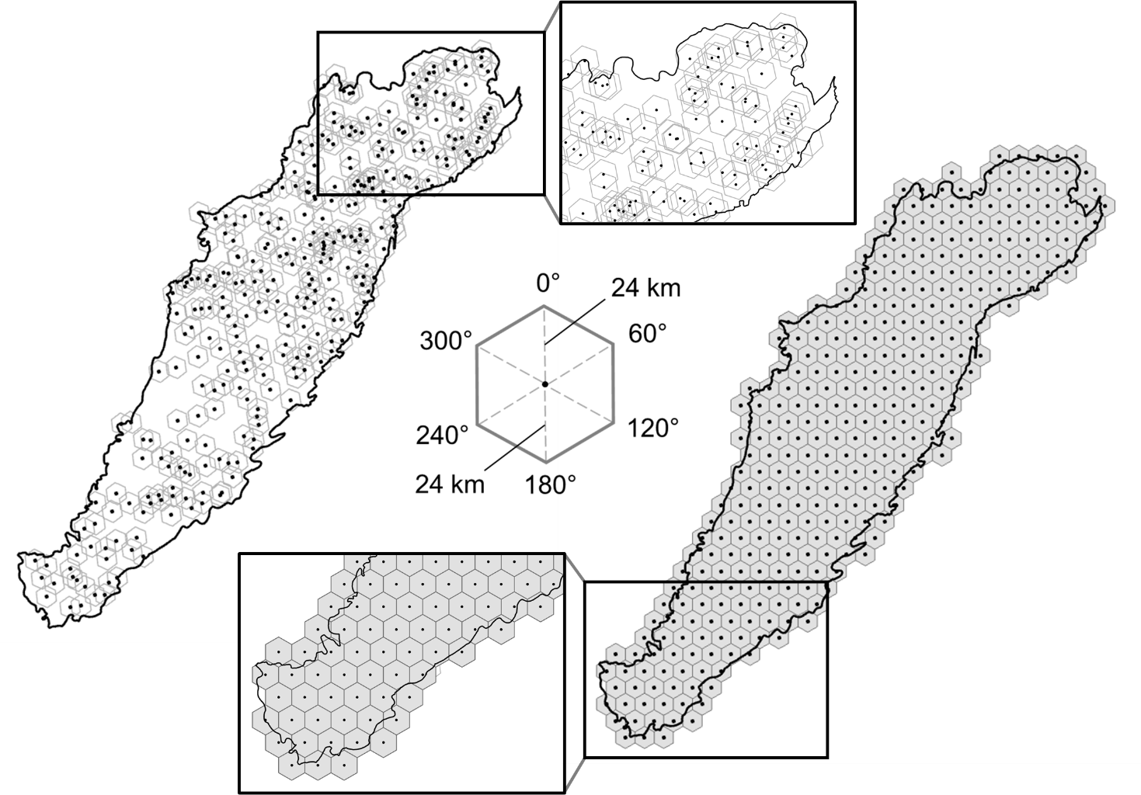

Figure 7. Sampling hexagons (left) corresponding to the 322 North American Breeding Survey routes (black points; Sauer et al. 2013) and hexagonal grid (right) covering the Appalachian Mountains Bird Conservation Region (outlined in black). All hexagons, whether sampling hexagons or hexagonal grid cells, were regular shapes with vertices at 0°, 60°, 120°, 180°, 240°, and 300° that were spaced approximately 24 km from the centerpoint of the hexagon (see center diagram); thus, the hexagonal grid cells (right) used for prediction matched the dimensions of the sampling hexagons (left) used for model building.









Figure 8. Whisker plots for each species (Table 1), displaying the slope coefficients of the predictor environmental variables (LAT = latitude [1 or 2 parameters], ELEV = elevation [1 or 4 parameters], LAT×ELEV = latitude x elevation interaction [1 parameter], MJT = mean May-June temperature [2 parameters], TD = temperature difference [2 parameters], MAP = mean March-April precipitation [2 parameters], MJP = mean May-June precipitation [2 parameters], DF = deciduous and mixed forest [1 parameter], CF = conifer forest [1 parameter], DL = developed land [1 parameter]), with a point at the mean values for the posterior distributions and whiskers encompassing the 95% credible intervals. For the first 6 species (BTBW, BHVI, CAWA, LEFL, SUTA, VEER), latitude and elevation were both specified as linear and a simple interaction between latitude and elevation was included. For the latter 8 species (CERW, EAWP, KEWA, REVI, SCTA, SWWA, WEWA, WOTH), latitude was specified as an orthogonal polynomial with 2 degrees (i.e., quadratic), elevation was specified as an orthogonal polynomial with 4 degrees, and there was no interaction between latitude and elevation. Points with closed circles indicate statistical significance (i.e., credible intervals do not overlap zero).















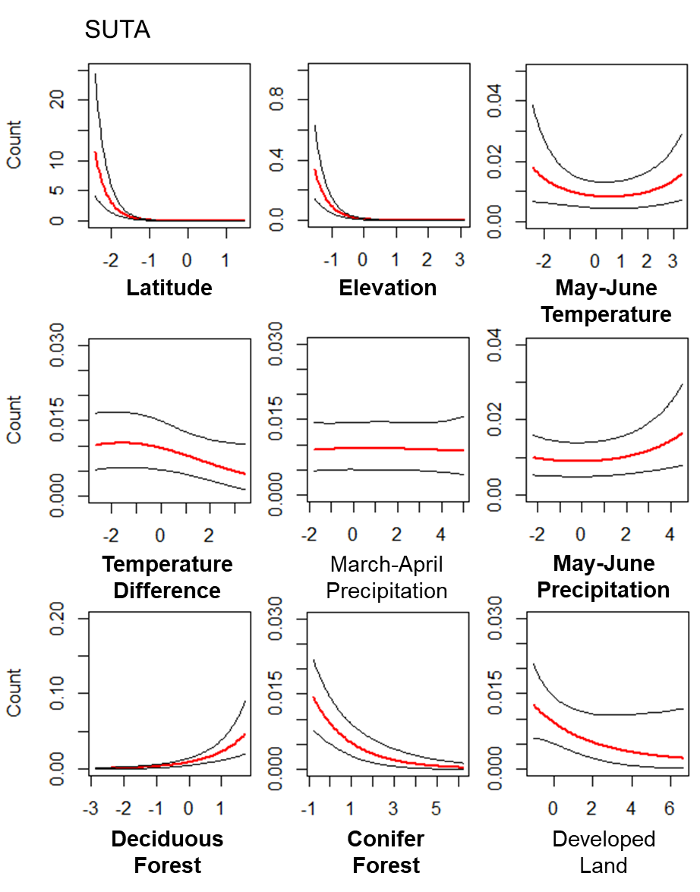













Figure 9. Plots of the relationships between the predictor variables (Table 2) and the mean expected count (red line) for each of the 14 focal forest songbird species (Table 1), with 95% credible intervals (black lines). The predictor variables are scaled, such that zero is the mean value, and reflect the range of the data. Bolded predictor variables have statistically significant beta coefficients (i.e., credible intervals do not overlap zero).

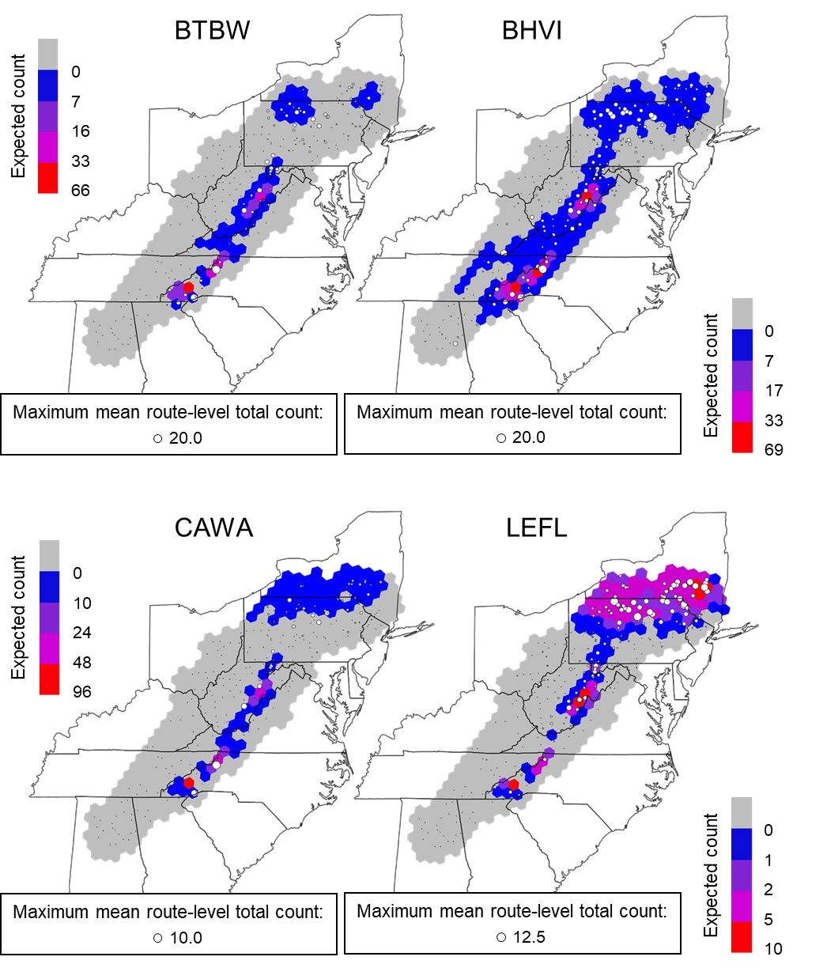

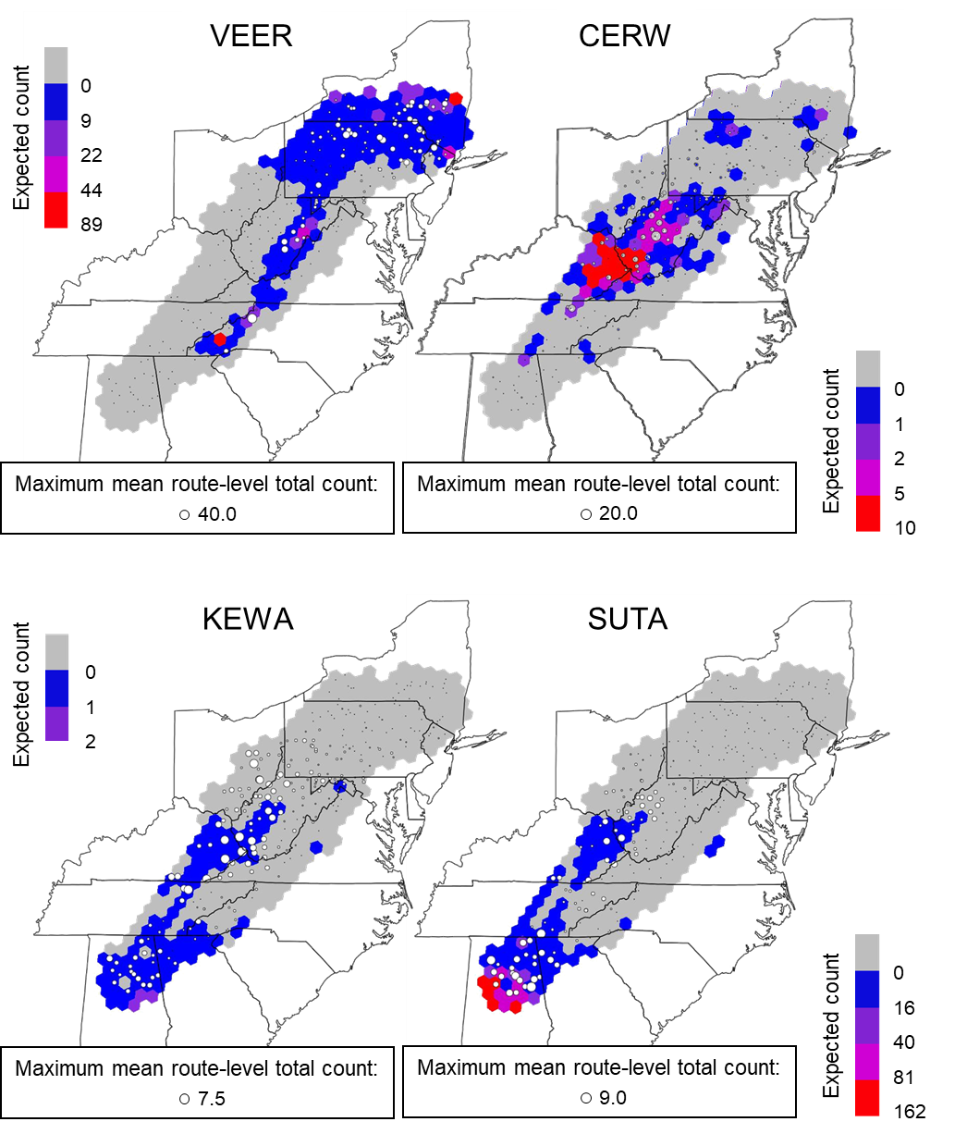

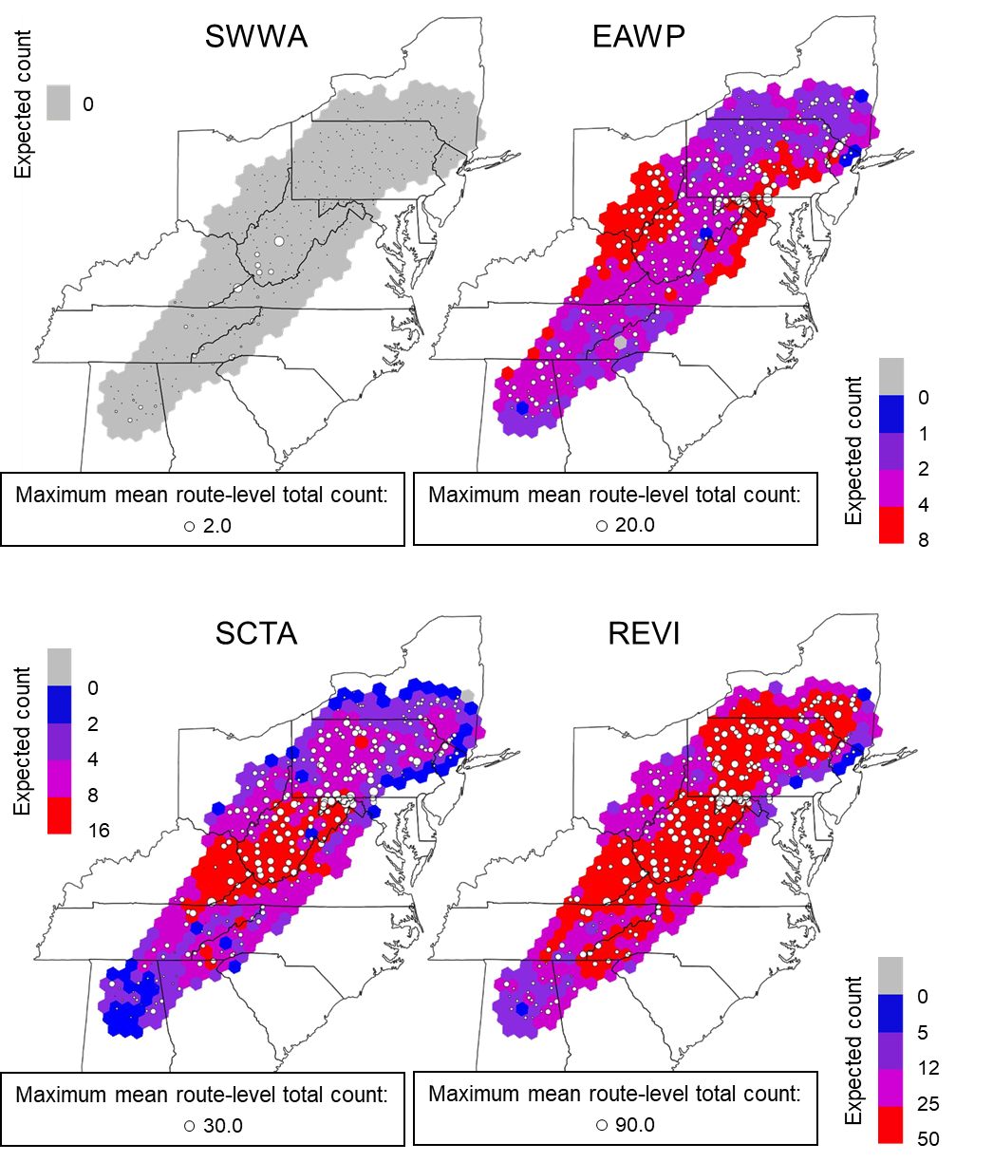

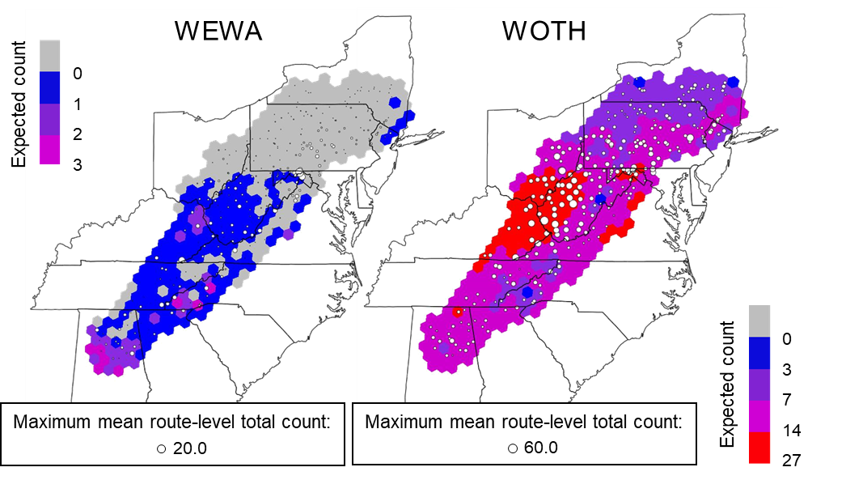

Figure 10. Maps of the projected contemporary (2000) distribution of each focal species (Table 1) across the study region, overlaid with white circles representing the 322 North American Breeding Bird Survey routes. The color of each hexagonal grid cell reflects the expected count from the model corresponding to each species (see Table 3 for model details), and the size of the white circles reflect the mean route-level total counts across years, with the maximum value presented for each species.

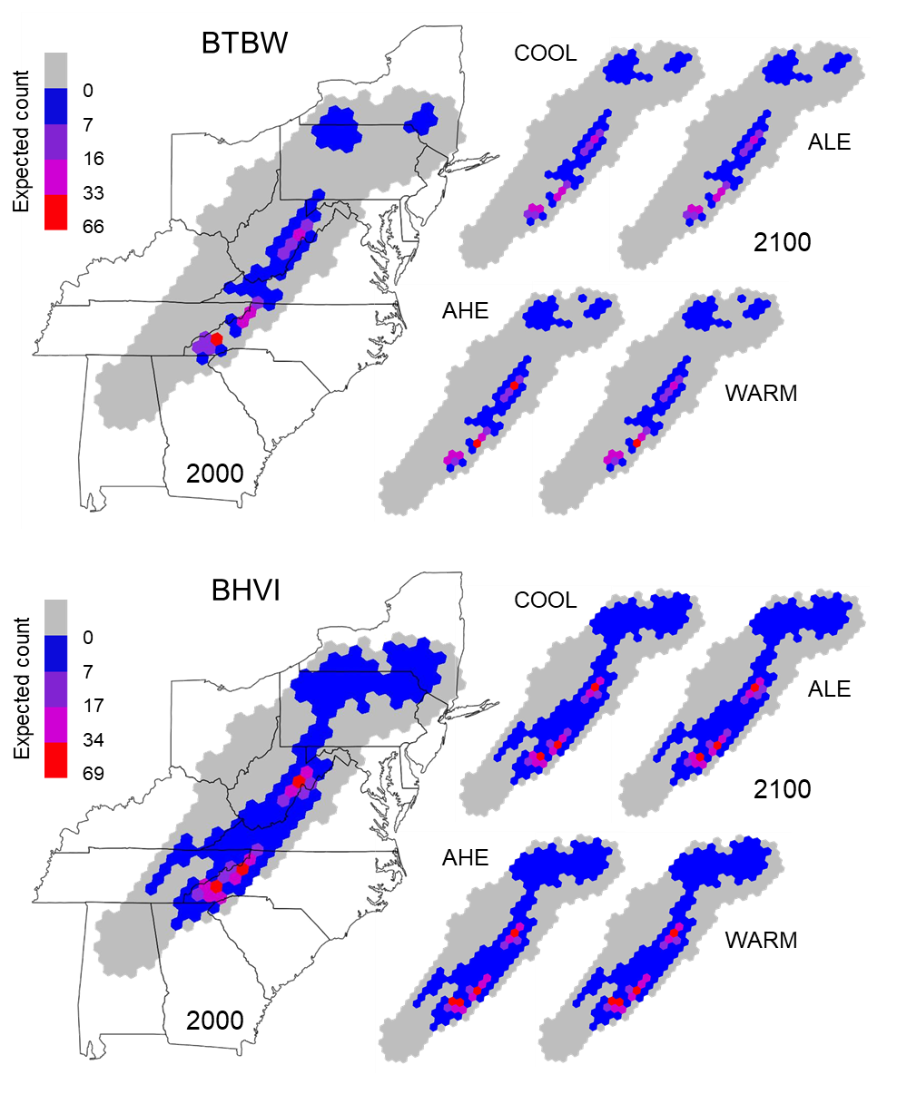

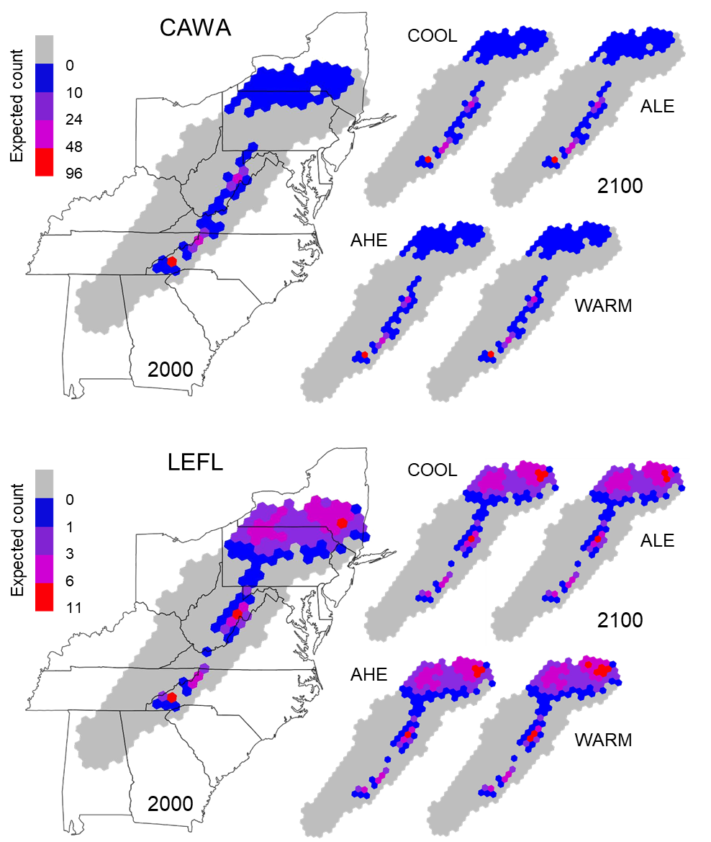

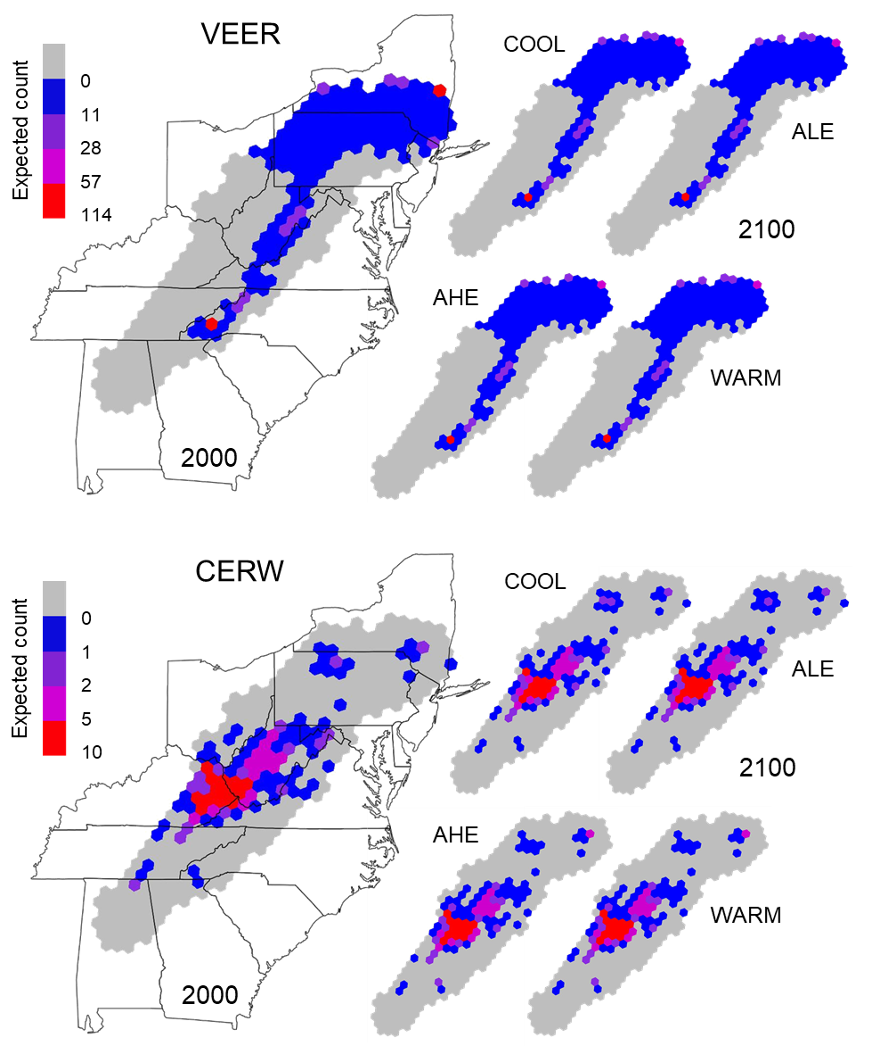

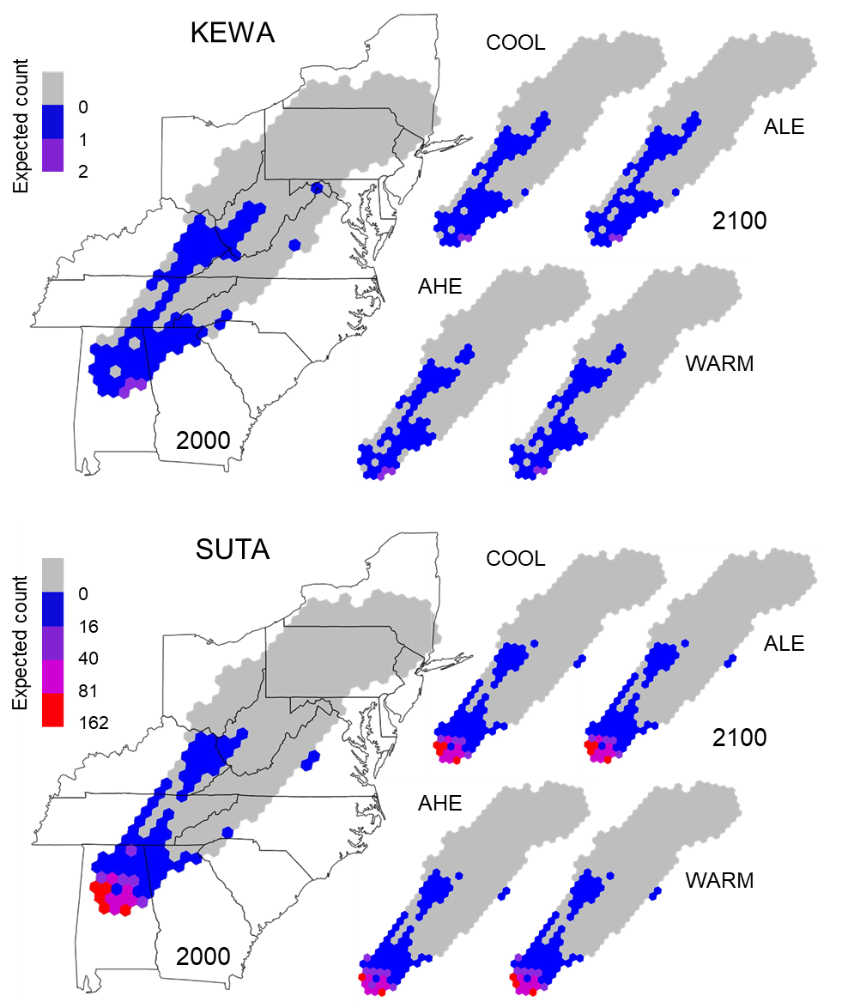

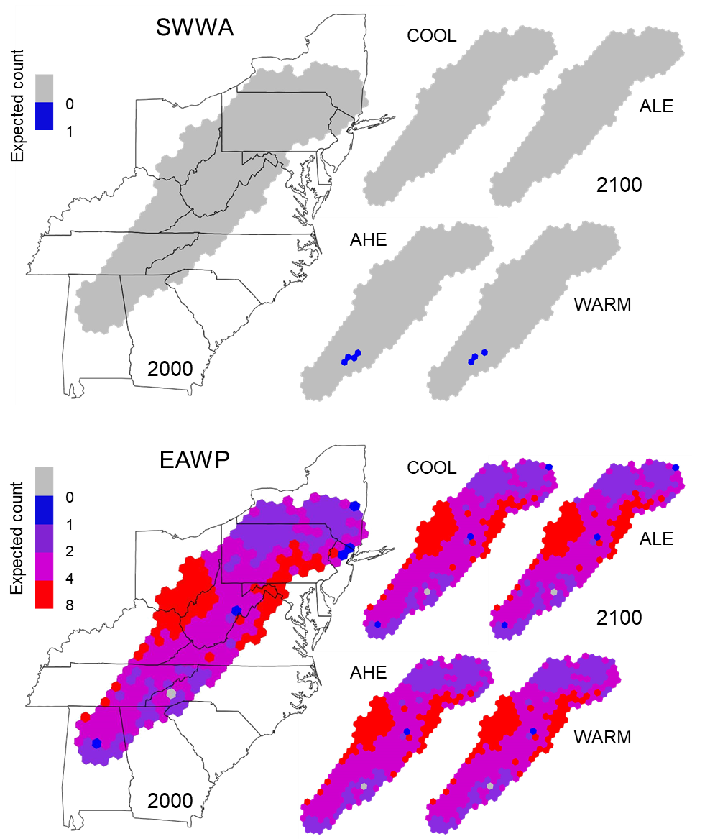

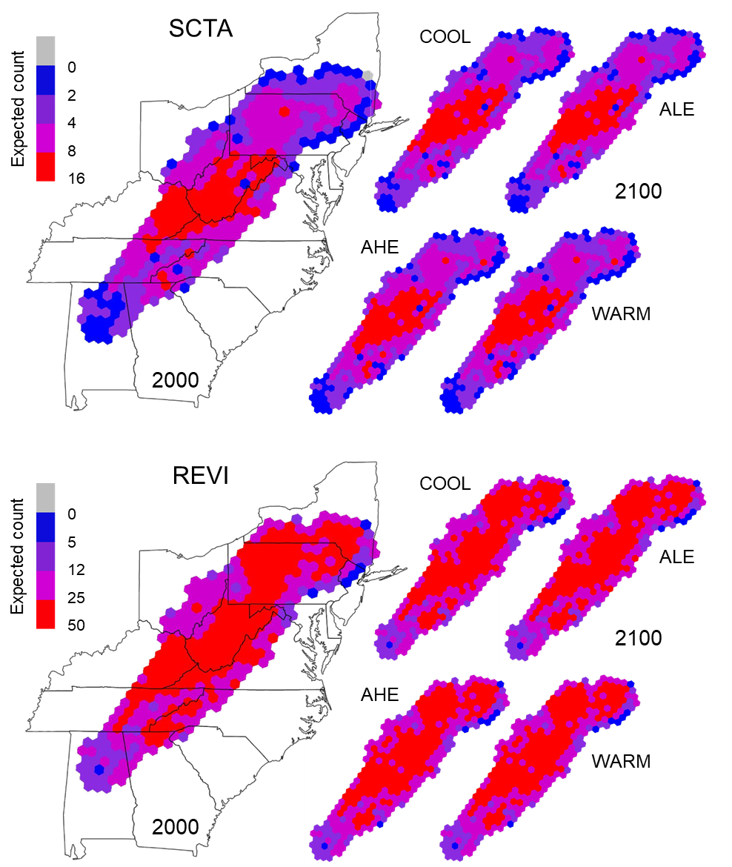

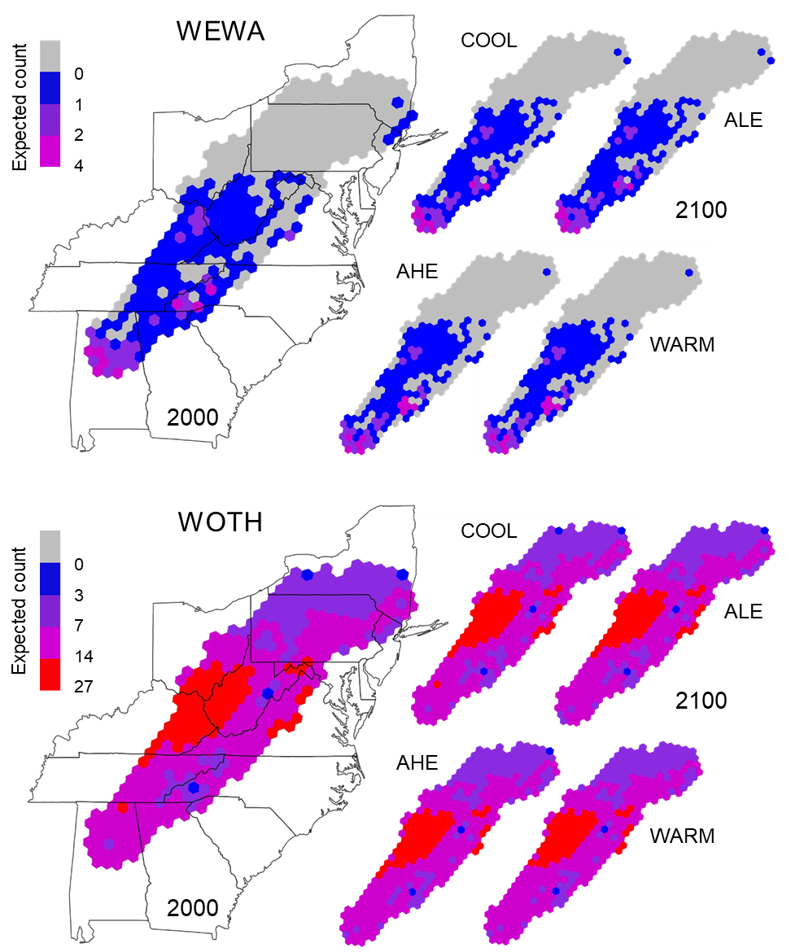

Figure 11. Maps of the projected contemporary (2000) and future (2100) distributions of each focal species (Table 1) across the study region. Future distributions were modeled based on 4 future climate and land cover combination scenarios, the coolest (COOL) and warmest (WARM) scenarios and the average low (ALE) and average high (AHE) emission scenarios. The color of each hexagonal grid cell reflects the expected count from the model corresponding to each species.

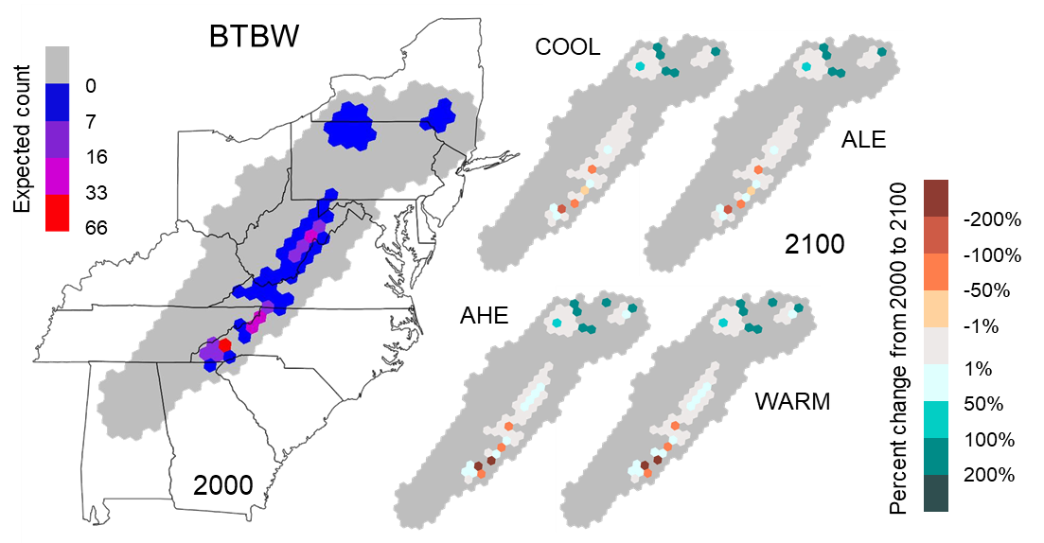

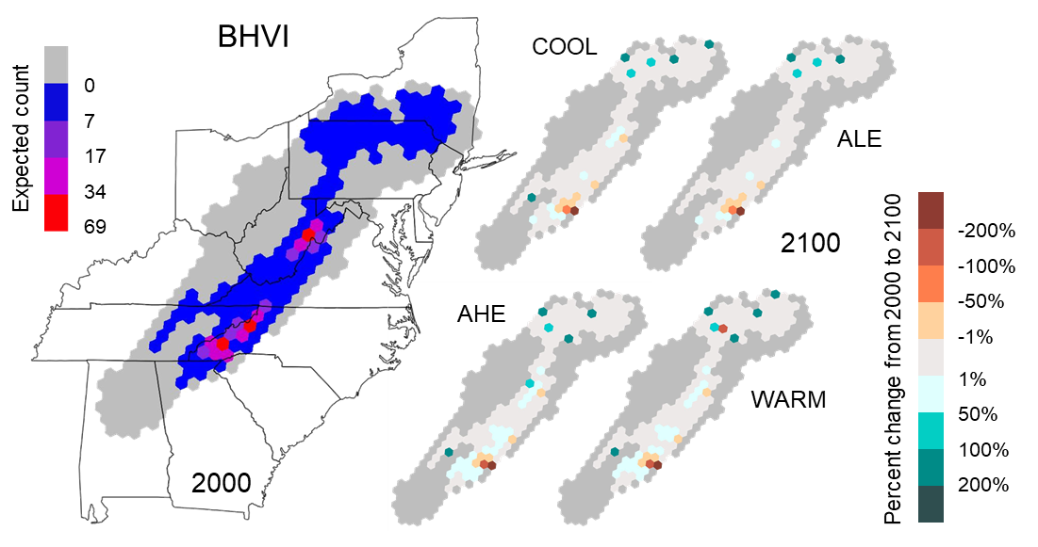

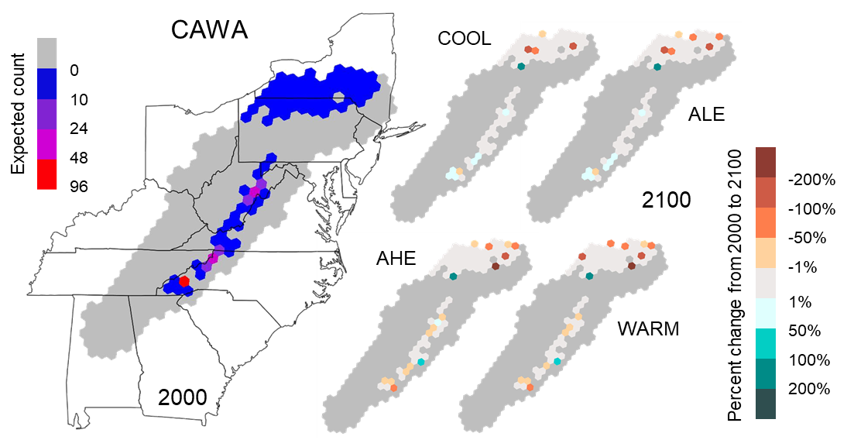

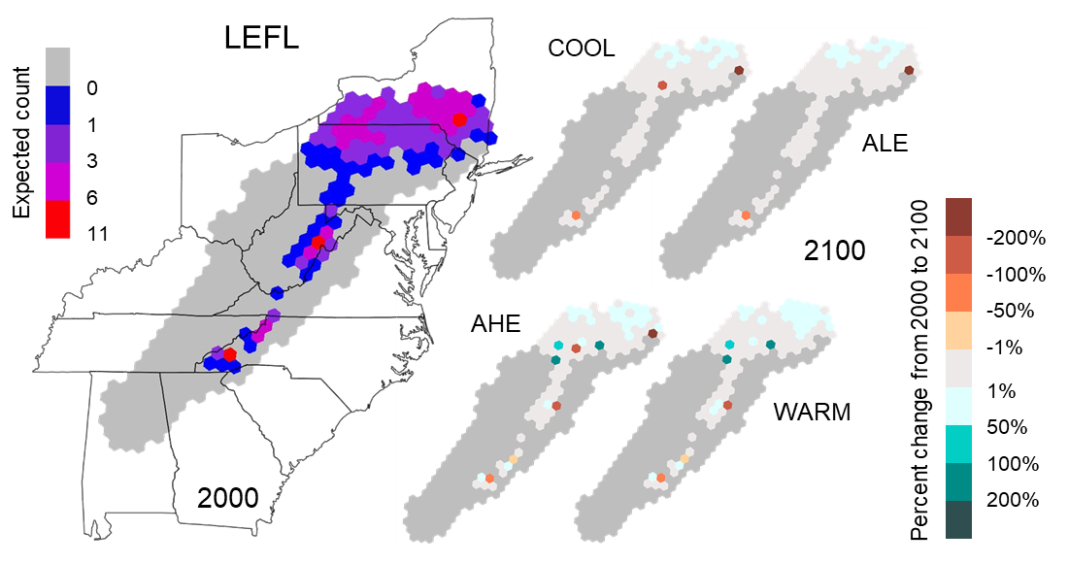

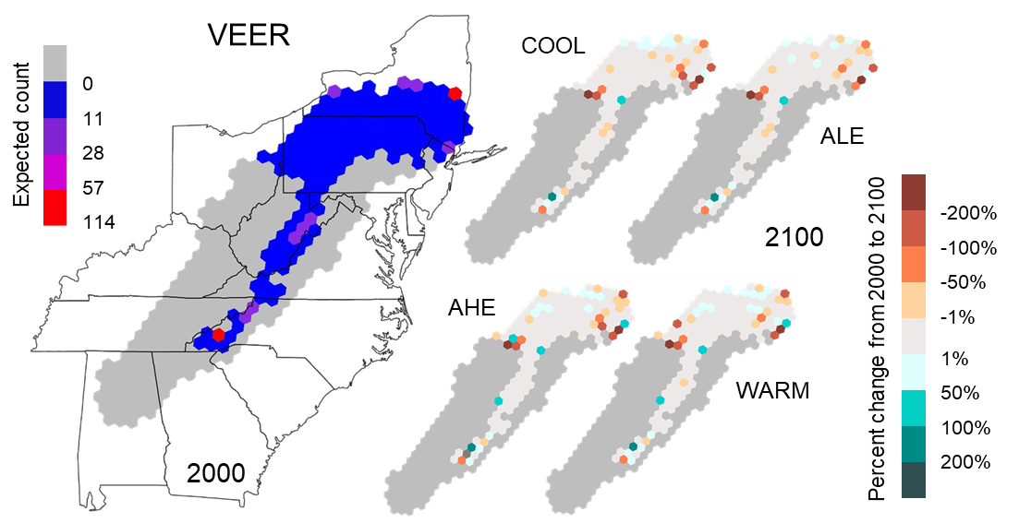

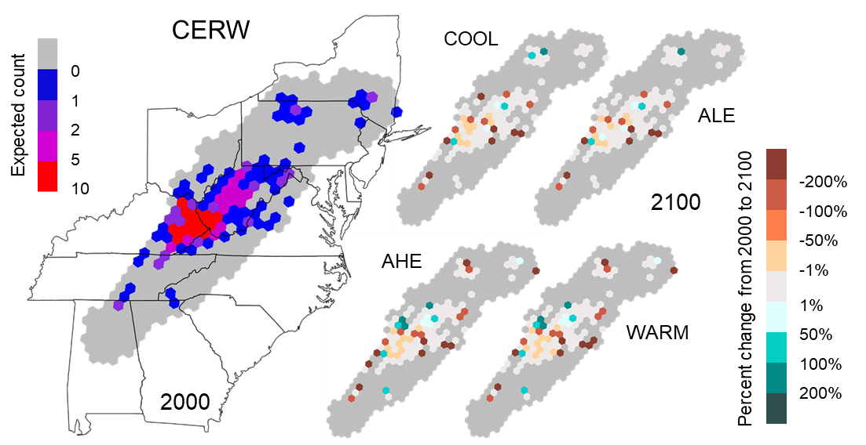

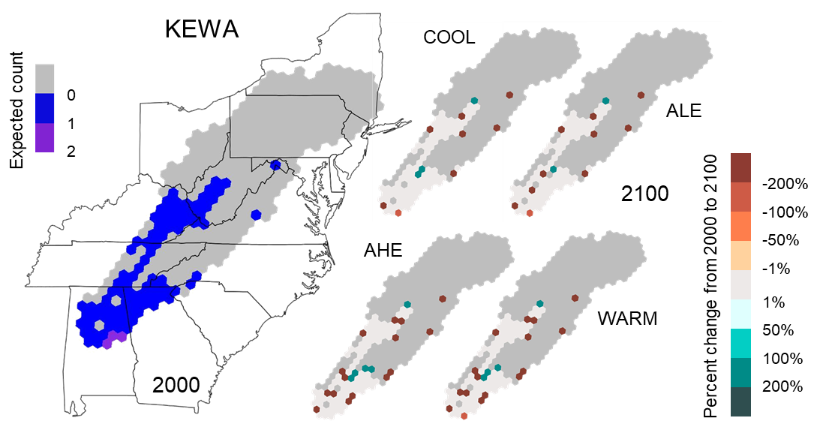

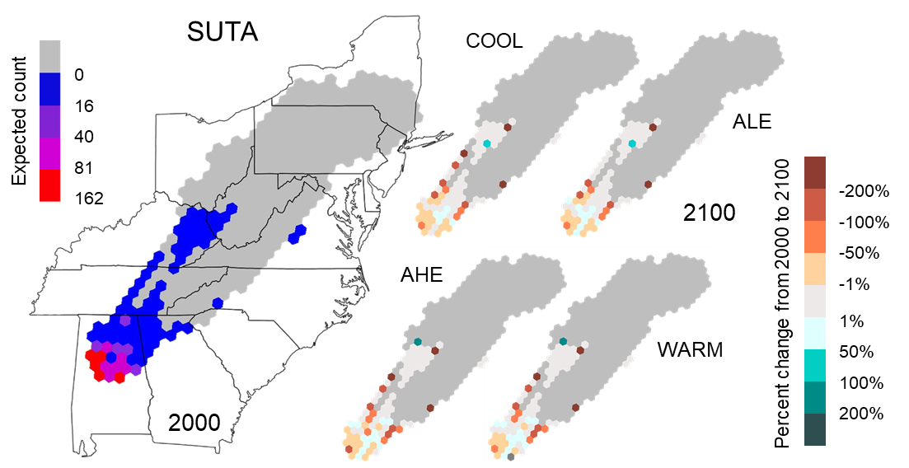

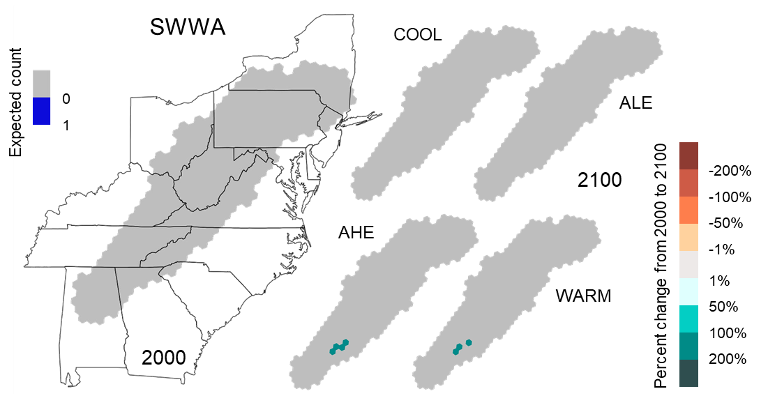

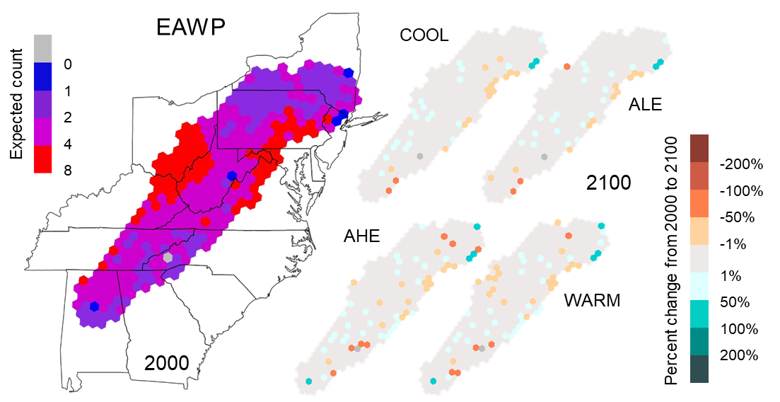

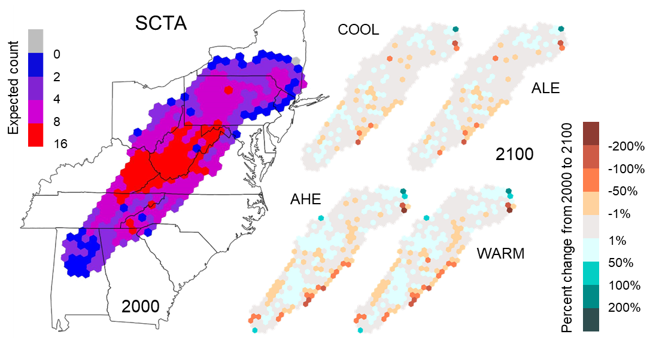

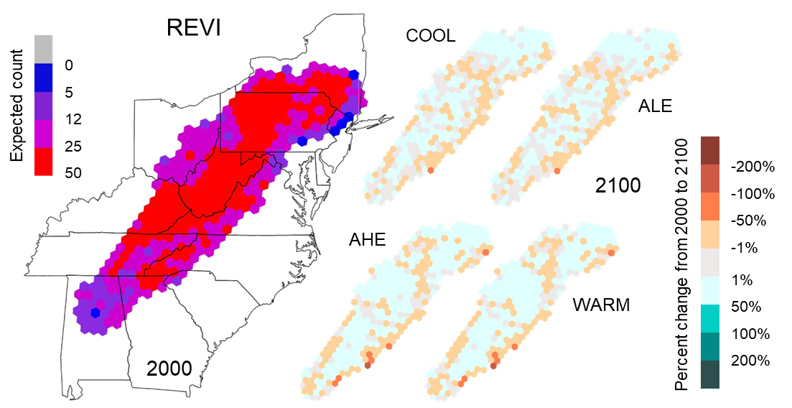

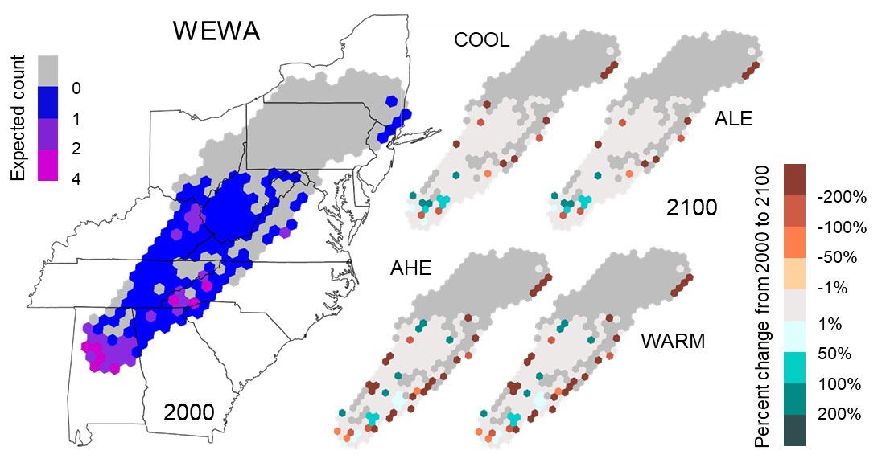

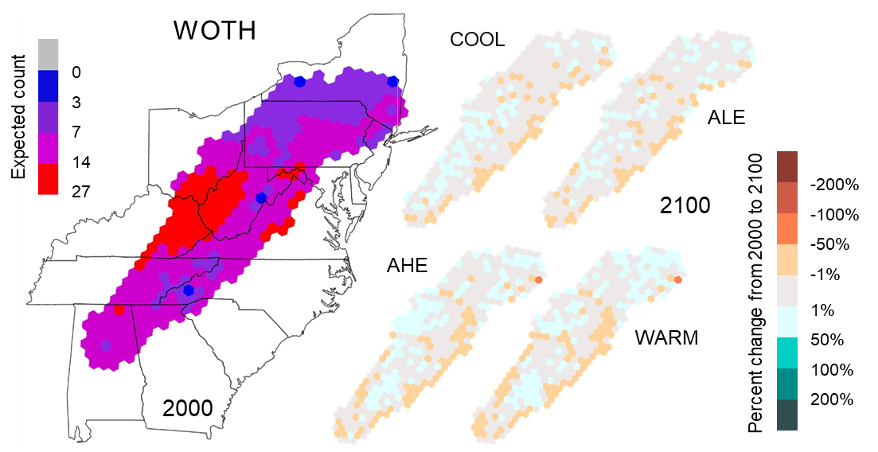

Figure 12. Maps of the percent differences in projected contemporary (2000) and future (2100) distributions of each focal species (Table 1) across the study region. Future distributions were modeled based on 4 future climate and land cover combination scenarios, the coolest (COOL) and warmest (WARM) scenarios and the average low (ALE) and average high (AHE) emission scenarios. The color of each hexagonal grid cell reflects the expected count in 2000 on the left and the percent changes in the expected counts from 2000 and 2100 on the right.

**Appendix A**

JAGS model code for the negative binomial model with spatial dependence

model{

# PRIORS

r ~ dgamma(0.01,0.01)

tau ~ dgamma(0.01,0.01)

s2 <- 1/tau

phi ~ dunif(0,1)

b0 ~ dnorm(0,0.01)

for (b in 1:C) {

beta[b] ~ dnorm(0,0.01)

}

# NOTES: Loop over C (number of coefficients)

for (a in 1:S){

mu[a] <- b0

for (b in 1:S){

# Covariance matrix:

Sigma[a, b] <- s2*exp(log(phi)*dist[a,b])

}

}

# NOTES: Loop over S (number of unique BBS routes)

site[1:S] ~ dmnorm.vcov(mu[1:S],Sigma[1:S,1:S])

# LIKELIHOOD

for(i in 1:N){

y[i] ~ dnegbin(p[i],r)

log(lambda[i]) <- inprod(beta[1:C],x[i,1:C])+site[id[i]]

p[i] <- r/(r+lambda[i])

# FOR MODEL FIT - Squared Pearson residual: (obs-lambda)^2/(r(1-p)/p^2)

p.resid[i] <- pow((y[i]-lambda[i]), 2)/((r*(1-p[i]))/(pow(p[i],2)))

y.new[i] ~ dnegbin(p[i],r)

p.resid.new[i] <- pow((y.new[i]-lambda[i]),2)/((r*(1-p[i]))/(pow(p[i],2)))

}

# NOTES: Loop over N (number of sites).

# MODEL FIT AND CHECKING

overall.fit <- sum(p.resid[])

overall.fit.new <- sum(p.resid.new[])

overall.p.val <- step(overall.fit.new - overall.fit)

}

**Appendix B**

JAGS model code for the negative binomial model without spatial dependence

model {

# PRIORS

beta0 ~ dnorm(0,0.01)

tau_l ~ dgamma(0.01,0.01)

mu_logr ~ dnorm(0,0.01)

tau_logr ~ dgamma(0.01,0.01)

for (s in 1:S){

# Site-level random effect for the expected count

site_l[s] ~ dnorm(0,tau_l)

# Site-level random effect for the dispersion parameter

site_r[s] ~ dnorm(mu_logr,tau_logr)

log(r[s]) <- site_r[s]

}

# NOTES: Loop over S (number of unique BBS routes)

for (b in 1:C) {

beta[b] ~ dnorm(0,0.01)

}

# NOTES: Loop over C (number of coefficients)

# LIKELIHOOD

for (i in 1:N){

y[i] ~ dnegbin(p[i],r[id[i]])

log(lambda[i]) <- beta0+inprod(beta[1:C],x[i,1:C])+site_l[id[i]]

p[i] <- r[id[i]]/(r[id[i]]+lambda[i])

# FOR MODEL FIT - Squared Pearson residual: (obs-lambda)^2/(r(1-p)/p^2)

p.resid[i] <- pow((y[i]-lambda[i]),2)/((r[id[i]]*(1-p[i]))/pow(p[i],2))

y.new[i] ~ dnegbin(p[i],r[id[i]])

p.resid.new[i] <- pow((y.new[i]-lambda[i]),2)/((r[id[i]]*(1-p[i]))/

pow(p[i],2))

}

# NOTES: Loop over N (number of sites).

# MODEL FIT AND CHECKING

overall.fit <- sum(p.resid[])

overall.fit.new <- sum(p.resid.new[])

overall.p.val <- step(overall.fit.new - overall.fit)

}